NAME:

**Year 2 A-level PHYSICAL EDUCATION**

**Sports Development**

[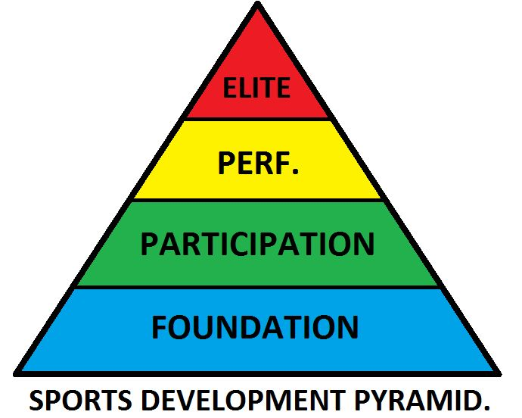](https://www.google.co.uk/url?sa=i&rct=j&q=&esrc=s&source=images&cd=&cad=rja&uact=8&ved=0ahUKEwjgpqj44e_UAhVJshQKHYoOADgQjRwIBw&url=https://uk.pinterest.com/hannahwinsbury/physical-education/&psig=AFQjCNHbrEStE5tNNZ4sImWXk9J9Clg0gg&ust=1499262398492831)

By the end of this section, you should be able to understand:

The characteristics and functions of key concepts and how they create the base of the sporting development continuum.

Physical recreation. Sport. Physical education. School sport.

The similarities and the differences between these key concepts.

The personal, social and cultural factors required to support progression from talent identification to elite performance.

The generic roles, purpose and the relationship between organisations in providing support and progression from talent identification through to elite performance.

National governing bodies. National institutes of sport. UK Sport.

The key features of national governing bodies’ whole sport plans.

The support services provided by national institutes of sport for talent development.

The key features of UK Sport’s World Class Performance Programme, Gold Event Series and Talent Identification and Development. Or equivalent current named programmes.

**The Sporting Development Continuum**

**1**

**Sport Development**

**Task 1:** Read and take notes from chapter 13.1 on the key concepts.

**Task 2:** Use the support PowerPoint to make some notes on the different levels of the sport development continuum.

[](https://www.google.co.uk/url?sa=i&rct=j&q=&esrc=s&source=images&cd=&cad=rja&uact=8&ved=0ahUKEwjgpqj44e_UAhVJshQKHYoOADgQjRwIBw&url=https://uk.pinterest.com/hannahwinsbury/physical-education/&psig=AFQjCNHbrEStE5tNNZ4sImWXk9J9Clg0gg&ust=1499262398492831)

**Task 3:** Use the support PowerPoint to make some notes on the four key concepts:

|  |  |
| --- | --- |
| **Physical Recreation** | **Physical Education** |
| **School Sport** | **Sport** |

**Task 4:** Complete the diagram below. [4]

**1**

**Sport Development**

Explain how the four key concepts have functions for individuals and for society.

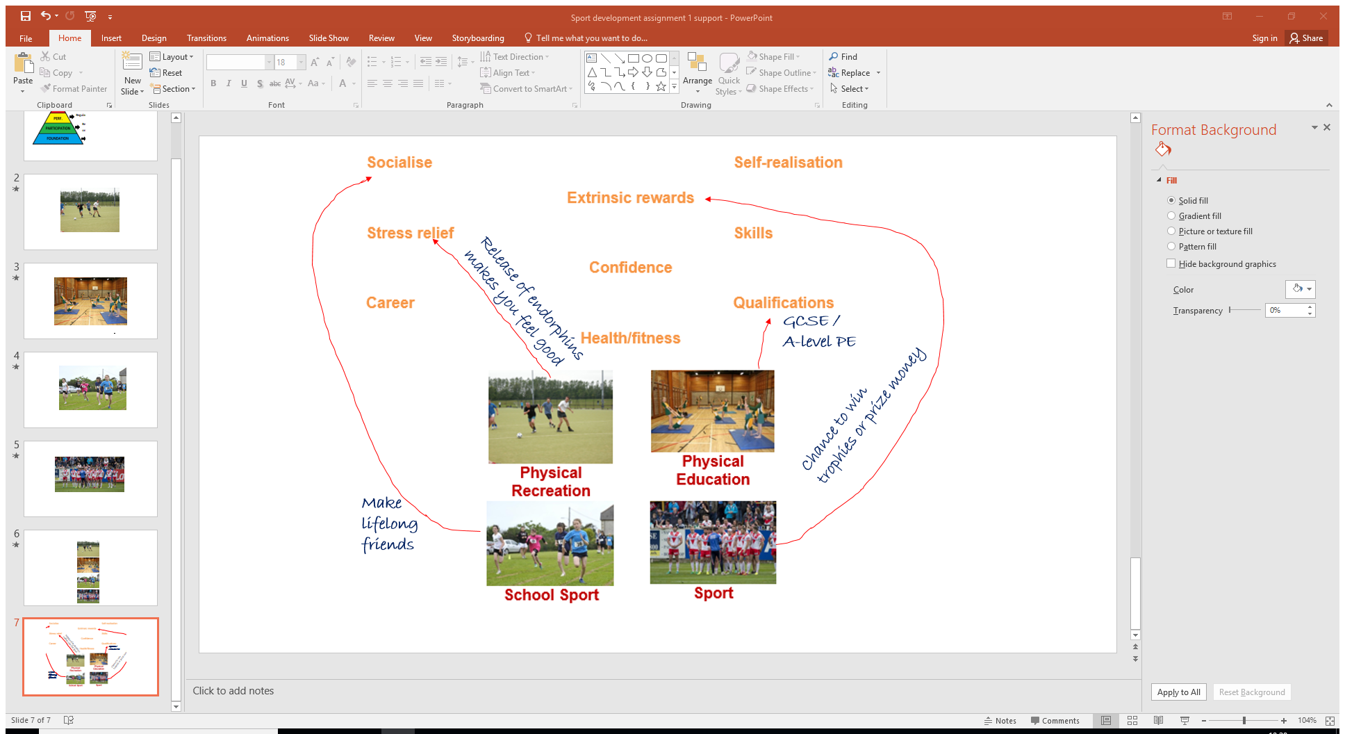

**Reduced crime Worker productivity**

**Community integration**

**National pride Economic benefits**

**Reduced strain on NHS**

Explain how sport might impact negatively to individuals **and** society [4].

**1**

**Sport Development**

……………………………………………………………………………………………………………………………………………………………………………………………………………………………………………………………………………………………………………………………………………………………………………………………………………………………………………………………………………………………………………………………………………………………………………………………………………………………………………………………………………………………………………………………………………………

Explain how the key concepts create the base (foundation) of the sporting development continuum. [4]

……………………………………………………………………………………………………………………………………………………………………………………………………………………………………………………………………………………………………………………………………………………………………………………………………………………………………………………………………………………………………………………………………………………………………………………………………………………………………………………………………………………………………………………………………………………

Identify three differences between school PE and school sport. [3]

**1**

**Sport Development**

………………………………………………………………………………………

………………………………………………………………………………………

………………………………………………………………………………………

………………………………………………………………………………………

…………………………………………………………………………………………

…………………………………………………………………………………………

…………………………………………………………………………………………

Use examples to explain two differences between tennis as a recreation and

tennis as a sport. [4]

…………………………………………………………………………………………………………………………………………………………………………………………………………………………………………………………………………………………………………………………………………………………………………

………………………………………………………………………………………………………………………………………………………………………………………………………………………………………………………………………………………………………………………………………………………………………………………………………………………………………………………………………………………………………………………………………………………………

Total marks for this assignment is 19