Sport Development Assignment 4

**4**

**Sport Development**

**Task 1:** Read the extract from the textbook below. Use this, as well as your

Sport Development Assignment 3 work to help you complete the essay plan on UK Sport programmes below.

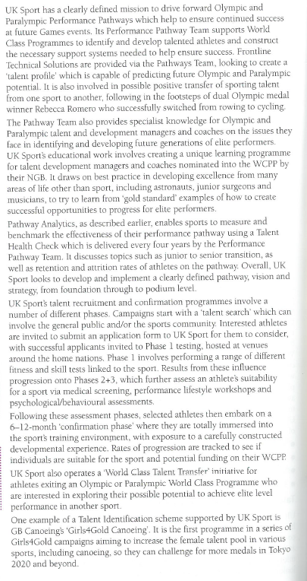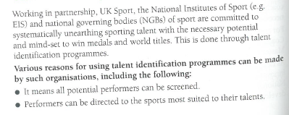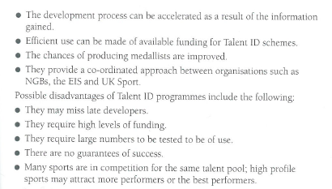

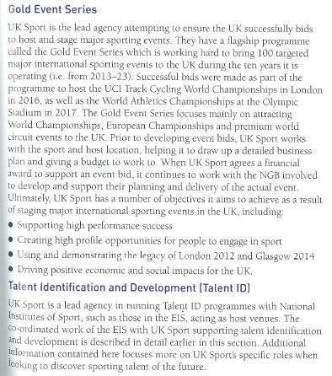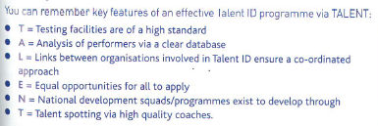

**4**

**Sport Development**

UK Sport is responsible for strategic support for elite sports performers.

Evaluate the impact of named UK Sport programmes on elite performers **and** on UK society. [8]

Essay plan:

|  |  |  |
| --- | --- | --- |
| **AO1** – Knowledge of UK sport programmes | **AO2** – Application of knowledge | **AO3** – Evaluation/Analysis |
| **World Class Performance Pathway** |  |  |
| **Gold Event Series** |  |  |
| **Target Tokyo, Tall and talented, Girls4Gold or equiv.** |  |  |
| **100% ME** |  |  |

**Task 2:** Use the support powerpoint to help you fill in the notes below



