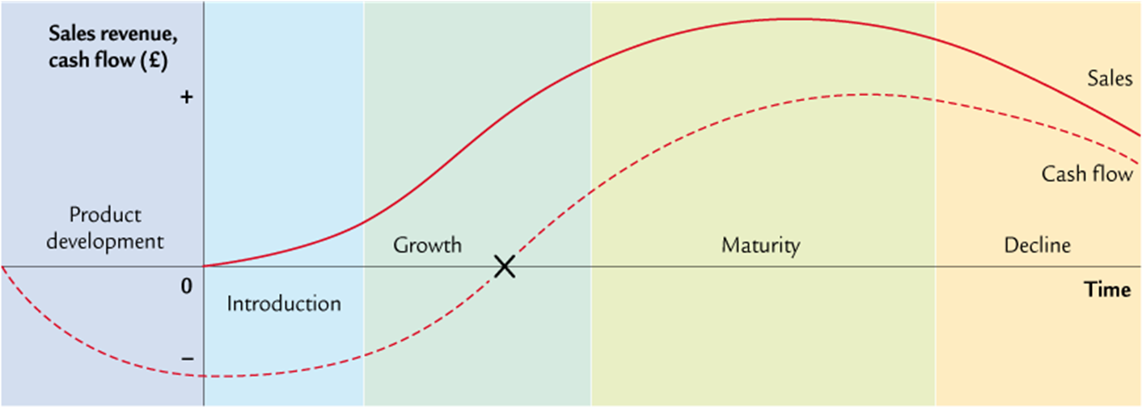

|  |  |  |  |  |  |
| --- | --- | --- | --- | --- | --- |
| Sales |  |  |  |  |  |
| Cash Flow |  |  |  |  |  |
| Profit |  |  |  |  |  |
| Market Growth |  |  |  |  |  |
| Costs |  |  |  |  |  |
| Marketing |  |  |  |  |  |
| Competition |  |  |  |  |  |