# Worksheet 1 Structure of the Internet

### Task 1

1. Define the following Computing terms:  
   1. The Internet

* 1. World Wide Web
  2. Backbone

1. Label the diagram of the structure of the different levels of the Internet:

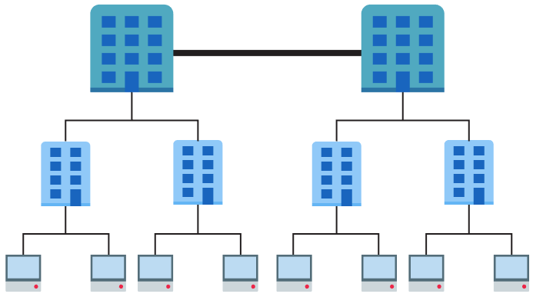

1. IP version 4 addresses such as 13.1.67.234 and 115.90.12.101 are used to identify devices on a network. As such they need to be unique for each device.
   1. The value of each number in an IP address ranges from 0 to 255. Calculate how many addresses are possible in theory.
   2. Explain why version 4 is not enough for use on the Internet.

# Task 2

IP addresses are difficult for humans to remember. DNS provides a resolution of domains names into their IP addresses.

If you type 216.58.213.174 into the address bar of your browser, you should get the www.google.co.uk web page.

We type the URL, as it is easier to remember, but it is just a label for the actual IP address that connects your computer to the Google servers.

Use the website <http://ping.eu/nslookup> to find the IP addresses of the following three websites and two more of your choice:

|  |  |
| --- | --- |
| **Website** | **IP address(es)** |
| google.co.uk |  |
| bbc.co.uk |  |
| en.wikipedia.org |  |
|  |  |
|  |  |

Check they work by typing them into a browser address bar. (Some only work in one direction.)

Compare your results with other people. They may be different. Can you explain why?

# Task 3

1. Five Regional Internet Registries (RIRs) record the allocation of IP addresses in different geographical locations.   
     
   Research the names of these and the broad geographical area that are responsible for:

|  |  |
| --- | --- |
| **Name** | **Region** |
|  |  |
|  |  |
|  |  |
|  |  |
|  |  |

1. URLs are used to specify the location and means of accessing a resource across a network.   
     
   (a) Correctly label the parts of the following URL with ‘**Domain name**’, ‘**Protocol**’, ‘**Resource**’, ‘**host’**:

http://www.foodsupermarket.com/cheeses.html

(b) Identify the fully qualified domain name.