# Homework 5 IP addresses Answers

1. A small business has an office with three employees. The network is designed as follows:

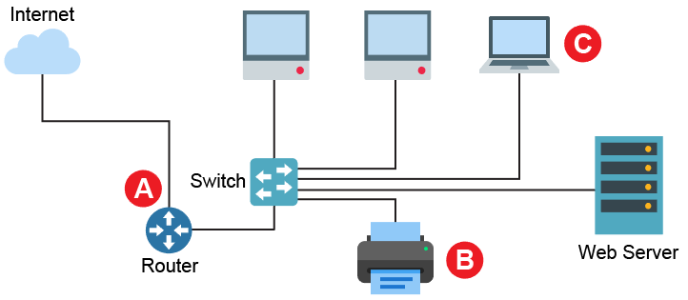

* 1. The network uses private IP addresses in the format 192.168.104.x.   
     Explain what sort of addresses these are. [2]  
       
     IP addresses that aren’t routable on the Internet;

Can be used in any way that the user requires within the LAN;

* 1. The network has been given the external IP address: 83.48.154.43. Suggest suitable IP addresses to be used at points A, B and C as shown above. [3]

|  |  |
| --- | --- |
| **A** – The external port of the router | 83.48.154.43 |
| **B** – The network printer | 192.168.104.1 to 254 |
| **C** – The laptop | 192.168.104.1 to 254  (but not the same as B) |

* 1. The internal subnet mask on the network is 255.255.255.0. The server has an IP address of 192.168.104.8. Identify the network ID and the host ID of the server. [2]

Network ID: 192.168.104.0

Host ID: 8

* 1. The company is expected to grow very quickly and could require IP addresses for almost 500 devices.

With reference to the maximum hosts available, explain why the current   
network will not be suitable. [1]

Current network will only allow 254 hosts on the network;

Additional hosts would need a new subnet within an enlarged LAN

* 1. The external router has NAT and port forwarding facilities.

Explain how these features will be useful on the network as it is designed now. [4]

NAT allows private IP addresses to access the Internet;

This enables the devices on the internal network to access Internet resources;

Port forwarding passes on external traffic to an internal server;

The web server can still be given a private IP address;

The router will need to be configured so that traffic with web service destination ports are forwarded on to it;

1. Dynamic Host Configuration Protocol (DHCP) is often used on a network to configure network hosts automatically.  
   1. Explain why a DHCP server can operate with a pool of IP addresses that has fewer addresses than the number of devices that may wish to access it. [2]

DHCP allocates IP addresses to devices that request them;

The pool of addresses is leased out to these devices; for the duration of their connection when they are then handed back;

Should there be more hosts than IP addresses that make requests, they can be shared around as it is unlikely that all devices should require a connection at the same time;

* 1. Describe in detail the process that clients and a DHCP server use in order to   
     assign an IP address. [4]

Process started with client sending a DHCPDISCOVER broadcast;

This is the first point of contact to an available DHCP server to start the request process;

Any available DHCP server then sends back a DHCPOFFER;

This includes the configuration details such as the IP address, the subnet mask, etc.

The client sends back a DHCPREQUEST;

This confirms that the client wants to use this IP address;

Lastly, the server sends a DHCPACK;

This confirms to the client this request has been accepted and the IP address the IP address won’t be leased to another client as it had been allocated to this one.

[Total 18 Marks]