Candidates may use any calculator allowed by Pearson regulations.
Calculators must not have the facility for symbolic algebra manipulation,
differentiation and integration, or have retrievable mathematical
formulae stored in them.
Instructions
- Use black ink or ball-point pen.
- If pencil is used for diagrams / sketches / graphs it must be dark (HB or B).
  - Fill in the boxes at the top of this page with your name,
centre number and candidate number.
- Answer all questions and ensure that your answers to parts of questions
are clearly labelled.
- Answer the questions in the spaces provided
– there may be more space than you need.
- You should show sufficient working to make your methods clear.
Answers without working may not gain full credit.
- Answers should be given to three significant figures unless otherwise stated.
Information
- A booklet ‘Mathematical Formulae and Statistical Tables’ is provided.
- There are 8 questions in this question paper. The total mark for this paper is 75.
- The marks for each question are shown in brackets
– use this as a guide as to how much time to spend on each question.
Advice
- Read each question carefully before you start to answer it.
- Try to answer every question.
- Check your answers if you have time at the end.
Answer ALL questions. Write your answers in the spaces provided.

1 (a) Prove that
tanh⁻¹ (x) = −k < x < k
stating the value of the constant k.
(5)
(b) Hence, or otherwise, solve the equation
2x = tanh
(5)
(Total for Question 1 is 10 marks)
___________________________________________________________________________

2 The roots of the equation
x³ – 2x² + 4x – 5 = 0
are p, q and r.
Without solving the equation, find the value of
(i)
(ii) (p – 4)(q – 4)(r – 4)
(iii) p³ + q³ + r³
(8)
(Total for Question 2 is 8 marks)
___________________________________________________________________________

3
f(x) =
(a) Using a substitution, that should be stated clearly, show that
= A sinh^{–1} (Bx) + c
where c is an arbitrary constant and A and B are constants to be found.
(4)
(b) Hence find, in exact form in terms of natural logarithms, the mean value of f(x) over
the interval [0, 3].
(2)
(Total for Question 3 is 6 marks)
___________________________________________________________________________

4 The infinite series C and S are defined by
C = cos 𝜃 + cos 5𝜃 + cos 9𝜃 + cos 13𝜃 + …
S = sin 𝜃 + sin 5𝜃 + sin 9𝜃 + sin 13𝜃 + …
Given that the series C and S are both convergent,
(a) show that
C + iS =
(4)
(b) Hence show that
S =
(4)
(Total for Question 4 is 8 marks)
___________________________________________________________________________

5 An engineer is investigating the motion of a sprung diving board at a swimming pool.

Let E be the position of the end of the diving board when it is at rest in its equilibrium position
and when there is no diver standing on the diving board.

A diver jumps from the diving board.
The vertical displacement, h cm, of the end of the diving board above E is modelled by
the differential equation
where t seconds is the time after the diver jumps.
(a) Find a general solution of the differential equation.
(2)

When t = 0, the end of the diving board is 20 cm below E and is moving upwards with a
speed of 55 cm s^{–1}.
(b) Find, according to the model, the maximum vertical displacement of the end of the
diving board above E.
(8)
(c) Comment on the suitability of the model for large values of t.
(2)
(Total for Question 5 is 12 marks)
___________________________________________________________________________

6 In an Argand diagram, the points A, B and C are the vertices of an equilateral triangle
with its centre at the origin. The point A represents the complex number 6 + 2i.
(a) Find the complex numbers represented by the points B and C, giving your answers in
the form x + iy, where x and y are real and exact.
(6)

The points D, E and F are the midpoints of the sides of triangle ABC.
(b) Find the exact area of triangle DEF.
(3)
(Total for Question 6 is 9 marks)
___________________________________________________________________________

7
M = where k is a constant
(a) Find the values of k for which the matrix M has an inverse.
(2)
(b) Find, in terms of p, the coordinates of the point where the following planes intersect

2x – y + z = p
3x – 6y + 4z = 1
3x + 2y – z = 0
(5)
(c) (i) Find the value of q for which the set of simultaneous equations
2x – y + z = 1
3x – 5y + 4z = q
3x + 2y – z = 0
can be solved.
(ii) For this value of q, interpret the solution of the set of simultaneous equations
geometrically.
(4)
(Total for Question 7 is 11 marks)
___________________________________________________________________________

8
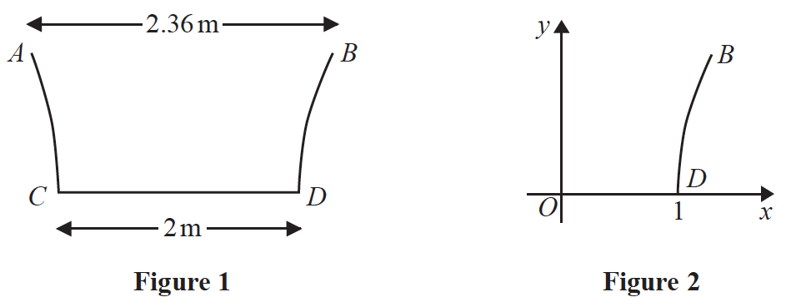

Figure 1 shows the central vertical cross section ABCD of a paddling pool that has a
circular horizontal cross section. Measurements of the diameters of the top and bottom
of the paddling pool have been taken in order to estimate the volume of water that the
paddling pool can contain.
Using these measurements, the curve BD is modelled by the equation
y = ln (3.6x – k) 1 ⩽ x ⩽ 1.18
as shown in Figure 2.
(a) Find the value of k.
(1)
(b) Find the depth of the paddling pool according to this model.
(2)

The pool is being filled with water from a tap.
(c) Find, in terms of h, the volume of water in the pool when the pool is filled to a depth
of h m.
(5)

Given that the pool is being filled at a constant rate of 15 litres every minute,
(d) find, in cm h^{–1}, the rate at which the water level is rising in the pool when the depth of
the water is 0.2 m.
(3)

(Total for Question 8 is 11 marks)
___________________________________________________________________________

TOTAL FOR PAPER IS 75 MARKS

