**Young's double slits experiment - Laser**

Your lab report will be assessed for:

CPAC4: Correctly tabulating sufficient data and

CPAC5: Plotting Graphs and calculating gradient  
CPAC5: Percentage uncertainties.

### Theory

For a double source interference pattern, the distance between adjacent bright fringes is w, given by:

$w= \frac{λD}{s}$ 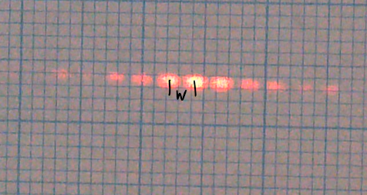

where   
λ is the wavelength of the light used

D is the distance to the eyepiece / screen

s is the slit separation

### Apparatus

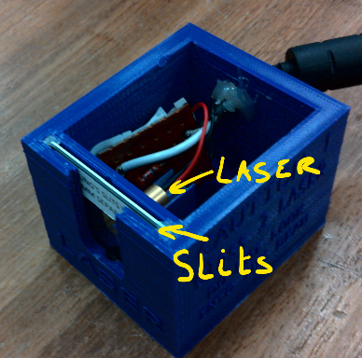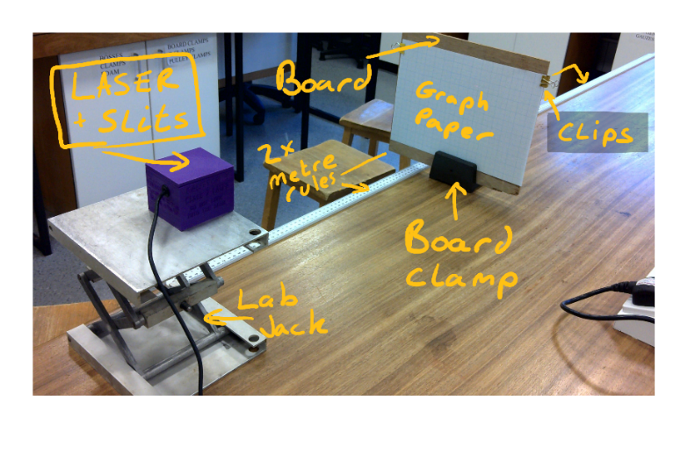

LASER + Slit box

Lab Jack

Board + Board clamp

2x Metre Rules

Bulldog clips

If you were doing this experiment you would need to be very careful not to look into the laser!

### Method (that we performed to obtain the included data)

Set-up the equipment as shown. Use blu-tac to secure the rules and laser box.

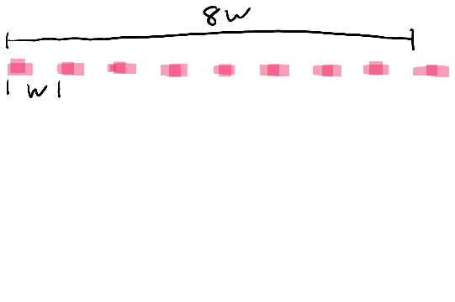The Laser box should be aligned with the front of the lab jack, and the lab jack aligned with zero on the first rule. Ideally the pattern is in line with the horizontal rules of the graph paper.

You will start with an initial distance D of 30.0cm and take readings every 10cm up to 2m.

For each value of D measure across N fringe widths (minimum 6 max 10.. 8 is ideal!). You can choose to measure from centre to centre or left edge to left edge. But put one clear mark on the paper at that point.

Once Nw for all values of D have been taken turn the LASER off and remove the graph paper from the board.

Use the attached measurements and record the length of N w and then tabulate using the following format: You should record for at least 8 values of D:

|  |  |  |  |  |
| --- | --- | --- | --- | --- |
| **Number of fringes N** | **D / m** | **N w / mm** | **w/ mm** | **w/ m** |
|  |  |  |  |  |
|  |  |  |  |  |
|  |  |  |  |  |
|  |  |  |  |  |
|  |  |  |  |  |
|  |  |  |  |  |
|  |  |  |  |  |
|  |  |  |  |  |
|  |  |  |  |  |
|  |  |  |  |  |

### Analysis

Using the attached Graph paper (no excel this time please) Plot a graph of w against D and measure the gradient of the best-fit line. If you do not have a printer, using word shapes is surprisingly effective. Ensure your graph plots cover more than half the graph paper. The gradient triangle should cover more than half the line of best fit!

**Gradient Calculation:**

**Gradient = ­­­­­­­­­­­­­­­_______________**

From the equation given in the theory, the gradient of this line is equal to λ / s, from which the wavelength can be calculated if the slit separation, s is known.

The slit separation s is as 0.1 mm. Convert this value to SI units and use it with your gradient to calculate a value for .

**=________________________** m

### Uncertainties and error

The absolute uncertainty of a **metre rule** is +/-0.5mm, as we apply this to the zero and the measurement of D we use 1mm (0.001m) to calculate %UD. To calculate %UD we use the median value of D (1.00m)

$$\%U_{D}=\frac{0.001}{1.000}*100=0.1\%$$

Now calculate the % Uncertainty for your value of N w using the same method for the D=1m reading .

NOTE the %Uw is the same as N w

**%UNW Calculation:**

**%UNW = ___________________________________**

We are going to assume there is no uncertainty in the value for s

**The total %U = %UD + %Uw. =­­­­­­­­­­­­­­­­­­­­­­_________________________**

Why did we measure w for several value for D rather than just 1?  
  
 __________________________________________________________________________________________

Why did we measure the average fringe separation over eight fringes?  
  
__________________________________________________________________________________________

The Manufacturer’s quoted value for **wavelength of the LASER is 650nm.**

Calculate the % difference using:

$$\%Difference=\frac{650*{10}^{-9}-\left(your value\right)}{650*{10}^{-9}}*100$$**%Diff= _____________________________**

### Discussion and Conclusion

Was the %Difference bigger than the %Uncertainty?   
  
____________________________________________________________________

How close to the line of best fit were your data points? Did the LOBF go through the origin? Are there any obvious anomalies ?

What do you think is the most likely source of unaccounted for errors? Was it reasonable to assume the slit separation had no uncertainty? (The slits quote the separation as 0.1mm)

