Film Studies yr1 coursework – short film study
Having watched the short films in class, jot down initial observations regarding film form, narrative etc. And, where possible, discuss where these short films have influenced your own ideas.
Example:
Short film example | Analysis notes- film form, genre, narrative, representation, aesthetics etc. | Notes on potential inspiration for my own ideas
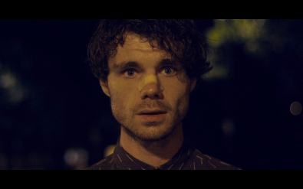  Stutterer (2015) [12] | The film has an interesting use of audio. The character unable to communicate orally, we hear his inner thoughts and concerns in voiceover. The scene particularly when he sees the girl he has been writing to has a really illustrative use of diegetic sound.  The film has limited dialogue, with most of it coming through voiceover and text conversation over social media.  Cinematography is used purposefully. The birds-eye POV shots allow the audience to engage emotionally with the character on a personal level. | I really like the use of sound in this film. I will thus utilise voice over in a similar way.

Short film example | Analysis notes- film form, genre, narrative, representation, aesthetics etc. | Notes on potential inspirations for my ideas
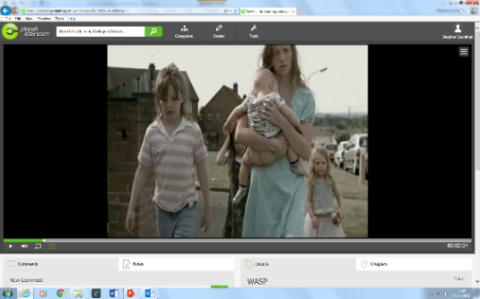

Wasp (2003) [24]
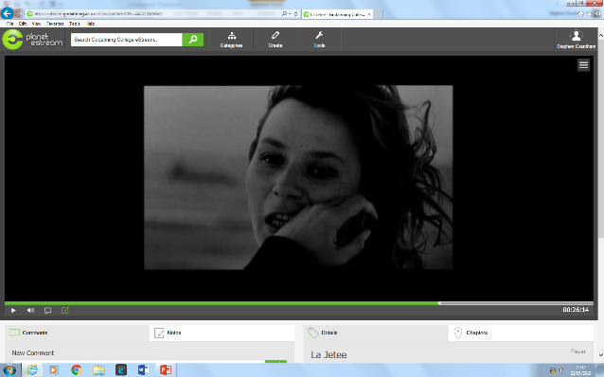

La Jetee (1962) [28]
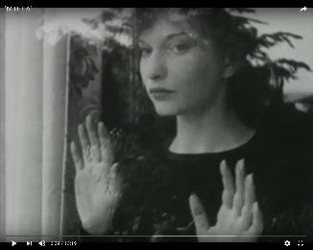
Meshes of the Afternoon (1943) [14]

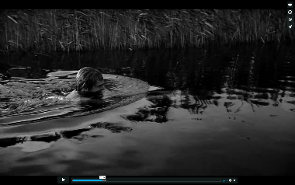

Swimmer (2012) [18]

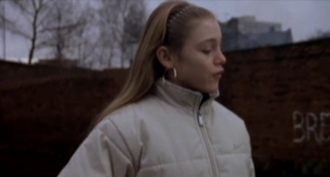

About a Girl (2001) [9]

All six films, add up to 105 minutes of running time.

