**Introduction to “People” (Human Resources)**

**and changes in working practices / the flexible workforce**

1. Explain three responsibilities of a Human Resources department

|  |
| --- |
|  |

2. Consider small and large businesses. What are the similarities and differences in their human resource functions?

|  |
| --- |
|  |

3. Working practices have been changing rapidly over the last 30 years. Employment practices are very different now than in the 1970s and before. List the reasons for these changes?

|  |
| --- |
|  |

**Flexible working practices**

Use the lesson slides, exam board notes and Flexible Working Scanned textbook pages to help you complete the table

|  |  |  |  |  |
| --- | --- | --- | --- | --- |
| **Method** | **Description** | **Advantages** | **Disadvantages** | **Impact / use of tech** |
| Flexible hours |  |  |  |  |
| Home working |  |  |  |  |
| Part time working |  |  |  |  |
| Temporary working |  |  |  |  |
| Job sharing |  |  |  |  |
| Multi-skilling |  |  |  |  |
| Zero hours contracts |  |  |  |  |
| Hot desking |  |  |  |  |

**Past Paper Question Practice**

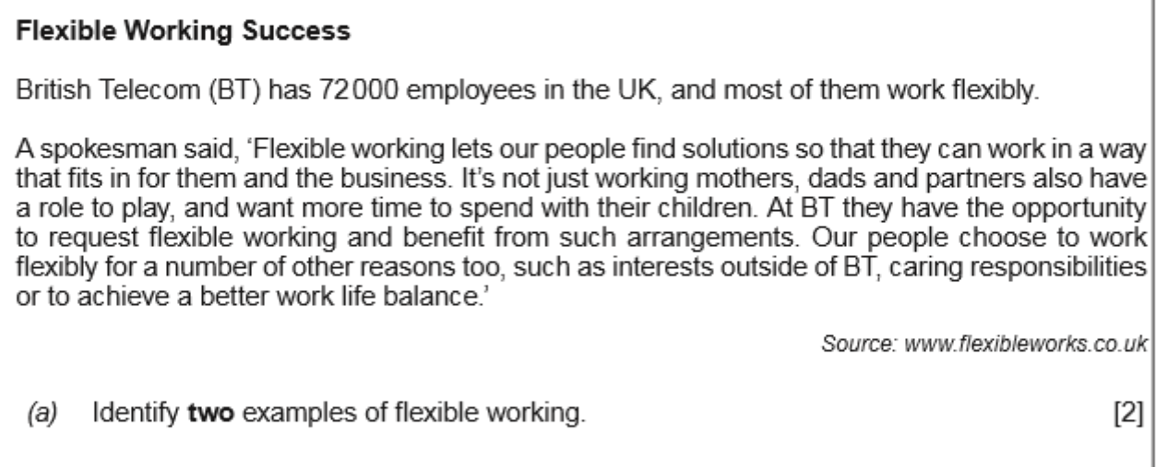

|  |
| --- |
|  |

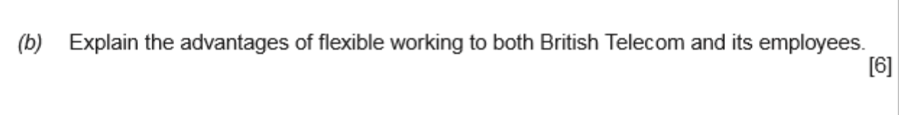

|  |
| --- |
| *Example: By offering flexible working to their staff, BT may find that employees need to take less time off for things like medical appointments or childcare because workers will be able to fit this in around their working hours. This may result in less absenteeism leading to BT being able to maintain normal levels of service and productivity.* |

