Past Exam Questions on PRODUCT LIFE CYCLE

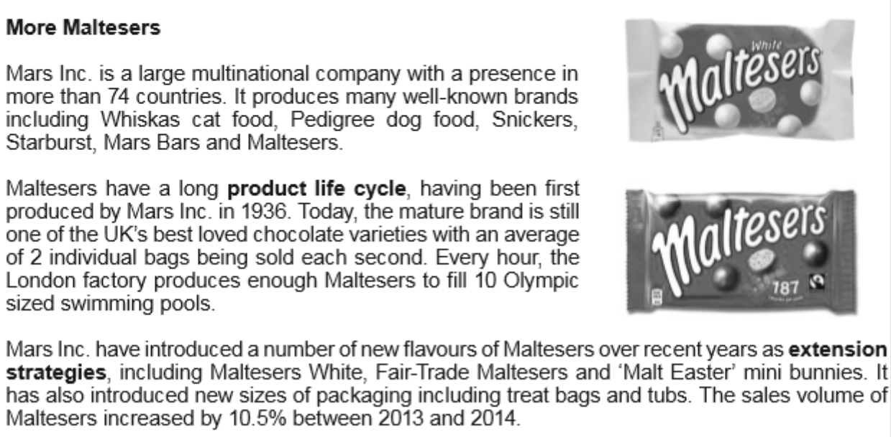

1. What is meant by the term ‘extension strategy’? [2]
2. With reference to the data and with the aid of a clearly labelled diagram, illustrate the product life cycle for the Maltesers brand. [4]
3. Evaluate the usefulness of a product life cycle to Marks Inc. [8]