Recruitment and training at Starbucks

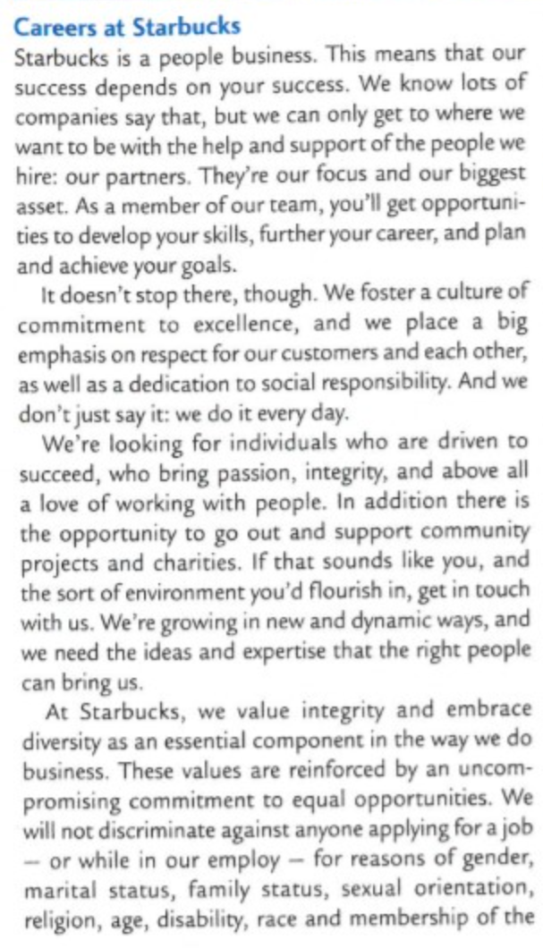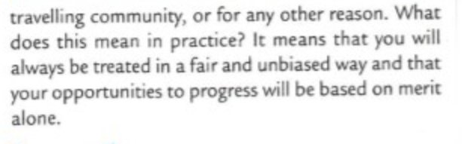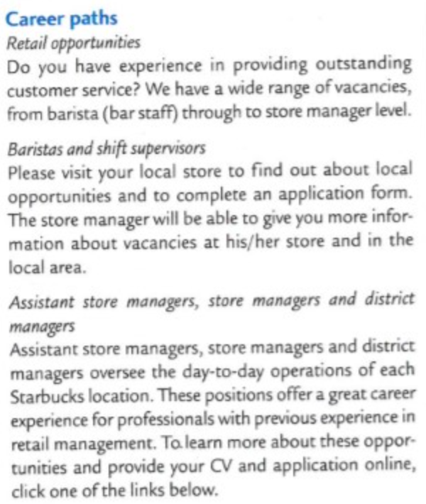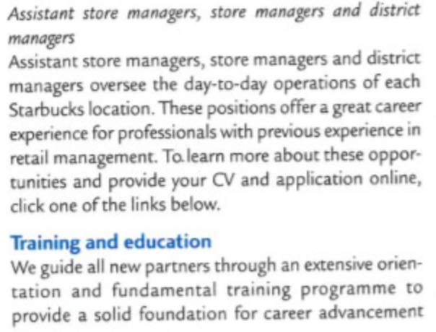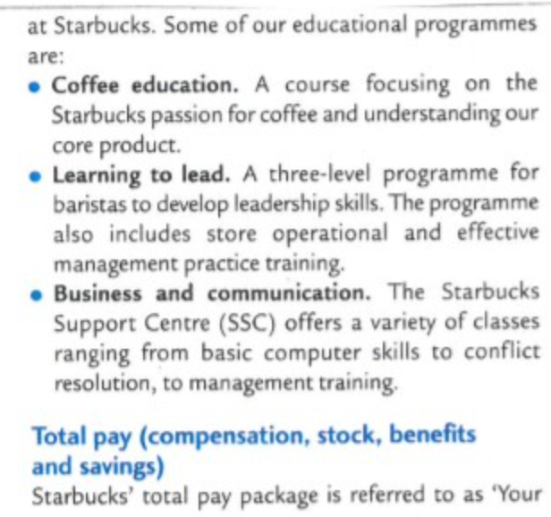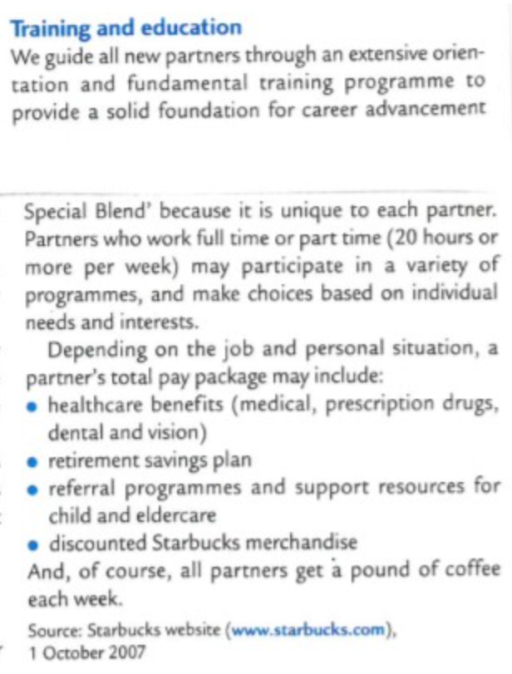

Questions are on the next page

1. Explain the likely benefits to Starbucks of its induction (“orientation”) training programme [4 marks]

|  |
| --- |
|  |

2. Analyse the possible reasons for differences between the recruitment process for a new barista and a new store manager at Starbucks [6 marks]

|  |
| --- |
|  |

3. Discuss the differences between the types of training that would be most appropriate for developing the effectiveness of a barista and a new Store Manager at Starbucks. [4 marks]

|  |
| --- |
|  |