**Stereotypes** = generalisations about a group of people. They lead to low participation and ‘channelling’.

|  |
| --- |
|  |

(Lead to low participation rates)

**Discrimination =**

To treat people unfairly

**Prejudice =**

**Equal Opportunities**

**PE**

**Paper 1**

**Revision**

Example =

Example =

Example =

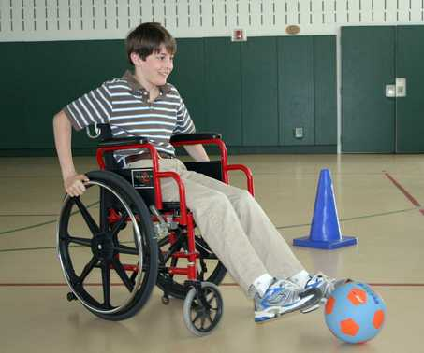

Barriers: Lack of…

1. **C _ _ _ _**  – limits chance for competition

2. **A _ _ _ _ _**  - to/within sports facilities

3. **Specialist _ _ _ _ _ _ _**  – with relevant qualifications

4. **M _ _ _ _ coverage**

5. **A_ _ _ _ _ _ _ s -** of needs in PE Programmes

Solutions:

1. **Competition** – with more clubs/ a _ _ _ _ _ _

sports e.g. wheelchair rugby

2. **Access** - to facilities e.g. r_ _ _ s

3. **Specialised coaches** - trained _ _ _ ff

4. **Specialist facilities** - m _ _ _ _ _ _ _ t_ _ _ _ _ _ _ _ y

e.g. sports wheelchairs

5. **Campaigns** – to promote P_ _ _ _ _ _ _ _ c role models using media/

6. **Awareness** - of needs integrated into PE programmes/

“Integrate where possible, s _ _ _ _ _ _ _ _ where necessary”

7. **EFDS =**

Barriers:

1. Discouraged by p_ _ _ _ _ s

2. R_ _ _ _ _ discrimination

3. Sport has a low social s_ _ _ _ s

4. Lack of ethnic minority c_ _ _ _ _ s/

role models

5. M_ _ _ _ _ _ _ _ p may exclude minorities

6. Lower socio-_ _ _ _ _ _ _ _ group – e.g. lack money for transport

7. R _ _ _ _ _ _ _ _ observance e.g. dress code

8. Stereotyping/’c_ _ _ _ _ _ _ _ _ g’ – e.g. you’re black, you’re fast, you’re on the wing



Solutions:

1. R_ _ _ models

2. B_ _ _ for ‘racist’ actions

3. Sp_ _ _s Dev_ _ _ pment O _ _ icers -promote minority participation

4. Awareness e_ _ _ _ tion for teachers in schools e.g. on effects of discrimination

5. S_ _ _ _ Eng_ _ _ _ programmes e.g. Sporting Equals promote equality

6. _ _ programmes cater for minorities - eg relaxed _ _ _ / showering rules

7. Campaigns - by _ _ _ s e.g. ‘Kick Racism Out’

Barriers:

1. ……………………………………….

2. ……………………………………….

3. ……………………………………….

4. ………………………………………..

5. ………………………………………..

Solutions:

1. Advertising/_ _ _ _ models

2. Reduced e_ _ _ y f_ _ s

3. T_ _ _ _ _ sessions

4. More _ _ _ er-c_ _ _ facilities

5. Crè_ _ _ facilities

6. School e_ _ _ _ -curr_ _ _ _ _ r clubs

7. Street games (National Partner of Sport England)

[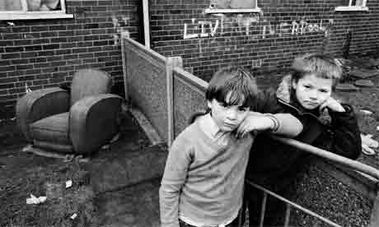](http://www.google.co.uk/url?sa=i&rct=j&q=working+class+england&source=images&cd=&cad=rja&docid=QprRpmi4dOeOYM&tbnid=aEmvCbEVGfZuoM:&ved=0CAUQjRw&url=http://www.guardian.co.uk/books/2009/jan/10/andrew-ohagan-george-orwell-memoriallecture&ei=9MJKUbm_Hs2M0wX2iYDADw&bvm=bv.44158598,d.d2k&psig=AFQjCNHIQqevot1lAKI5HYXY3BVU6tLMZg&ust=1363940443543543)

Solutions:

1. Offer options which are:

_ _ d _ o _ (dry, warm), Individual activities,

C_ _ _ _ l/recreational, non-_ _ _ _ _ _ _ / non aggressive,

s _ c_ _ _ _ y acceptable for women

Single sex/w_ _ _ _ only

1. Improvements to school PE:

Make _ _ interesting/rewards, After-school _ _ _ _ _,

Inspirational t_ _ _ _ _ _ s, Sports a_ _ _ _ _ _ _ _ _ s

Better _ _ _ _ _ with local clubs, Emphasise importance of

h_ _ _thy lifestyle, Leadership/c_ _ _ _ _ _ g opportunities

1. C_ _ _ _ e facilities
2. Use of role models/ _ _ _ _ _ coverage/ ‘this girl can’
3. Educate on physiological/ st_ _ _ _ _ _ _ _ _ _ l myths
4. Women In Sport (National partner of Sport England)

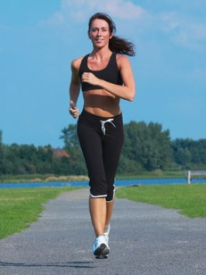

Barriers:

1. S_ _ _ _ l discrimination

2. Lack of media coverage/_ _ _ _ models

3. T_ _ _ _ _ _ _ _ _ _ stereotyping e.g. being ‘ladylike’

4. Physiological m_ _ _ s/poor body image

5. Sport as a m_ _ _ preserve – keep women out!

6. Lack dispo_ _ _ _ e income

7. Lack of t_ _ e available (domestic responsibility)

8. Fewer female c_ _ _ s / range of appropriate activities

Roles:

Local Partners

**Equal Opportunities**

**PE**

**Paper 1 Revision**



National Partners

**Social control**

**Society**

**Socialisation**

**Stratification**

**Social change**

**Interactionist approach/ Social action theory**

**Social structures**

|  |  |  |
| --- | --- | --- |
| **Benefits of raising participation** | **To Individuals**  **Remember to explain how sport causes the benefit to occur!** | **To Society**  **Remember to explain how sport causes the benefit to occur!** |
| **Health & Fitness benefits** | *Lower risk of CHDs – e.g. playing on the wing in Rugby burns fat, contributes to lowers cholesterol and blood pressure reducing risk of angina.* |  |
|  |  |
|  |  |
| **Social benefits** |  |  |
|  |  |
|  |  |