1. Towns and the connections between them can be represented as a graph which has a set of nodes connected by edges. This representation is an abstraction.

(a) Define the term data abstraction. [2]

(b) Complete the adjacency list for this graph. [2]

|  |  |  |
| --- | --- | --- |
| **A** | **🡪** |  |
| **B** | 🡪 |  |
| **C** | 🡪 |  |
| **D** | 🡪 |  |

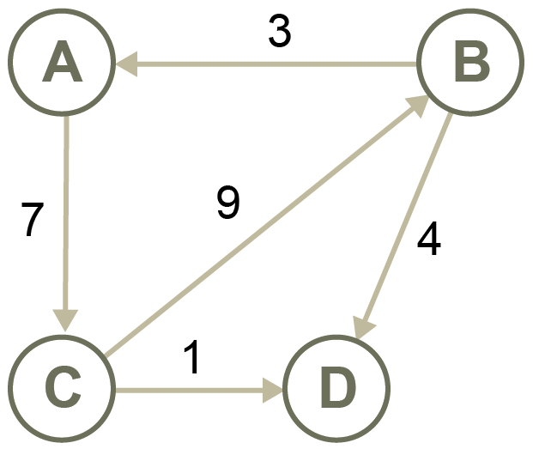

(c) Complete the adjacency matrix for this graph. [2]

|  |  |  |  |  |
| --- | --- | --- | --- | --- |
|  | **A** | **B** | **C** | **D** |
| **A** |  |  |  |  |
| **B** |  |  |  |  |
| **C** |  |  |  |  |
| **D** |  |  |  |  |

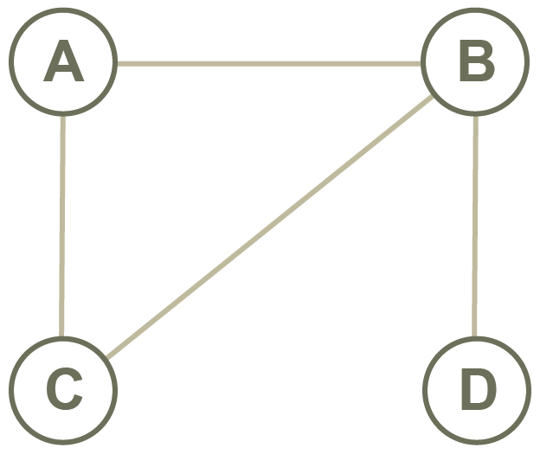

1. A tree is an abstract data type.

(a) Define the term **tree**. [2]

(b) Here is a binary tree.

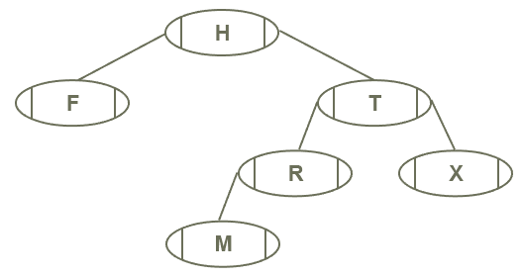

Complete the array implementation of this tree. [2]

|  |  |  |  |
| --- | --- | --- | --- |
|  | left | data | right |
| A[0] | 3 | H | 1 |
| A[1] |  |  |  |
| A[2] | 5 | R | -1 |
| A[3] | -1 | F | -1 |
| A[4] | -1 | X | -1 |
| A[5] |  |  |  |

(ii) List the nodes in the order in which they are visited for each traversal. [3]

Pre-order:

In-order:

Post-order:

(c) Add the following items to a binary tree so that it may be quickly searched to find a particular item:

Liam, Mary, Zoe, Carla, David, Lucy, Adam [2]

1. Scalars have only magnitude. Vectors have both magnitude and direction. Mathematical operations can be used to combine vectors and scalars.

(a) Here are two vectors:

a = (6, -1) b = (-3, -3)

1. Calculate the result of a + b. Show your working. [1]

(ii) Calculate the magnitude of vector b. Show your working. [1]

(b) Vector u is defined as (4, 2).

(i) Calculate 4u. Show your working. [1]

1. What is the effect of multiplying a vector by a scalar? [1]

(c) *p* = [4, 3, 2, 1] represents the count of people completing the number of laps around a field, expressed in *f* = [10, 20, 30, 40].

Determine the total laps by calculating *p* • *f*. Show your working. [1]

(d) Dot product can be used to calculate even parity.

*u* = [1, 1, 1, 1] and *v* = [1, 0, 0, 1].

Determine the parity bit by calculating *u* • *v*. [2]

4. An insurance company keeps details about vehicles that it insures, policy holders and insurance policies.

The details are held in a relational database using the following relations. (Not all fields are shown)

**Vehicle**

RegistrationNo VARCHAR (8)

Make VARCHAR (12)

Model VARCHAR (15)

Colour VARCHAR (12)

DateRegistered DATE (dd/mm/yy)

**Policy**

PolicyNumber CHAR (8)

ExpiryDate DATE (dd/mm/yy)

ExcessAmount Currency (integer, e.g. 500)

**Owner**

OwnerID CHAR (6)

Firstname VARCHAR (15)

Surname VARCHAR (20)

DateOfBirth DATE (dd/mm/yy)

Address VARCHAR (30)

Postcode VARCHAR (10)

Some policy holders may have several vehicles insured. Each vehicle has a unique insurance policy.

(a) Write the three relations in the format

TableName (attribute1, attribute 2, ….)

Show how the tables will be related using foreign keys.

Underline the primary key of each table, and identify any foreign keys with an overbar.

e.g. [6]

(b) Complete the entity relationship diagram below showing the degree of the   
relationships between the entities. [3]

Vehicle

Policy

Owner

(c) Write SQL statements to extract the following data:

(i) the registration number, make, model and date registered of all vehicles with dateRegistered before 2015, displayed in order of date registered [4]

(ii) The Policy number, registration number and make of all cars with an ExcessAmount of 500 or more in descending order of ExcessAmount. [5]

(d) Write SQL statements to do the following:

(i) Create a new table for Claims, which has the following fields:

ClaimID CHAR (6) Primary key

ClaimDate DATE (dd/mm/yy)

PolicyNumber Char (8) (Foreign key, link to Policy relation) [6]

(ii) Update the record for the vehicle with registration number FG16 JUR, in which the model name was wrongly recorded. It should be “Golf Mk6”. [3]

(iii) Insert a new record into the OWNER table with the following field values: [2]

OwnerID 123456

Firstname Jess

Surname Kotton

DateOfBirth 01/03/1990

Address 56 Sloane Street

Postcode IP4 9MN

5.A normalised floating point representation uses a 7-bit mantissa and a 5-bit exponent, both stored using **two’s complement format**.

(a)     In binary, write the most **negative** number that can be represented using this normalised floating point system in the boxes below:

      

                                    Mantissa                         Exponent

**(2)**

(b)     This is a floating point representation of a number:

      

                                               Mantissa                                            Exponent

Calculate the denary equivalent of the number. Show how you have arrived at your answer.

Working: ...................................................................................................

..................................................................................................................

..................................................................................................................

**(1)**

Answer: ....................................................................................................

**(1)**

(c)     Write the normalised floating point representation of the denary value 416 in the boxes below. Show how you have arrived at your answer.

Working: ...................................................................................................

..................................................................................................................

**(1)**

Answer:

      

                                               Mantissa                                            Exponent

**(1)**

(d)     Write the normalised floating point representation of the negative denary value –12.5 in the boxes below. Show how you have arrived at your answer.

Working: ...................................................................................................

..................................................................................................................

.................................................................................................................. **(2)**

Answer:

      

                                               Mantissa                                            Exponent

**(1)**

(e)     The table below lists three different calculations that might cause an error to occur in a floating point system. Complete the table below by stating the name of the type of error that may occur for each calculation. You should **not** give the same answer more than once.

|  |  |  |
| --- | --- | --- |
|  | **Calculation** | **Type of error** |
|  | Multiplying two very large numbers together. |  |
|  | Dividing a number by a very large number. |  |
|  | Adding together two numbers of very different sizes eg a tiny number to a very big number. |  |

**(3)**