**Workforce Performance**

**Use the data to help you answer the questions**

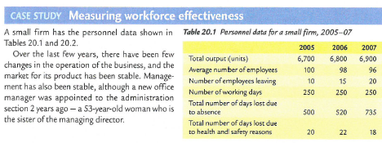

**1a**. Labour Productivity definition:

|  |
| --- |
|  |

**1b**. Labour Productivity formula:

|  |
| --- |
|  |

**1c**. Calculate Labour Productivity for each year

|  |  |  |  |
| --- | --- | --- | --- |
| Year | 2005 | 2006 | 2007 |
| Labour Productivity |  |  |  |

Show your workings out below:

|  |
| --- |
|  |

**2a**. Labour Turnover definition:

|  |
| --- |
|  |

**2b**. Labour Turnover formula:

|  |
| --- |
|  |

**2c**. Calculate Labour Turnover for each year

|  |  |  |  |
| --- | --- | --- | --- |
| Year | 2005 | 2006 | 2007 |
| Labour Turnover |  |  |  |

Show your workings out below:

|  |
| --- |
|  |

**Q3a**. Explain Absenteeism :

|  |
| --- |
|  |

**Q3b**. Absenteeism Formula:

|  |
| --- |
|  |

**Q3c.** Calculate absenteeism for each year:

|  |  |  |  |
| --- | --- | --- | --- |
| Year | 2005 | 2006 | 2007 |
| Absenteeism |  |  |  |

Show your workings out below:

|  |
| --- |
|  |

**Q4.** Explain workforce performance:

|  |
| --- |
|  |

**Q5: Use your findings from Q1&2 and table 20.2 below to help you answer this question**

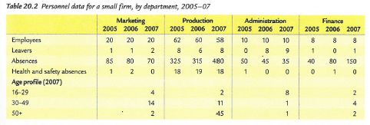

**Q** Discuss the issues, including causes and effects, which these indicators raise for human resource management policies to the firm

Plan:

* 1st paragraph: Describe what has happened to i) labour productivity ii) labour turnover iii) absenteeism and iv) health and safety absenteeism from 2005 to 2007
* 2nd paragraph: Analysis: Which indicator is most concerning for the HR department and why? Base this paragraph on the data from the various departments (marketing, production, admin and finance). What can the business do to improve this aspect of workplace performance
* 3rd paragraph: Evaluation: Does the business need to keep a measure of performance under review? Why? Comment on the age of staff in the administration department - The new office manager is a 53 year old woman who is sister of the managing director - what can you deduce about the management style and communication is this business?

|  |
| --- |
|  |