Break even calculation practice

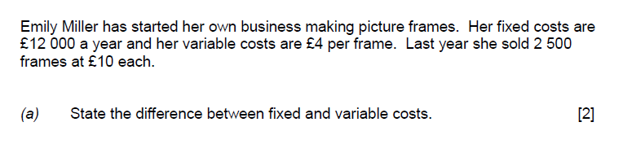

|  |
| --- |
| 1A) |

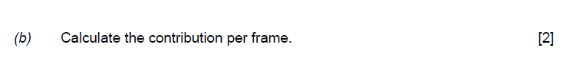

|  |
| --- |
| 1B) |



|  |
| --- |
| 1c) |



|  |
| --- |
| 1D) |

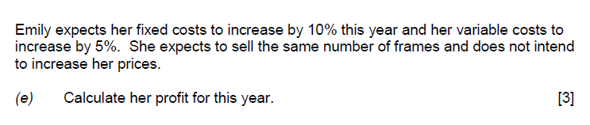

|  |
| --- |
| 1e) |

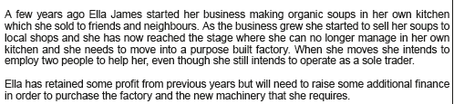

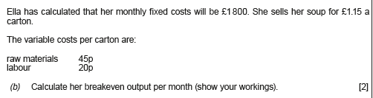

|  |
| --- |
| 2b) |

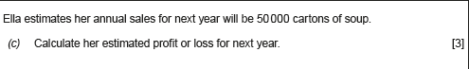

|  |
| --- |
| 2c |