General Certificate of Education

Godalming College Benchmark

**Computing Paper 1 (Programming) Feb**

**For this paper you must have:**

! access to the Electronic Answer Document

! a copy of the *Preliminary Material*. You must **not** use a calculator.

**Time allowed**

! 1 Hour 15 Mins

**Instructions**

! Type your answers into the Electronic Answer Document.

! Enter the information required on the front of your Electronic Answer Document.

! Answer **all** questions.

! You will need access to:

– a computer

– a printer

– appropriate software

– the electronic version of the Skeleton Program.

! Before the start of the examination make sure your **Centre Number, Candidate Name** and **Number**

are shown clearly in the footer of the Electronic Answer Document (not the front over).

**Information**

! The marks for questions are shown in brackets.

! The maximum mark for this paper is 55

! No extra time is allowed for printing and collating.

! The question paper is divided into four sections.

You are advised to spend time on each section as follows:

Section B - 20 minutes

Section C - 55 minutes

**At the end of the examination**

! Tie together all your printed Electronic Answer Document pages and hand them to the invigilator.

**Total Score 55**

M/Jun10/COMP1

**COMP1**

**Section B**

You are advised to spend no more than **20 minutes** on this section.

Type your answers to **Section B** in your Electronic Answer Document.

You **must save** this document at regular intervals.

These questions refer to the *Preliminary Material* and require you to load

the **Skeleton Program**, but do not require any additional programming.

R efer either to the *Preliminary Material* issued with this question paper or your

electronic copy.

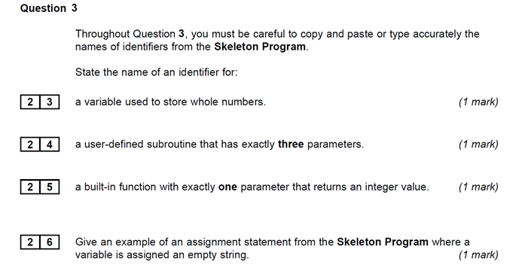

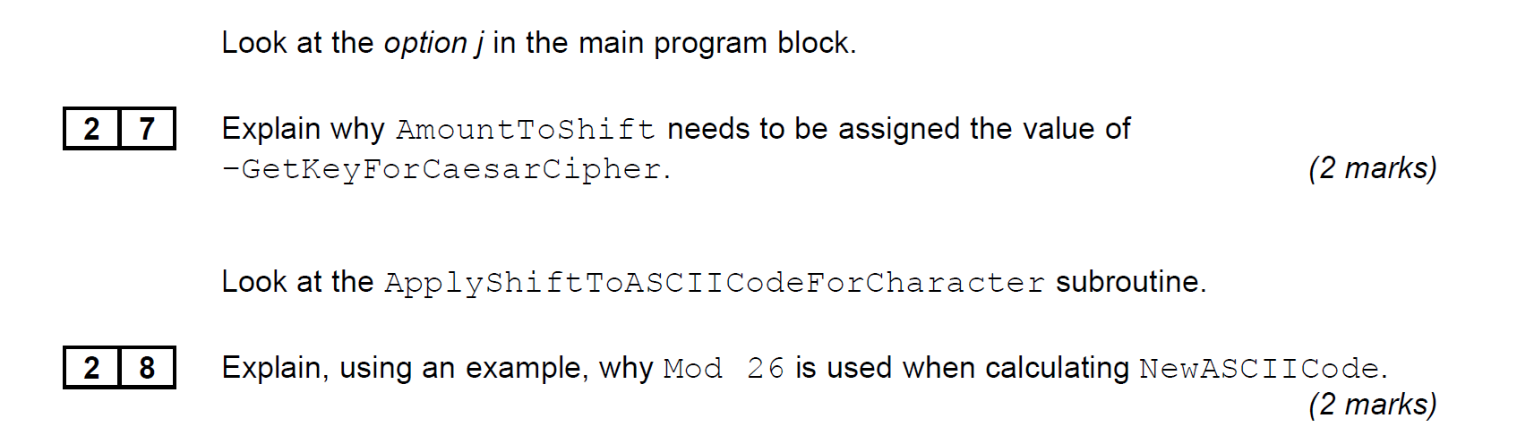

**Turn over**

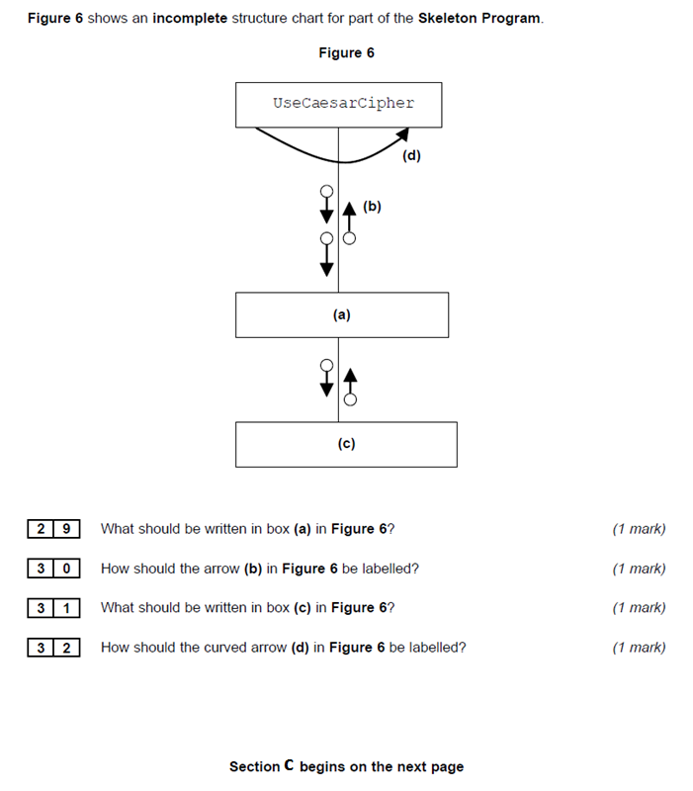12 Marks

**Section C**

You are advised to spend no more than **55 minutes** on this section.

Type your answers to **Section C** in your Electronic Answer Document.

You **must save** this document at regular intervals.

T hese questions require you to load the **Skeleton Program** and make

programming changes to it.

**Question 4**

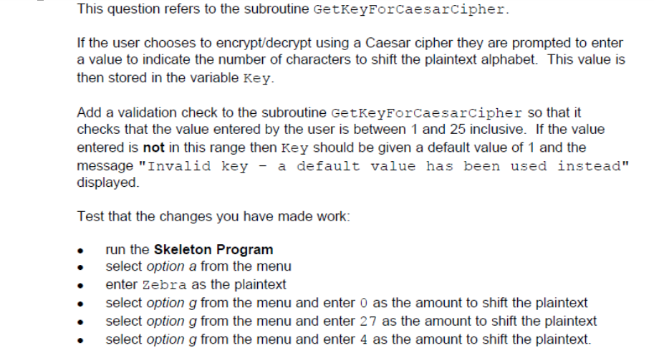 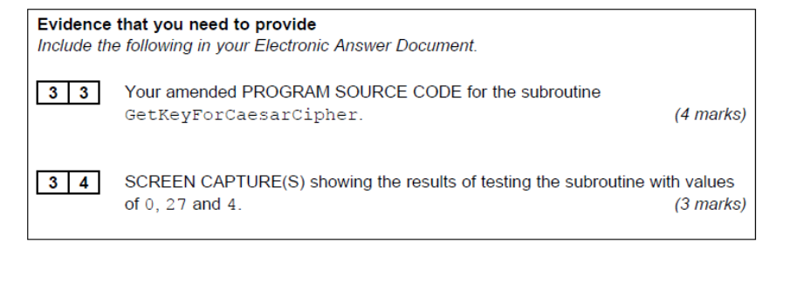

**Question 5**

This question will extend the functionality of the Skeleton Program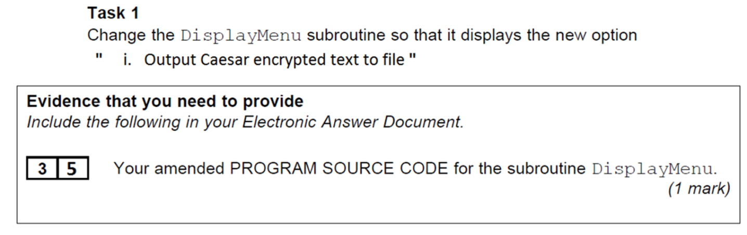

Adapt the main program block so that the case where the user selects option i is dealt with.

Open a file called "CaesarEncrypted.txt" in ‘output’ mode.

In a suitable loop structure use the existing subs ‘GetTextFromUser’, ‘GetKeyForCaesarCipher’ and ‘UseCaesarCipher’ to input and encrypt the user’s plaintext phrases. These should then be written to the file. Use the ‘PrintLine’ command to avoid writing parentheses to the text file. **The user is expected to make at least one text entry to the file.**

After each entry display the message ("Do you want to enter more text?(Y/N)") and collect the user’s response. You should declare and use a character variable ‘Answer’ to determine the terminating condition for the loop.

Finally, close the file.

Test that the changes you have made work:

* Run the Skeleton Program
* Select Option i from the menu
* Enter the text “Joe loves programming” (without quotes) and an amount to shift “1”.
* Answer “Y” for 2 more entries
* The second entry is “Phil loves programming” with a shift of “2”
* The third entry is “I love programming” with a shift of “3”
* Enter “N” to terminate the option.

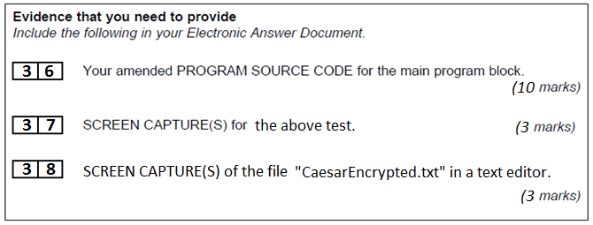

**Question 6**

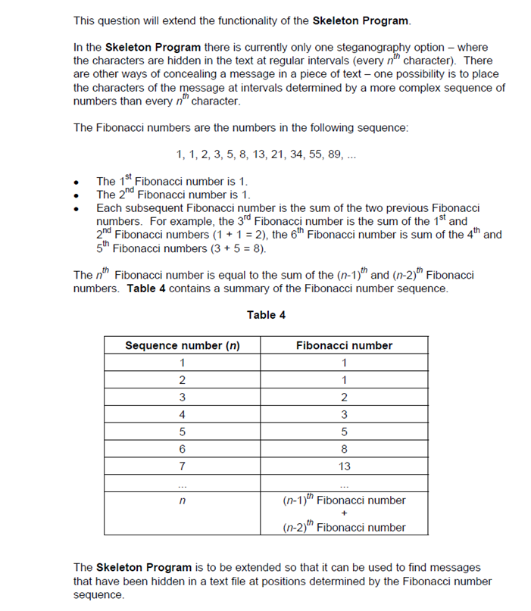

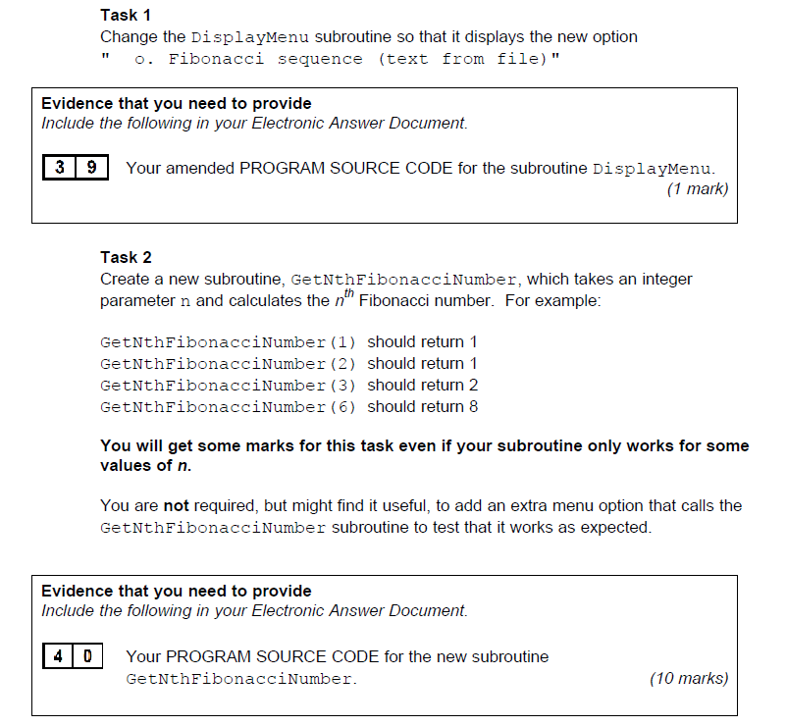

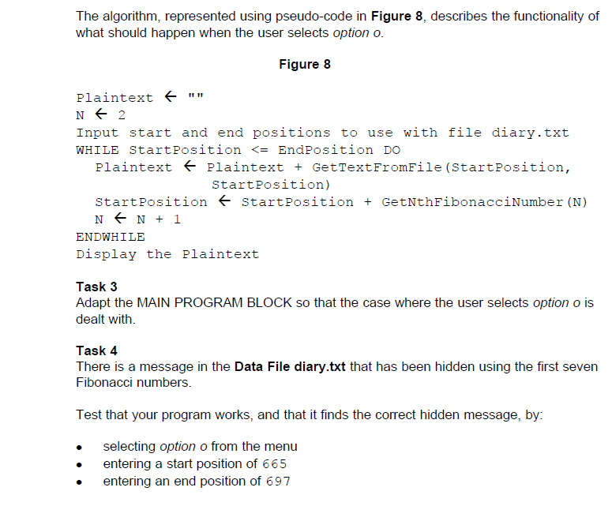

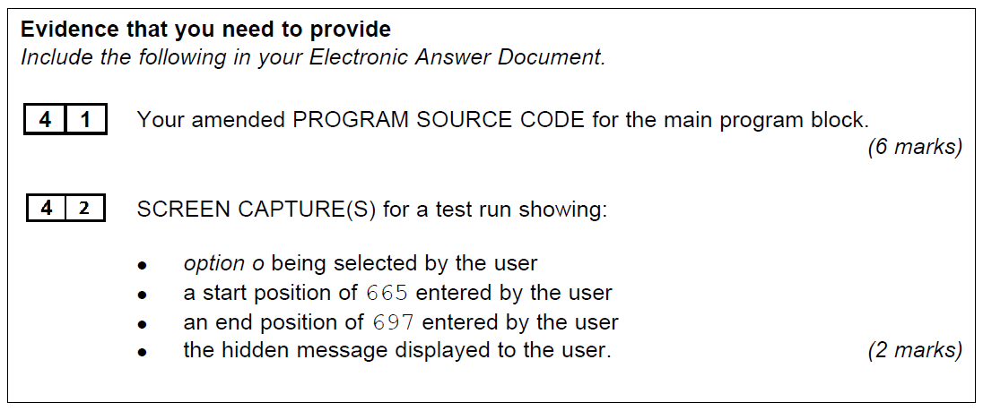**43 Marks**

**55 Marks Total**

**END OF QUESTIONS**