Organisational Structures Workbook

**LESSON 1**

Define “*organisational structure*”

|  |
| --- |
|  |

Key terminology:

|  |  |
| --- | --- |
| **Term** | **Definition** |
| Hierarchy |  |
| Chain of command |  |
| Span of control |  |
| Delegation |  |
| Authority |  |
| Responsibility |  |
| Centralisation |  |
| Decentralisation |  |
| Delayering |  |
| Empowerment |  |

Organisational structures

**QUICK QUESTIONS**

1. Which of the following will be shown on an organisational chart?
2. the roles and titles of people within the organisation
3. the names and addresses of customers
4. details of suppliers
5. the business's stakeholders.
6. Complete the following sentence by filling in the missing words.

'It is possible for a manager to **………………….** authority to a subordinate. However, **……………..** must remain with the manager.'

1. Of what is the following a definition: The number of layers within an organisation?
2. Of what is the following a definition: The way that power and authority are passed down in an organisation?
3. Which of the following is **not** associated with a 'tall' hierarchical structure?
4. many levels of hierarchy within the organisation
5. wide spans of control

c. a long chain of command

d. a large number of people between the person at the top and those at the bottom of the organisation.

6. Complete the following sentence by filling in the missing terms:

'A **………...** organisational structure contains few levels of hierarchy but a **…….…..** span of control.'

7. Which group of employees are most likely to lose their jobs because of a policy of delayering?

1. directors
2. senior managers
3. middle managers
4. supervisors

**PROGRESS QUESTIONS (use the textbook pages to help you)**

1. State three factors that can be discovered about a business from examining its organisational chart.

|  |
| --- |
|  |

1. Explain the circumstances in which a business might benefit from the use of a matrix structure. Include a diagram of the structure.

|  |
| --- |
|  |

1. Explain how delayering can benefit an organisation.

|  |
| --- |
|  |

1. Explain the possible drawbacks of delayering in the short term.

|  |
| --- |
|  |

**LESSON 2**

**Organisational Structures**

Read the article ‘Organisational Structure’ and answer the following questions:

Q1. What does the structure of an organisation refer to?

|  |
| --- |
|  |

Q2 If an organisation’s structure is inappropriate what may happen?

|  |
| --- |
|  |

Q3. Why do organisation structures change?

|  |
| --- |
|  |

Q4 What are the benefits of the functional approach?

|  |
| --- |
|  |

Q5 What are the drawbacks of having a more formal structure?

|  |
| --- |
|  |

Q6. Why does it cost so much to restructure?

|  |
| --- |
|  |

Q7. What does the effectiveness of a restructuring programme depend on?

|  |
| --- |
|  |

**Span of Control**

Read the article ‘Is there a right span of control?’ and answer the following questions:

1. What is meant by a low (narrow) span of control?

|  |
| --- |
|  |

1. How will a low span of control affect the number of levels of hierarchy?

|  |
| --- |
|  |

1. According to theory what are circumstances for enabling a higher/wider span of control?

|  |
| --- |
|  |

1. Why is the optimum span of control five?

|  |
| --- |
|  |

1. What are the disadvantages of a small/narrow span of control?

|  |
| --- |
|  |

1. How can companies prevent the disadvantages of a narrow span of control?

|  |
| --- |
|  |

1. What are the problems with a too wide span of control?

|  |
| --- |
|  |

1. What are the factors which affect the right span of control?

|  |
| --- |
|  |

1. Span of control doesn’t exist in a true matrix – why?

|  |
| --- |
|  |

**Why might delayering go wrong?**

Read the article ‘Why might delayering go wrong?’ and answer the following questions:

Q1. In the 1950’s, a typical UK business had approximately 12 layers to their hierarchy. Nowadays, how many layers do most companies have?

|  |
| --- |
|  |

Q2. Why did Jack Welch, former Chief Executive of the American manufacturer General Electric, restructure the business?

|  |
| --- |
|  |

Q3. What are the benefits of delayering?

|  |
| --- |
|  |

Q4. Describe the problems of delayering? (don’t just write the subheadings – provide a summary of each)

|  |
| --- |
|  |

**Organisational structures**

**Past Paper Questions**

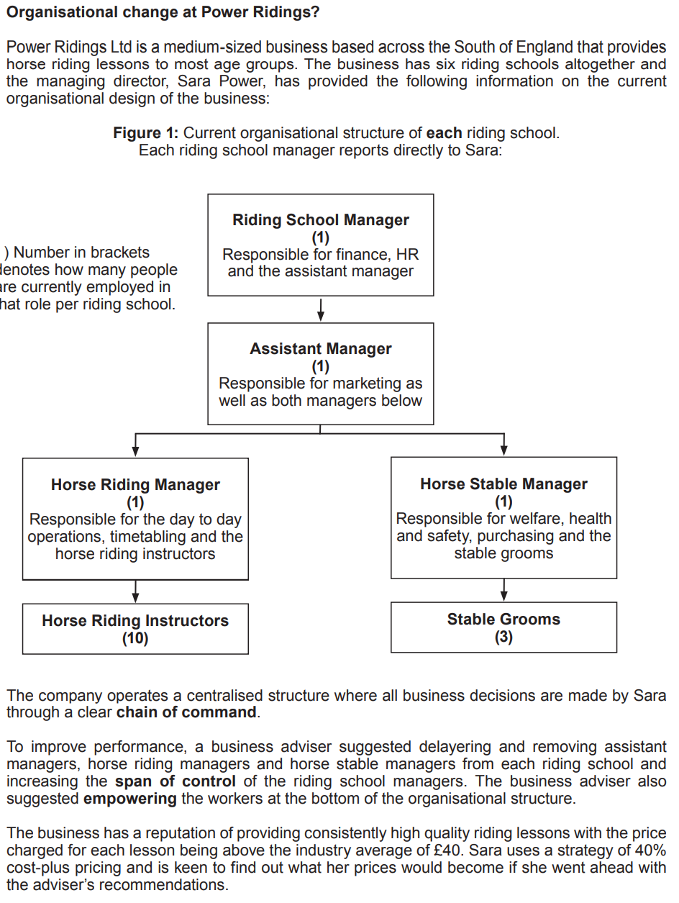

a) What is meant by the term “*chain of command*”? [2]

|  |
| --- |
|  |

b) What do you understand by the term “*span of control*”? [1]

|  |
| --- |
|  |

b) (i) Taking into account the business adviser’s proposed changes, what will be the new span of control of the riding school managers? [1]

|  |
| --- |
|  |

c) Sara calculated that on average it would cost £25 to provide each riding lesson after delayering had taken place. Based upon her 40% cost-plus pricing strategy, calculate the average selling price of each riding lesson after delayering has taken place [2]

|  |
| --- |
|  |

d) Advise Sara whether to go ahead with the business adviser’s suggestions [10]

|  |
| --- |
|  |

