|  |  |  |  |  |
| --- | --- | --- | --- | --- |
| A_ _ L_ _ _ _  _ _ _ _ S | [Image result for drugs in sport](https://www.google.co.uk/url?sa=i&rct=j&q=&esrc=s&source=images&cd=&cad=rja&uact=8&ved=2ahUKEwjJ7862qfjZAhUDwxQKHeR0Dm8QjRx6BAgAEAU&url=https://www.trainmag.com/health/performance-enhancing-drugs-sports/&psig=AOvVaw2eJTzADyzjzmV--h4fE6vF&ust=1521546718251991)  Drugs &  M _ _ _ _ _ _ _ | [Image result for olympic swim suits](http://www.google.co.uk/url?sa=i&rct=j&q=&esrc=s&source=images&cd=&cad=rja&uact=8&ved=2ahUKEwj408_UqfjZAhWLPxQKHcKGCR4QjRx6BAgAEAU&url=http://blogs.denverpost.com/olympics/2016/05/13/speedo-unveils-olympic-swimsuit-worn-missy-franklin/27105/&psig=AOvVaw08sU6gzzEOwTuiOu0_CJXe&ust=1521546790086327)Cl_ _ _ _ ng | [Image result for 4g olympic legacy surfaces](http://www.google.co.uk/url?sa=i&rct=j&q=&esrc=s&source=images&cd=&cad=rja&uact=8&ved=2ahUKEwiRyNWaqPjZAhVJbhQKHVYYAmYQjRx6BAgAEAU&url=http://mcardlesport.co.uk/category/blog/&psig=AOvVaw1O-vSGnlwfgur_AQZ73dwt&ust=1521546393104851)  S_ _ _ _ _ _s | S _ _ _ _ _ _ _ G |
| [Image result for london olympic legacy facilities](https://www.google.co.uk/url?sa=i&rct=j&q=&esrc=s&source=images&cd=&cad=rja&uact=8&ved=2ahUKEwiypMnNp_jZAhWBvBQKHZCnBIkQjRx6BAgAEAU&url=https://www.independent.co.uk/sport/olympics/olympics-legacy-did-the-games-succeed-in-rejuvenating-east-london-8711691.html&psig=AOvVaw0TzTT9Lb74AUWO4thqktyi&ust=1521546234768008)F_ _ _ _ ities | Equipment/  M_ _ _ rials | M_ _ _ _ | [Image result for creatine](https://www.google.co.uk/url?sa=i&rct=j&q=&esrc=s&source=images&cd=&cad=rja&uact=8&ved=2ahUKEwiK4ontp_jZAhVCthQKHZxrBwgQjRx6BAgAEAU&url=https://www.supplementworld.co.za/optimum-nutrition-micronized-creatine-powder.html&psig=AOvVaw0pcvUGOQN23FrGR83N1-Yo&ust=1521546309204495)  S_ p_l_ _ents | Drug t_ _ _ ing |

= positive impact

**PE**

**Revision**

*More immediate, reliable feedback e.g. analysis apps*

= negative impact

*Safer – e.g. stronger cricket helmets*

Performer

Sport

Coach

Audience

*Breaks in play e.g. waiting for video ref decision*

*Olympic legacy facilities for years to come e.g. Olympic Stadium*

_ _ _ H – S _ _ _ _ Camera

(Frame-by-frame p _ _ _ -b_ _ K)

Provides data on:

G_ _ _ analysis – e.g. pass completion, body position/ p _ _ _ _ _ _ , identifies e _ _ _ _ _

S_ _ _ _ -based N _ _ _ _ _ _ _ _ n system

Tracks performers’ m _ _ _ _ _ nt

Provides data on S _ _ _ _, D _ _ _ _ _ _ _ n, A _ _ _ _ _ _ _ _ _ _ _ , D _ _ _ _ _ _ _ _ _ _ n, D _ _ _ _ _ _ e covered

Quantitative Data = N _ m _ _ _ _ _ _, O _ _ _ ctive

B _ _ _ _ _ ing apparatus

Measures _ _ used and _ _ _ breathed out

Provides data on _ _ D _ _ _ _ T

C _ _ _ _ _ _ ETRY (REE), VO2 Max, Respiratory Exchange _ _ _ _ _ (RER)

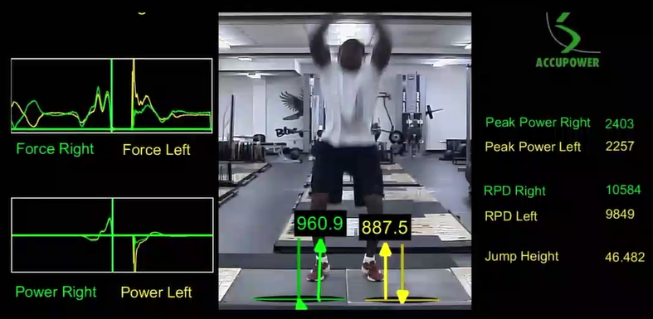

**Video Analysis software**

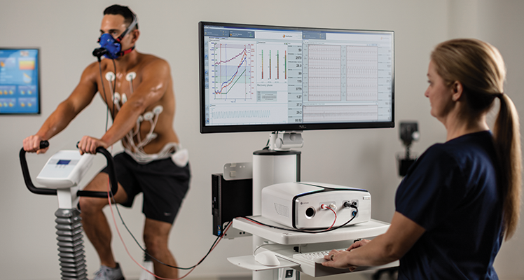

Metabolic Cart Software

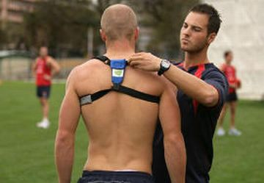

**GPS motion tracking software**

RER used to monitor training intensity

VO2 Max scores identify talent for aerobic sports