**People – Motivation**

**Financial and Non-financial methods of motivation**

*Use the exam board notes in the Business Functions/People/Motivation section on Godalming Online and pages 381 – 394 of the Business Studies text book to help you answer the following questions.*

1. Describe the difference between financial and non-financial methods of motivation (use examples)

2. Define the following financial methods of motivation:

|  |  |
| --- | --- |
| Method | Definition (with examples/links to theories where applicable) |
| Piece rate |  |
| Commission |  |
| Bonus schemes |  |
| Wages |  |
| Salaries |  |
| Profit sharing |  |
| Profit-related pay |  |
| Performance-related pay |  |
| Fringe benefits |  |

3. Define the following non-financial methods of motivation:

|  |  |
| --- | --- |
| Method | Definition (with examples/links to theories where applicable) |
| Job enrichment |  |
| Job enlargement |  |
| Job rotation |  |
| Job design |  |
| Communication |  |
| Empowerment |  |
| Team working |  |
| Quality circles |  |
| Training |  |
| Flexible working |  |

4. Identify and explain two problems a business might encounter as a result of using piece rates to pay its employees?

1.

2.

5. Briefly explain two advantages and two disadvantages of to a business or using performance related pay?

1 AD.

2 AD.

1. DISAD.

2. DISAD.

6. Explain two problems that might result from using financial incentives to motivate employees?

1.

2.

7. Briefly explain two advantages and two disadvantages to a business of introducing job enrichment?

1. AD

2. AD

3. DISAD

4. DISAD

8. Explain how job enrichment is linked to the motivation theories with which you are familiar.

9. Explain one advantage and one disadvantage to a business of introducing a system of job rotation?

1.

2.

10. How might the empowering of its employees benefit a business?

Case Study Questions:

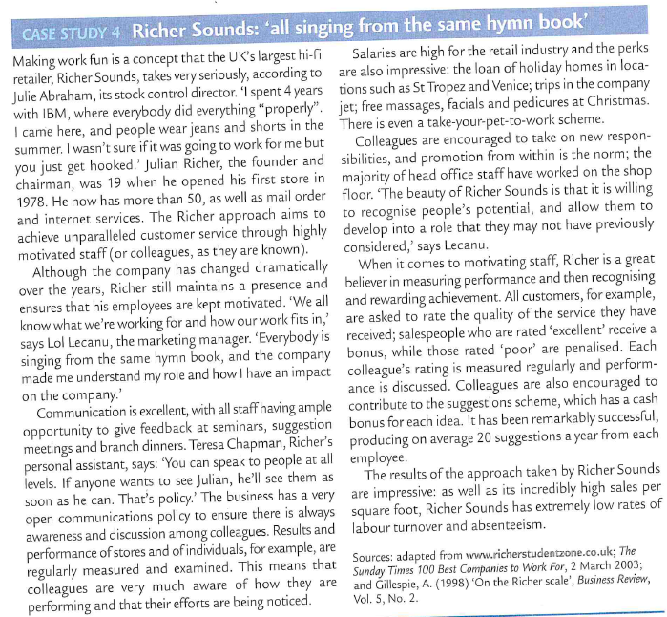

1. Identify and explain two types of financial incentives used by Richer Sounds to motivate its workforce.

2. Identify and explain two non-financial incentives used by Richer Sounds to motivate its workforce.

3. Analyse two possible advantages and two disadvantages of giving managers independence to set up their own reward scheme.

4. Salaries at Richer Sounds are relatively high for the retail industry. Evaluate the extent to which this is what motivates its staff.

5. Discuss whether it is easier to motivate worker with financial incentives in the short term rather than in the longer term.