**Secret Messages code mock Feb 2019 Mark Scheme**

(a)     **VB.Net**Sub Main()  
    Dim Names(4) As String  
    Dim Current As Integer  
    Dim Max As Integer  
    Dim Found As Boolean  
    Dim PlayerName As String  
  
    Names(1) = "Ben"  
    Names(2) = "Thor"  
    Names(3) = "Zoe"  
    Names(4) = "Kate"  
    ;Max = 4  
    Current = 1  
    Found = False  
    Console.WriteLine("What player are you looking for?")  
    PlayerName = Console.ReadLine  
    While Found = False And Current <= Max  
        If Names(Current) = PlayerName Then  
            Found = True  
        Else  
            Current = Current + 1  
        End If  
    End While  
    If Found = True Then  
        Console.WriteLine("Yes, they have a top score")  
    Else  
        Console.WriteLine("No, they do not have a top score")  
    End If  
    Console.ReadLine()  
End Sub

**Mark as follows:**Correct variable declarations for Max, Current, Found,  
PlayerName and correct declaration for the Names array;  
Four correct values assigned to the correct positions in the Names array;  
Max, Current, Found initialised correctly;  
Correct prompt followed by PlayerName assigned value entered by user;  
WHILE loop formed correctly and correct conditions for the termination of the loop;  
First IF followed by correct condition and IF statement is inside the loop;  
THEN followed by correct assignment statement within a correctly   
formed IF statement;  
ELSE followed by correct assignment statement within a correctly formed IF statement;  
Second IF followed by correct condition and IF is after the loop;  
THEN followed by correct output within a correctly formed IF statement;  
ELSE followed by correct output within a correctly formed IF statement;

**I** Case of variable names, player names and output messages  
**A** Minor typos in variable names and output messages  
**A** Max declared as a constant instead of a variable  
**A** Alternative conditions with equivalent logic for the loop  
**A** Array positions 0–3 used instead of 1–4 if consistent usage throughout program

**11**

(b)      * * * * SCREEN CAPTURE* * * *   
**Mark as follows:**'What player are you looking for' + user input of ‘ Thor’ ;  
'Yes, they have a top scor' message shown;  
**I** spacing  
**R** If code for (a) would not produce this test run

**2**

(c)      * * * * SCREEN CAPTURE* * * *   
**Mark as follows:**'What player are you looking for?' + user input of ‘Imran’ ;  
'No, they do not have a top score' message shown;  
**I** spacing  
**R** If code for (a) would not produce this test run

**2**

**[15]**

**Question 3**

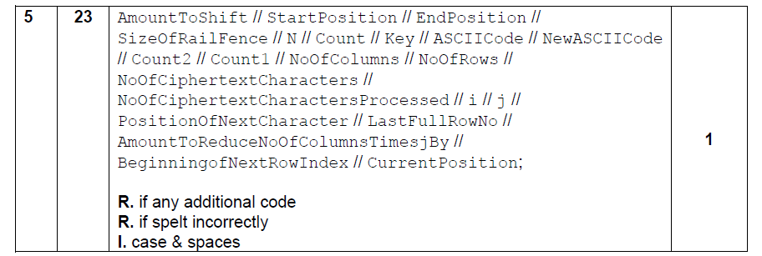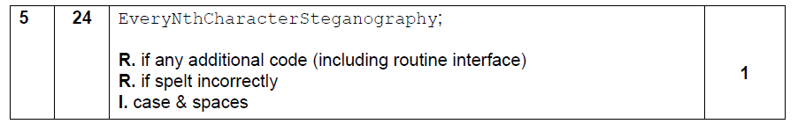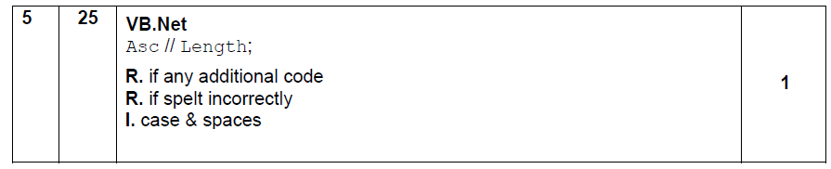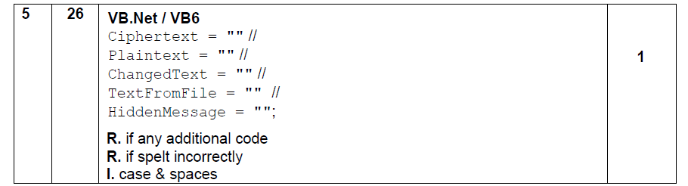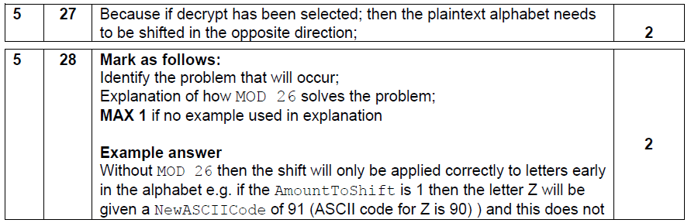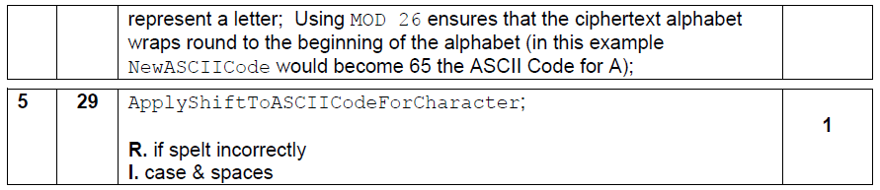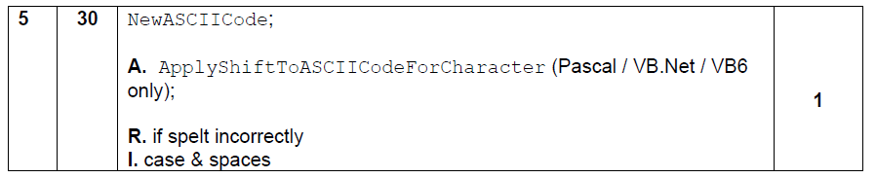

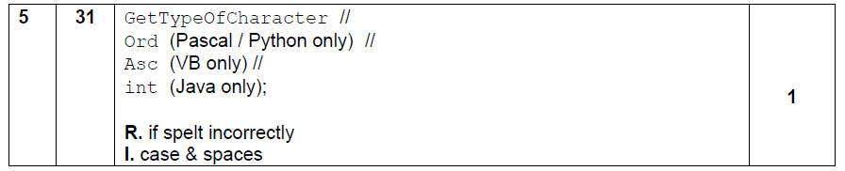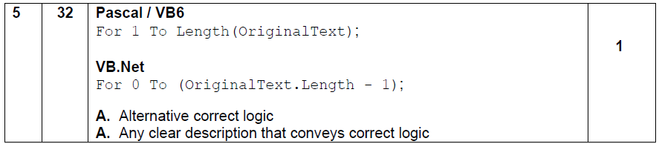

**Question 4**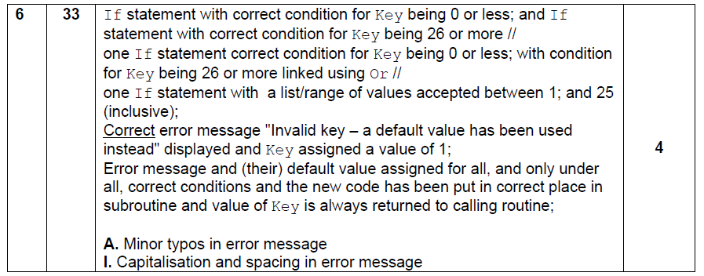

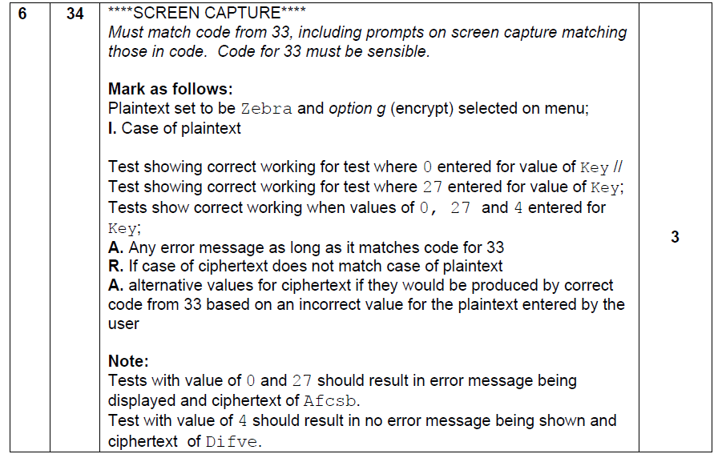

**VB.NET**

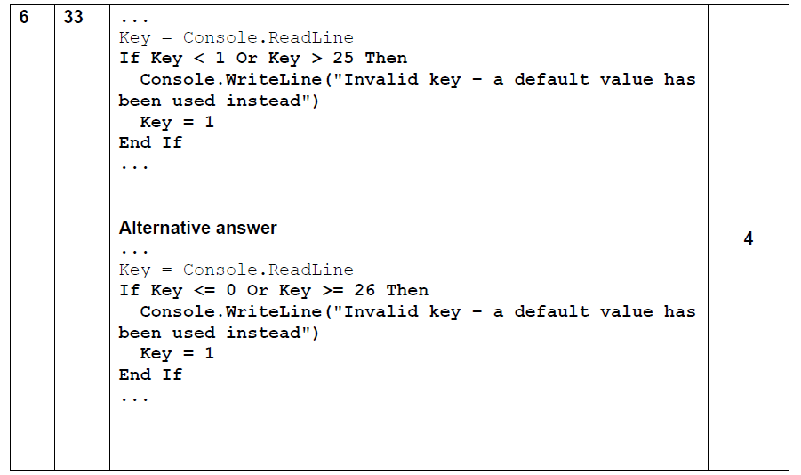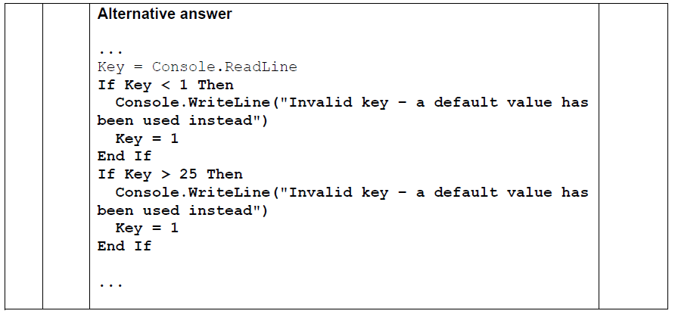

**Question 5**

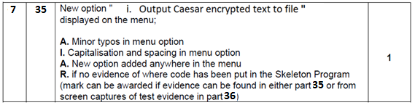

Case "i"

Dim Answer As Char = "Y"

FileOpen(1, "CaeserEncrypted.txt", OpenMode.Output)

Do

Plaintext = GetTextFromUser()

AmountToShift = GetKeyForCaesarCipher()

Ciphertext = UseCaesarCipher(Plaintext, AmountToShift)

PrintLine(1, Ciphertext)

Console.Write("Do you want to enter more text?(Y/N)")

Answer = Console.ReadLine

Loop Until Answer = "N"

FileClose(1)

Variable declaration Answer As Char 1 mark

File Opened to output text 1 mark

Use of Do….Loop Until 1 mark

Correct use of GetTextFromUser() 1 mark

Correct use of GetKeyForCaesarCipher() 1 mark

Correct use of UseCaesarCipher() 1 mark

Correct use of PrintLine() 1 mark

Prompt and input of Answer 1 mark

Correct termination of loop 1 mark

File closed 1 mark Total 10 marks

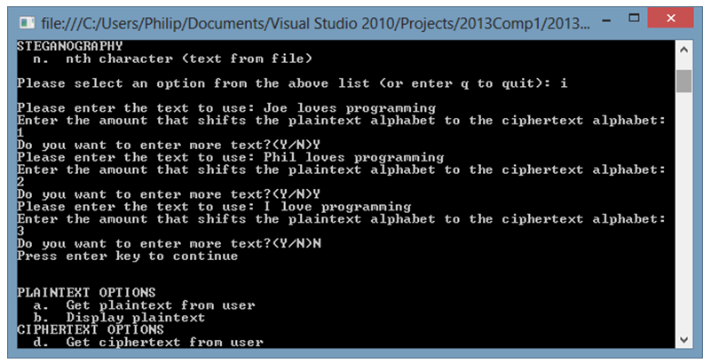

Correct input of “Joe loves programming” and shift = 1 1 mark

Correct responses “Y/Y/N” 1 mark

Correct 2nd & 3rd entry 1 mark Total 3 marks

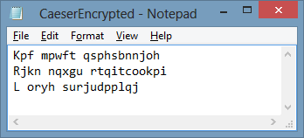

1 mark for each **perfectly** correct line in text file. 3 marks

**Question 6**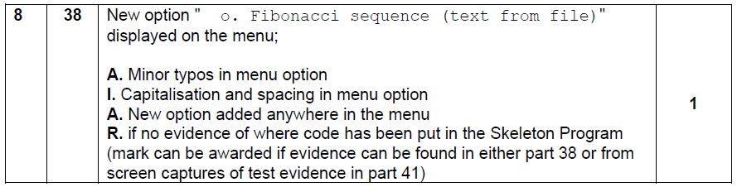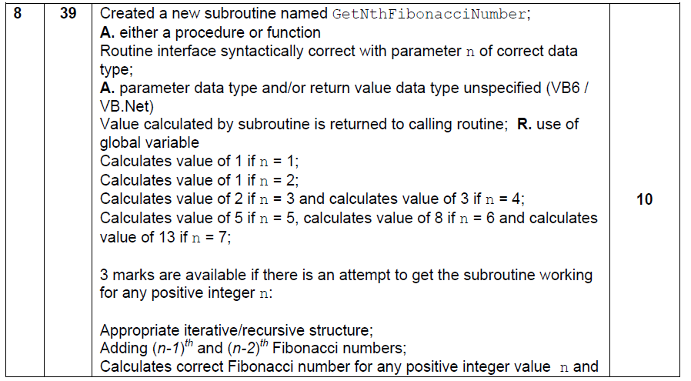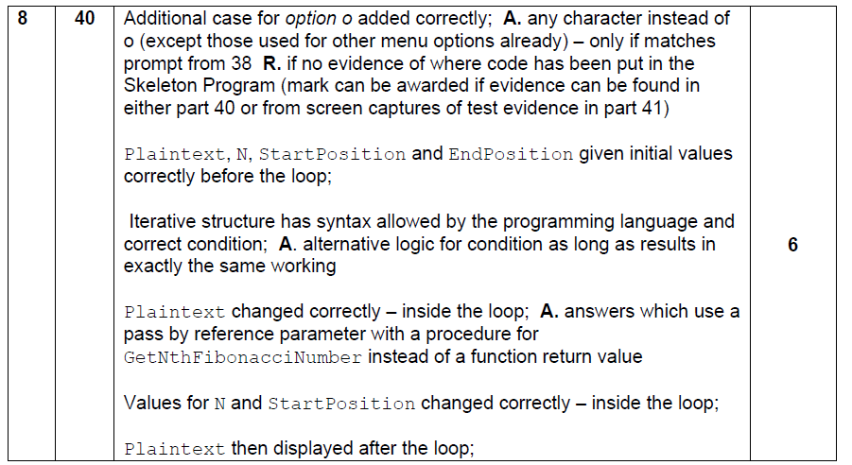

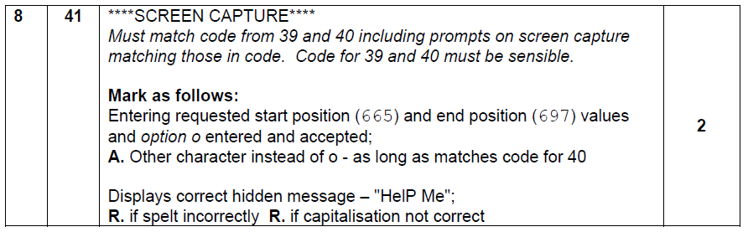

**VB.NET**

