**Cinematography** – *Describe the cinematography: Shot on location or in a studio? When is handheld camera used? Who are we being asked to align ourselves with? When do we see the use of POV? When are particular angles used?*

**Editing** – *Continuity or non-continuity? Interesting effects and transitions? Shot Length? When does it become fast pace or slow pace? Flash backs? Cross cutting?*

**Lighting** – *Consider the use of colour, isolated lighting, high key lighting, low lighting, what is being highlighted?*

*How is the ‘current’ time compared to ‘flashbacks’ or different locations?*

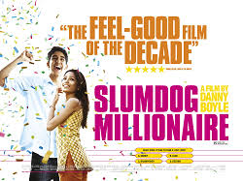

**Sound** *– Describe the musical score, non-diegetic music chosen and sound design? Leitmotif from the TV show ‘Who wants to be a Millionaire.’*

*When do we hear the urban soundtrack by A. R. Rahman featuring MIA?*

*Give examples of scenes in the film which uses opposites to help create meaning - Levi-Strauss’ theory – Jamal & Salim, poverty & wealth / happiness & status / India & West (Cultural Imperialism), Realism & Fantasy.*

**Mise en scene** – *Notable* *costumes, props, locations / décor and performance? Compare the glossy TV studio with the slum settings and grotty police station.*

**Characters:** Who are the main characters and how do they develop throughout the narrative?