**Management**

1. What is management? (see text book, page 395)

|  |
| --- |
|  |

2. Read the following article <https://www.theguardian.com/careers/difference-between-leadership-management>

Describe the difference between management and leadership

|  |
| --- |
|  |

3. Outline Fayol’s “Functions of Management”? (use text book pages)

|  |  |
| --- | --- |
| Planning |  |
| Organising |  |
| Commanding |  |
| Co-ordinating |  |
| Controlling |  |

4. Outline Mintzberg’s “Roles of Management”

|  |  |
| --- | --- |
| Information roles |  |
| Interpersonal roles |  |
| Decision making roles |  |

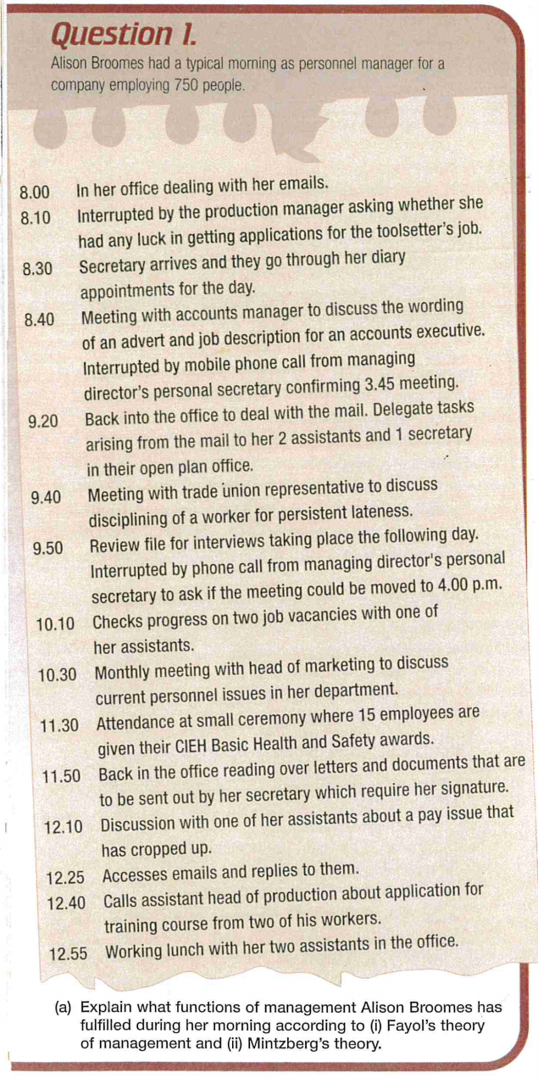

5. What are the steps in Drucker’s “Management by Objectives MBO” process?

|  |
| --- |
|  |

6. Outline the advantages and disadvantages of Drucker’s MBO

|  |  |
| --- | --- |
| Advantages | Disadvantages |
|  |  |

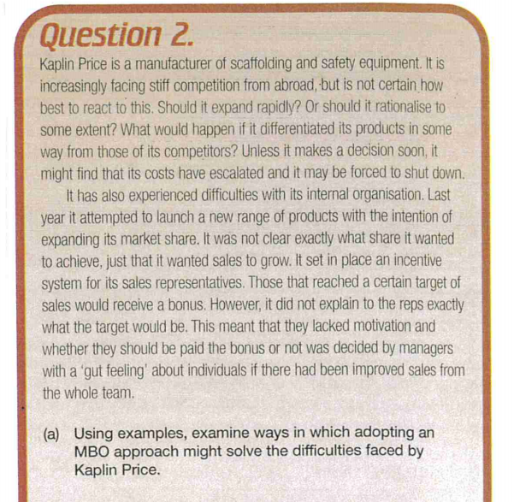

7. Describe the characteristics of Theory X and Theory Y Managers

|  |  |
| --- | --- |
| Theory X | Theory Y |
|  |  |

