“Discuss or Analyse” Questions

These types of questions are similar in structure, except ‘Discuss’ questions require a BALANCED argument, whereas ‘Analyse’ questions don’t need balance.

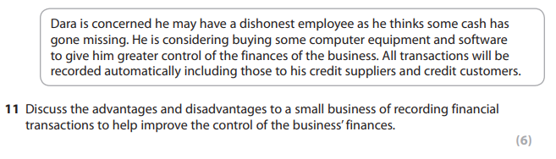

|  |
| --- |
| Point #1 (Advantage?) |

|  |
| --- |
| Point #2 (Disadvantage?) |

|  |
| --- |
| Point #3 (Advantage?) |

|  |
| --- |
| Point #4 (Disadvantage, if you have enough time) |

“Assess” or “Evaluate” Questions

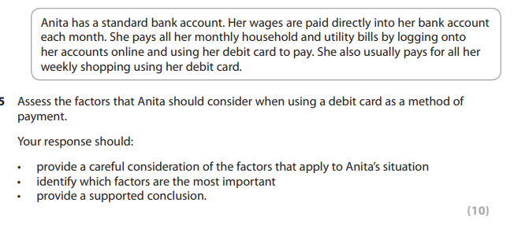

|  |
| --- |
| Point #1 (1st ‘factor’)  How important / valid is this point? |

|  |
| --- |
| Point #2 (2nd ‘factor’)  How important / valid is this point? More or less than the last point? |

|  |
| --- |
| Point #3 (3rd ‘factor’)  How important / valid is this point? More or less than the previous points? |

|  |
| --- |
| Conclusion. **Make your final decision**.  (Which is the most important ‘factor’? Why? Why is it more important than the other factors / why are they less important?) |