Employer – Employee relationships:

1. Define employer – employee relations

|  |
| --- |
|  |

2. What are the key employment concepts?

|  |
| --- |
|  |

3. What are the benefits of good employee/employer relations?

|  |
| --- |
|  |

4. What are the barriers to good employee / employer relations?

|  |
| --- |
|  |

## Research task – Duties and Rights

Using the CAB employee rights link on GOL, and your own research, answer the following questions:

1. In which two main places are employment rights are set out?
2. What does a written statement of employment contain, and does an employer need to provide a written contract for everyone?
3. Describe at least 3 circumstances where employees have a statutory right to paid leave / time off work?
4. List the main areas that health and safety law covers:
5. Explain what rights employees have in respect of:

- working hours

- breaks, and

- holidays

1. Explain what the minimum wage is, including age-related pay brackets. What is the National Living Wage?
2. Explain what rights an employee has if their employer wants to dismiss them
3. When can an employer dismiss ‘without notice’?
4. Do employees have any duties they need to meet?
5. Finally, why do you think all these employment rights and duties for employees and employers exist?

**Discrimination Scenarios**

Read the following statements carefully.

Decide if the situation is discriminatory or not. If it IS discrimination, explain on what grounds (e.g. Age) and what type of discrimination (e.g. direct). If not, explain why not.

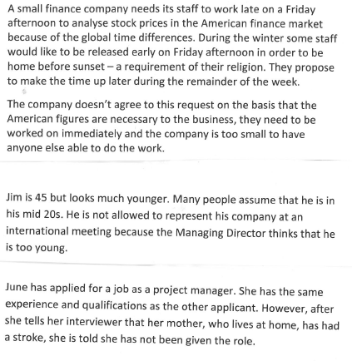

|  |
| --- |
|  |



|  |
| --- |
|  |



|  |
| --- |
|  |

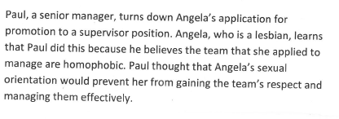

|  |
| --- |
|  |

**People in Organisations**

Employer/Employee relations

Investigate the main features of the Equality Act 2010 with special reference to ‘protected characteristic’.

<http://www.legislation.gov.uk/ukpga/2010/15/pdfs/ukpga_20100015_en.pdf>

What are the main features of the Equality Act 2010?

How does this piece of legislation impact on business activity? (e.g. production, marketing, finance, administration, human resources, research and development) Link to specific businesses to give your answer some context.