**Operations Management**

* **Operations Management definition:**

|  |
| --- |
|  |

Operations Management is about “**Productive Efficiency**”

* **Productive Efficiency definition:**

|  |
| --- |
|  |

* Resources = Factors of Production. What are the 4 Factors of Production?
* What is **production?**

|  |
| --- |
|  |

* **Three Types of Industry**

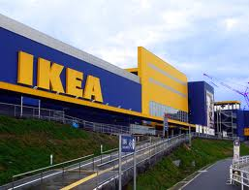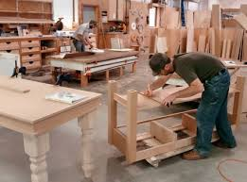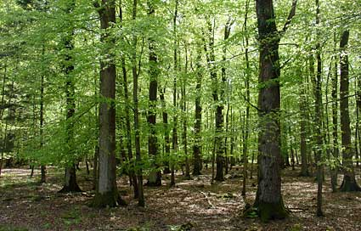

**Adding Value**

* **Added Value definition:**

|  |
| --- |
|  |

* **Added Value Formula**

|  |
| --- |
|  |

* **Example: iPhone 4**

Selling price = $599.99

Cost of materials = $187.51

Added value = ?

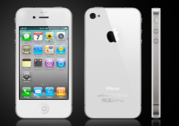

* **Explain the difference between adding value and profit**

|  |
| --- |
|  |

|  |  |
| --- | --- |
| **How do businesses add value?** | **How can businesses increase added value?** |
|  |  |

**Adding Value**

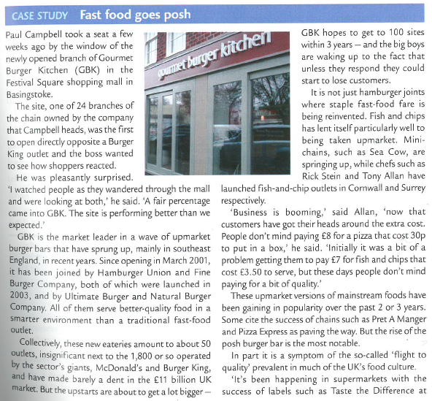

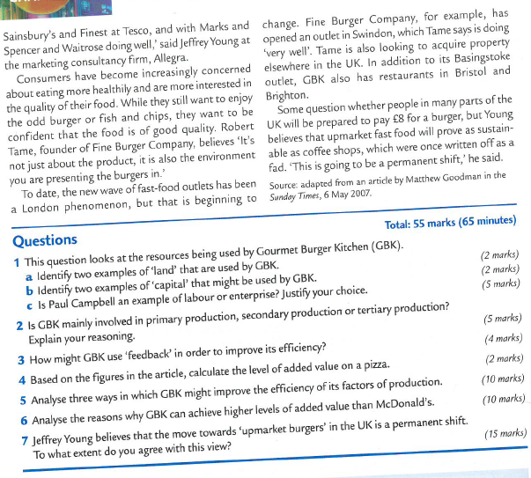

**GBK Case Study**

1a. Identify two examples of “land” that are used by GBK

|  |
| --- |
|  |

1b. Identify two examples of “capital” that might be used by GBK

|  |
| --- |
|  |

1c. Is Paul Campbell an example of labour or enterprise? Justify your choice.

|  |
| --- |
|  |

2. Is GBK mainly involved in primary production, secondary production or tertiary production? Explain your reasoning.

|  |
| --- |
|  |

4. Based on the figures in the article, calculate the level of added value on a pizza

|  |
| --- |
|  |

6. Analyse the reasons why GBK can achieve higher levels of added value than McDonald’s

|  |
| --- |
|  |

Adding value

**1. Missing words**

Adding value means creating a finished product that is worth more to the customer than the sum of the parts. At Starbucks, 25p of coffee beans, milk and flavourings turns into a selling price of £2.50. The £__________of value added pays for staff, the equipment, the sofas, the rent and still generates a generous _______________. Adding value is the ultimate goal of Research and Development teams and marketing departments. It generates the surplus that pays the bills.

The formula for calculating value added is: ________________ - bought-in goods and services.

**2. Ways to add value (Match the points A – H to the relevant product type or types)**

|  |  |  |
| --- | --- | --- |
| Product type | Ways to add value | Ways to add value |
| 1. Car manufacturing | A. Obtain a prestigious address | E. Carry out the process faultlessly |
| 1. Biscuit production | B. Measure up, then make to fit | F. Excellent design and styling |
| 1. Running a private hospital | C. Offer a short lead time | G. Impressive, prestige packaging |
| 1. Making wedding dresses | D. Add a technical innovation | H. Use low cost materials where they’re not visible to the customer |

**3. Calculations**

1. Tardew Car Dealers buys a 6 year old Fiesta for £700 cash. One car seat is replaced and a new exhaust fitted - the parts cost £105. After a thorough clean-up inside and out and a squirt of air freshener inside (materials cost: £5), the Fiesta goes onto the forecourt at £1,495 and is sold for £1,400 a week later.
2. Calculate the added value
3. Explain why this added value cannot be treated as pure profit.

1. *Strength* is a cure for baldness based on herbal medicines. It sells in bottles priced at £24 that provide enough for two weeks. A full cure is said to take one year, though the packaging says that only 50% of users will find the cure effective. Jenny Ireland, the inventor of *Strength,* has hired a well-known TV and film actor to promote the product on a series of TV commercials. The production process and costs of *Strength* are a closely guarded secret, but the materials themselves cost no more than 30p - the same as the packaging. Jenny often refers to the ‘huge overheads’ of running the business, but with sales of 2 million bottles last year, no wonder she has just bought herself a Mercedes sports car.
2. Calculate the i. value added per bottle

ii. total value added in the last year

b) Give one justification Jenny might find to defend the high price she charges for *Strength*.

**4. Outline one example of:**

4.1 Added value based upon deception or cleverness (such as Aero adds value by blowing air through chocolate

4.2 Added value based upon a unique selling point (a USP)

4.3 TV advertisements you have seen recently that seem focused upon adding value