**Task 1: Using the table below fill in the advantages and disadvantages of the various types of production** (use the text book pages and the exam board notes to help you)

|  |  |  |
| --- | --- | --- |
| **Production method** | **Advantages** | **Disadvantages** |
| Define Job production | .  .  .  .  . | .  .  .  .  . |
| Define Batch production | .  .  .  .  . | .  .  .  .  . |
| Define Flow production | .  .  .  . | .  .  .  . |

**Task 2: Carefully read the case study information and apply your knowledge to answer the questions below**

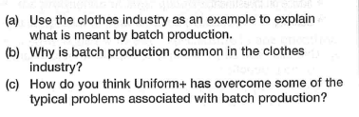

|  |
| --- |
| a) |

|  |
| --- |
| b) |

|  |
| --- |
| c) |

**Task 3: Carefully read the past paper question case studies and answer the questions (be mindful of your exam technique)**

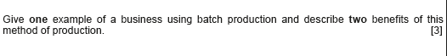

AO1 – 1 mark for appropriate example

AO2 – 2 marks for describing the benefits

|  |
| --- |
|  |

Questions continue on the next page

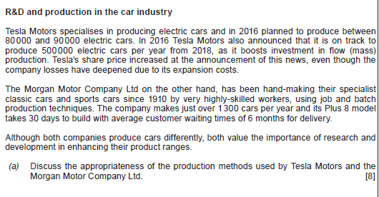

|  |
| --- |
| *Firstly, define the different methods of production*  *Make 1- 2 points about why flow IS appropriate for Tesla*  *Make 1-2 points about why may NOT be appropriate for Tesla*  *Then*  *Make 1-2 points about why job / batch IS appropriate for Morgan*  *Make 1-2 points about why job/ batch may NOT be most appropriate for Morgan*  *Overall conclusion re: whether you think their chosen methods are suitable – considering IT DEPENDS UPON…. E.g. their targets markets (niche vs mass), level of demand, brand image they are trying to promote, whether the high investment cost will be covered in the long run etc etc* |

