**Question:**

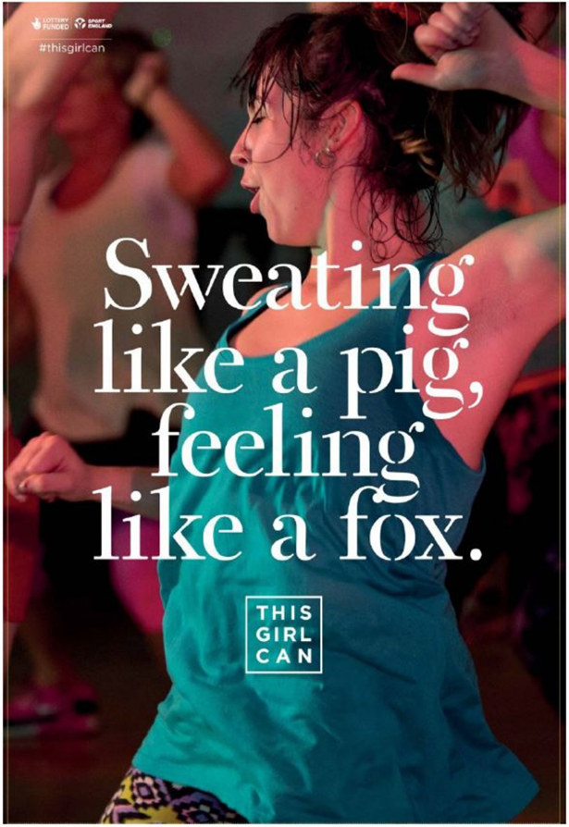Explore how the advertisement for This Girl Can uses the following elements of media language to create meanings:

1. Images [5]
2. Language [5]
3. Layout and design [5]

**Response:**

Type Answer Here:

**Question:**

Explain how social context influences magazines. Refer to GQ magazine to support your points. [5]

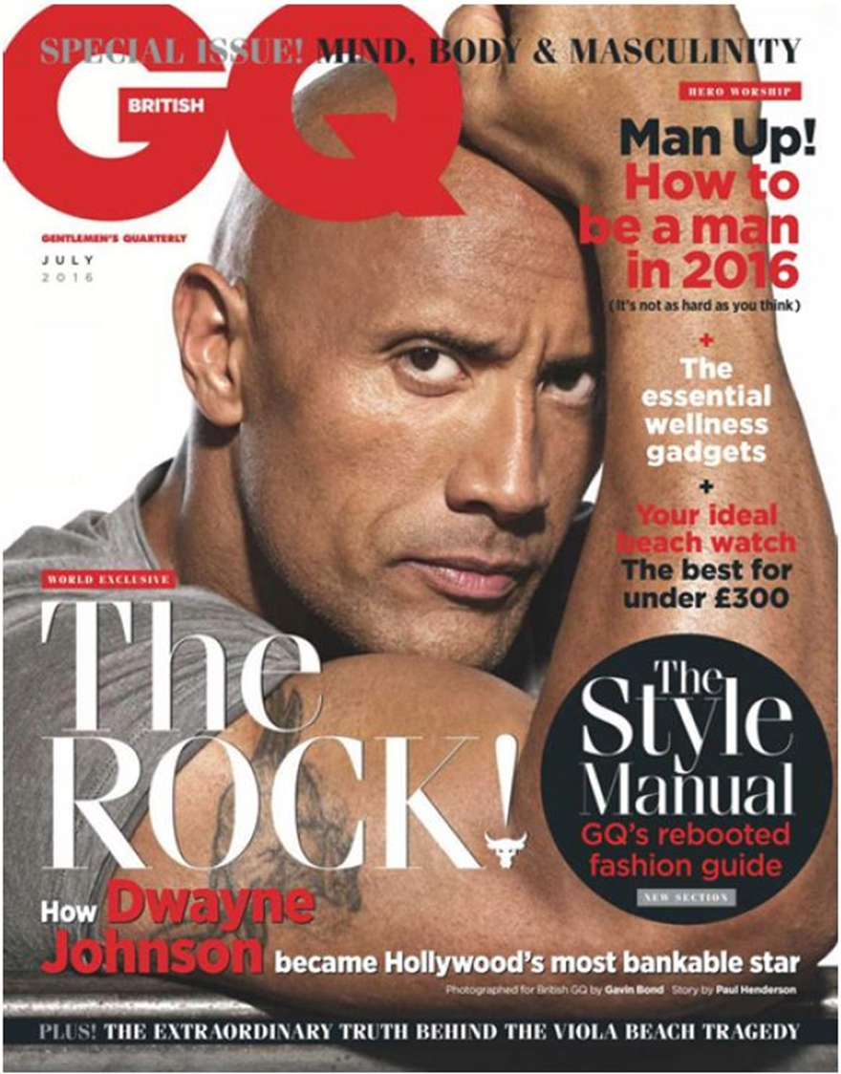

**Response:**

Type Answer Here:

**Question:**

Compare the representation of events in The Guardian front page and The Sun front page. [25]

In your answer, you must consider:

* How far representations convey particular viewpoints and messages
* How far the representation of events is similar in the two front covers
* How far the representation of events is different in the two front covers

*Remember to use examples from each set text and use the **Point, Evidence, Explain** structure

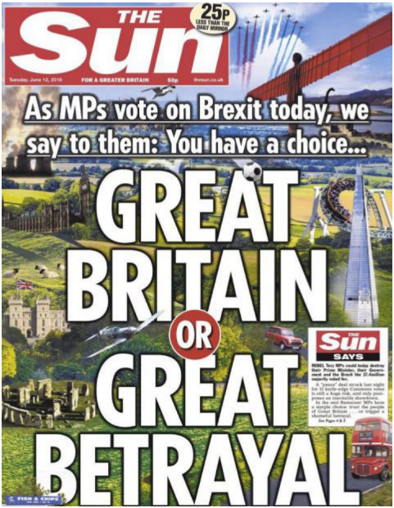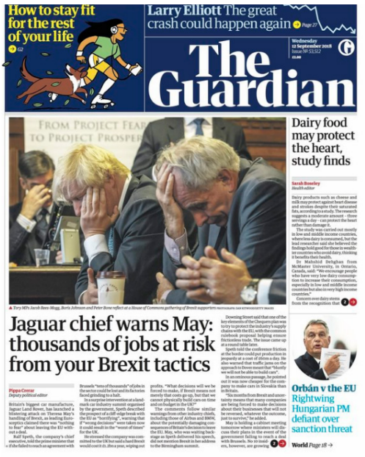

**Response:**

Type Answer Here: