Unit 4 | Magnetic Flux and Flux Linkage
Lesson 20
Learning Outcomes | To be able to calculate and explain the magnetic flux through a coil of wire
Learning Outcomes | To be able to calculate the magnetic flux linkage of a coil of wire
Learning Outcomes | To be able to calculate the magnetic flux linkage of a rotating coil | N. DWYER

Magnetic Flux, φ
Magnetic flux is a measure of how many magnetic field lines are passing through an area of A m².
The magnetic flux through an area A in a magnetic field of flux density B is given by: $φ=\text{BA}$
This is when B is perpendicular to A, so the normal to the area is in the same direction as the field lines.
Magnetic Flux is measured in Webers, Wb
The more field pass through area A, the greater the concentration and the stronger magnetic field.
This is why a magnet is strongest at its poles; there is a high concentration of field lines.
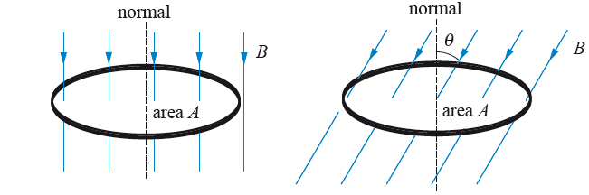
We can see that the amount of flux flowing through a loop of wire depends on the angle it makes with the field lines. The amount of flux passing through the loop is given by: $φ=\text{BA}\text{cos}θ$
θ is the angle that the normal to the loop makes with the field lines.

Magnetic Flux Density
We can now see why B is called the magnetic flux density. If we rearrange the top equation for B we get:
$B=\frac{φ}{A}$ So B is a measure of how many flux lines (field lines) passes through each unit area (per m²).
A flux density of 1 Tesla is when an area of 1 metre squared has a flux of 1 Weber.

Flux Linkage
We now know that the amount of flux through one loop of wire is: $φ=\text{BA}$
If we have a coil of wire made up of N loops of wire the total flux is given by: $Nφ=\text{BAN}$
The total amount of flux, $Nφ$, is called the Magnetic Flux Linkage; this is because we consider each loop of wire to be linked with a certain amount of magnetic flux.
Sometimes flux linkage is represented by $Φ$, so $Φ=Nφ$ which makes our equation for flux linkage $Φ=\text{BAN}$
Flux Linkage is measured in Webers, Wb

Rotating Coil in a Magnetic Field
If we have a rectangle of wire that has an area of A and we place it in a magnetic field of flux density B, we have seen that the amount of flux flowing through the wire depends on the angle between it and the flux lines.
The flux linkage at an angle θ from the perpendicular to the magnetic field is given by: $Nφ=\text{BAN}\text{cos}θ$
From our lessons on circular motion we established that the angular speed is given by $ω=\frac{θ}{t}$ which can be rearranged to $θ=ωt$and substituted into the equation above to transform it into: $Nφ=\text{BAN}\text{cos}ωt$
When t = 0 the wire is perpendicular to the field so there is a maximum amount of flux.
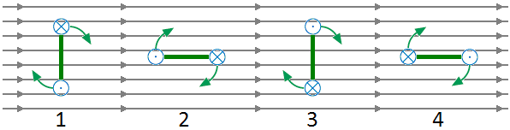
At 1 the flux linkage is a maximum in one direction. There is the lowest rate of change at this point.
At 2 the flux linkage is zero. There is the biggest rate of change at this point
At 3 the flux linkage is maximum but in the opposite direction. The lowest rate of change occurs here too.
At 4 the flux linkage is zero. There is the biggest rate of change at the point too but in the opposite direction.
Next lesson we will be looking at inducing an e.m.f. using a wire and a magnetic field. The size of the e.m.f. depends on the rate of change of flux linkage.

