Unit 4 | Transformers
Lesson 22
Learning Outcomes | To be able to describe a transformer and calculate the voltage and current in the secondary coil
Learning Outcomes | To be able to calculate the efficiency of a transformer and explain why they are used
Learning Outcomes | To be able to state the causes of inefficiency in transformers | N. DWYER

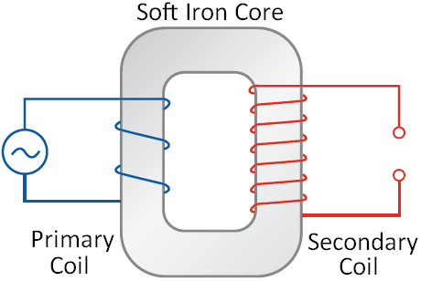
Transformers (Also seen at GCSE Physics 3)
A transformer is a device used to change the voltage/current of a circuit using electromagnetic induction. It consists of a soft iron core wrapped on both side with wire. The first coil of wire is called the primary coil and the other coil of wire is called the secondary coil.
A current doesn’t flow from one coil of wire to the other.
How They Work
A current flows through the primary coil which creates a magnetic field.
As this field is established the field lines cut through the turns of wire on the secondary coil. This induces an e.m.f. (voltage) and a current in the second coil.
Since the supply to the primary coil is constantly changing direction the magnetic field is constantly changing direction. This means the secondary coil also has an alternating e.m.f. and current.
An iron core is used because it is easily magnetised and demagnetised and conducts the magnetic field.

Transforming Voltage and Current (Also seen at GCSE Physics 3)
There are two types of transformers:
Step Up
The voltage in the secondary coil is larger than the voltage in the primary coil.
The current in the secondary coil is smaller than the current in the primary coil.
There will be more turns of wire on the secondary coil meaning more flux linkage
Step Down
The voltage in the secondary coil is smaller than the voltage in the primary coil.
The current in the secondary coil is larger that the current in the primary coil.
There will be fewer turns of wire on the secondary coil meaning less flux linkage

In both cases the voltage and current (V_{P} and I_{P}) in the primary coil of N_{P} turns is linked to the voltage and current (V_{S} and I_{S}) in the secondary coil of N_{S} turns by the following equation:
$$\frac{N_{S}}{N_{P}}=\frac{V_{S}}{V_{P}}=\frac{I_{P}}{I_{S}}$$

The National Grid (Also seen at GCSE Physics 1)
The National Grid is a system of transformers that increases the voltage (reducing the current) of an alternating electrical supply as it leaves the power station. Thick cables held above the ground by pylons carry the supply to our neighbourhood. A second series of transformers lowers the voltage to a safe level and increases the current to be used in our homes.
Why Bother?
Energy is lost in the transmission of electricity. The electrons flowing in the wire are constantly colliding with the positive ions of the metal that the wire is made from. If we increase the voltage of a supply this lowers the current. Lowering the current reduces the number of collisions happening per second hence reducing the amount of energy lost in reaching our homes.
The cables that carry the current have a larger cross sectional area, this lowers the resistance and energy lost.

Efficiency of a Transformer
The efficiency of a transformer can be calculated using the following equation:
Efficiency $=\frac{I_{S}V_{S}}{I_{P}V_{P}}$
The efficiency of a transformer can be increased by:
*Using low resistance windings to reduce the power wasted due to the heating effect of the current.
*Use a laminated core which consists of layers of iron separated by layers of insulation. This reduces heating in the iron core and currents being induced in the core itself (referred to as eddy currents).

