1. (a) Force = Bev ✓ Diagram ✓
Use Fleming's Right Hand Rule to work out the direction of the force,
v
Force
e
Field
but remember conventional current is opposite to electron flow.
[2]

(b) (i) Electrons in wire are being moved at right angles to the field ✓
[1]
(ii) There is a force on these electrons pushing them towards one end of the wire ✓
Electrons will move along the wire until electrostatic repulsion balances the magnetic force✓
This displacement of electrons produces a pd across the wire ✓
[3]
(iii) Length of wire (l) ✓
[1]
(iv) EMF = Blv ✓
[1]
(c) EMF = Blv = 5.2 ×10⁻⁵ × 20 × 300 ✓
= 0.31V ✓ Remember to give the unit in the final answer
[2]

Total 10 marks

2. (a) Galvanometer pointer deflects as magnet moves in ✓
Returns to zero as magnet stops ✓
Deflects in opposite direction ✓ same magnitude as magnet removed ✓
[4]
(b) Solenoid cuts the flux of the magnet ✓
Induces emf across solenoid, producing current in galvanometer ✓
When magnet stops, rate of cutting flux is zero, emf falls to zero ✓
When magnet removed, emf is reversed (Lenz's Law) ✓
Same rate of cutting flux so magnitude of emf is the same ✓
[5]

(c) The deflection of the galvanometer will be greater in each direction ✓
Flux is being cut at a faster rate ✓
[2]

Total 11 marks

3. (a) B = μ_{o} n I ✓ where n = number of turns per metre
B = 4π × 10 ⁻⁷ × 150/0.6 × 1.2 ✓
= 3.8 × 10 ⁻⁴ T = 0.38 mT ✓
[3]
(b) (i) Flux linkage through second coil is Φ = B × area × number of turns
= 0.38 ×10⁻³ × π × (2.5 × 10⁻²) ² × 50 ✓
= 3.7 × 10⁻⁵ Wb ✓

Induced emf = dΦ/dt = 3.7 × 10⁻⁵ / 0.1✓
= 3.7 × 10⁻⁴ V ✓
[4]
(ii) Assumption is that all the flux produced by the solenoid links with the second coil ✓
[1]
(c) By reversing the current, the change in flux linkage is doubled ✓
(It changes from 3.7 × 10⁻⁵ Wb to -3.7 × 10⁻⁵ Wb, i.e. 7.4 × 10⁻⁵ Wb)
Since the emf is the same, dΦ/dt must be the same ✓
So the time taken must also have doubled, i.e. 0.2 seconds ✓
[3]

Total 11 marks

4. (a) v = √2gs = √ (2 × 9.81 × 0.4) ✓ = 2.8ms⁻¹ ✓
This question is mainly about induction, but be prepared to use other
parts of physics when needed.
[2]

(b) EMF across the side moving into the field is Blv = 0.25 × 0.5 × 2.8 ✓
= 0.35V ✓
Total resistance of frame is 2Ω ✓
I = V / R = 3.5 / 2 = 0.175A ✓
[4]
(c) Force on wire due to field = BIl = 0.25 × 0.175 × 0.5 = 0.022N upwards✓
Total force acting downward on frame = mg - 0.022 ✓
= 0.01 × 9.81 - 0.022
= 0.0761N ✓
Acceleration = F/m = 0.0761 / 0.01 = 7.61ms⁻² ✓ downwards ✓
[5]

Total 11 marks

5. (a) The direction of an induced emf ✓ is such as to oppose the change producing it ✓
[2]
(b) (i) The positive peak shows the emf induced as the magnet enters the coil ✓
The rate of cutting flux increases as more of the field enters the coil so the emf increases ✓
By Lenz's Law, the current in the coil produces a magnetic field to try and repel the magnet ✓
[3]
(ii) As the magnet begins to drop out of the coil the emf becomes negative ✓
Again by Lenz's Law, the current in the coil must reverse to try and stop the magnet leaving the coil ✓
[2]
(iii) Since the magnet is accelerating under gravity, it is moving faster as it leaves the coil ✓
The rate at which flux is cut is increased, so the emf, shown by the size of the negative peak, is greater ✓
[2]
(iv) The magnet is moving faster as it falls out of the coil, the duration of the negative peak is shorter than that of the positive peak ✓
[1]

Total 10 marks

6. (a) The self inductance of a coil is the ratio of the induced emf ✓ across it to the rate of change
of current through it ✓
Alternatively in symbols: L = V / (dI/dt)
[2]
(b) (i) Current = 3.0A so the pd across the resistance is IR = 3.0 × 0.5 = 1.5V ✓
Voltage across L is 12 - 1.5 = 10.5V ✓
L = V/ (dI/dt) = 10.5 / 60 = 0.175H or 175mH ✓
[3]
(ii) At switch on there is no current immediately, so the whole battery voltage (12V)
is across the inductor ✓
dI/dt = V / L = 12 / 0.175 = 69As⁻¹ ✓
✓
[3]
(iii) After several seconds the current will have risen to a steady value ✓
It is no longer affected by L, so it can be found by I = V / R
I = 12 / 0.5 = 24A ✓
[2]
(c)
I (A)
t (s)

correct axes ✓ exponential shape of curve ✓
[2]

Total 12 marks

7. (a) (i) Hold search coil so that it is at right angles to field ✓
Twist coil sharply through 180º to reverse the field through it ✓
EMF (or current) induced is proportional to field strength ✓
[3]
(ii) Apparatus: to measure induced current use a sensitive galvanometer or ballistic galvanometer ✓
[1]
(iii) Measure: deflection of galvanometer ✓ at different distances from wire✓
Repeat measurements and average ✓
[3]
(iv) Errors: reading galvanometer deflection (moving) ✓
position of coil (held by hand) ✓
difficulty of twisting coil at same rate each time ✓
[3]
(b)
B
(galvanometer readings proportional to B)
B ∝ 1/r

distance r (m)

graph ✓ relationship ✓
[2]
(c) B = μoI / 2πr = 4π × 10⁻⁷ × 2 / (2π × 0.1) ✓ = 4 × 10⁻⁶ T✓ or 4μT
[2]

Total 14 marks

8. (a) (i) B is flux density, i.e. flux per unit area ✓ so: φ = B × area ✓
[2]
(ii) Units: B tesla (T) ✓ φ weber (Wb) ✓ which is Tm²
[2]
(b) (i) Area swept out by radial line in one revolution is area of disc = πr² ✓
= π × (0.25 × 10⁻²)² ✓
flux cut = B × area = 0.1 × π × (0.25 × 10⁻²)² ✓ = 2.0 × 10⁻⁶Wb ✓
[4]
(ii) This flux is cut 25 times per second
emf = dφ/dt = 2.0 × 10⁻⁶ / (1/25) ✓= 5 × 10⁻⁵V ✓
[2]
(iii) EMF across diameter is zero ✓
Opposite emfs across two radial lines cancel out
[1]

Total 11 marks

9. (a)
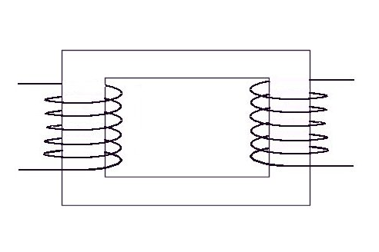
Input voltage V_{p}✓
Primary coil
(N_{p} turns) ✓
Output voltage V_{s} ✓
Secondary coil
(N_{s} turns) ✓
Laminated soft iron core ✓
Step up transformer, so V_{s} > V_{p} ✓Diagram ✓✓
[8]

(b) Faraday's Law states: induced emf is proportional to rate of change of flux linkage ✓
AC in the primary coil produces a varying magnetic flux in this coil ✓
This flux is linked to the secondary coil by the iron core ✓
Changing flux through secondary coil induces voltage across it ✓
[4]

Total 12 marks

10.(a) (i) Flux φ = B × area ✓ = 0.12 × (1 × 10⁻²)² = 1.2 × 10⁻⁵Wb ✓
emf = rate of change of flux = 1.2 × 10⁻⁵ / 0.60 = 2.0 × 10⁻⁵V ✓
current = V/R = 2.0 × 10⁻⁵ / 2.3 × 10⁻³ = 8.7 × 10⁻³A = 8.7mA ✓
[4]
(ii) Energy = power × time = IV × t ✓ = 8.7 × 10⁻³ × 2.0 × 10⁻⁵ × 0.60 ✓
= 1.04 × 10⁻⁷J ✓
[3]
(b) (i) Loop should have a larger area (e.g. 30cm × 30cm) ✓
and should be wound with many turns (e.g. 1000) ✓
[2]
(ii) Earth's field is small, greater area and more turns give flux linkage that will produce a measurable current ✓
[1]
(iii) Loop is mounted so it can be rotated ✓ about horizontal and vertical axes.
This allows horizontal and vertical components ✓ of field to be measured
[2]

Total 12 marks

11. (a) Currents induced ✓ in a piece of metal due to changing flux or movement through
a magnetic field ✓ Eddy currents circulate around paths of least resistance in metal ✓
[3]
(b) Eddy currents can be large and cause the metal to become hot.
Application: inductive heating e.g. for melting metals ✓
Disadvantage: energy loss in core of wound components e.g. transformers ✓
[2]
(c) Kinetic energy of pendulum is converted into heat energy ✓
by eddy currents induced in the vane. Energy loss causes pendulum to slow down ✓
[2]
(d) Oscillations last for longer time ✓
Eddy currents are smaller due to slots increasing resistance, so there is less energy loss✓
[2]

Total 9 marks

12. (a) Call the voltages and the number of turns on the primary and secondary coils: V_{p} , V_{s}, N_{p}, N_{s} .
Faraday's Law for the secondary coil: V_{s} = - N_{s} (dφ/dt) ✓
In order to maintain current in the primary, the input voltage V_{p} must equal the back
emf due to the changing flux ✓
So Faraday's Law also gives: V_{p} = - N_{p} (dφ/dt) ✓
Assume all the flux through the primary passes through the secondary,
so that φ is the same in each equation, then: - (dφ/dt) = V_{s} / N_{s} = V_{p} / N_{p} ✓
Thus: V_{s} / V_{p} = N_{s} / N_{p} ✓
[5]
(b) (i) Turns ratio N_{s} / N_{p} = V_{s} / V_{p} ✓ = 6 / 240 = 1 / 40 ✓
[2]
(ii) Power supplied = 24W at 240V
Current = P / V = 24 / 240 ✓= 0.1A ✓
[2]
(iii) This assumes that no power is lost in the transformer, i.e. the transformer is perfect ✓
[1]

Total 10 marks

13.(a) Connect search coil to a CRO ✓
Place coil between turns of slinky so its plane is at right angles to the field ✓
Measure amplitude of induced emf displayed on CRO ✓
Repeat measurement at different points along the slinky ✓
[4]
(b) (i) B ∝ I ✓ so twice the current gives twice the field strength ✓
This would double the amplitude of the CRO trace.
[2]
(ii) B ∝ n, where n is the number of turns per metre. Stretching the slinky to twice its length halves the turns per metre ✓ (since total number of turns remains the same).
Thus B is halved ✓
[2]
(iii) Since one change doubles B and the other halves it, the two together would leave B unchanged ✓
[1]
(c) Either: search coil and galvanometer, twist coil to induce current ✓
or: Hall probe with voltmeter to measure Hall voltage ∝ field ✓
[1]

Total 10 marks

14.(a) (i) The spokes of the wheel cut magnetic flux ✓
This induces an emf across each spoke, i.e. between the hub and the rim ✓
[2]
(ii) Change: the speed of rotation, the strength of the field, the orientation of the wheel in the field (any two) ✓✓
[2]
(b) (i) The bulb would light ✓ and then go out as the current decreased ✓
[2]
(ii) The wheel would slow down ✓ as energy is transferred to heat and light in the bulb ✓
[2]
(c) Since emf is ¹/₄, the rate of cutting flux must be ¹/₄ that of the first wheel ✓
This is B × area swept out per second ✓
B and rate of rotation are the same, so area of wheel must be ¹/₄ i.e. radius is halved ✓
[3]

Total 11 marks

15.(a)
Rotating coil ✓
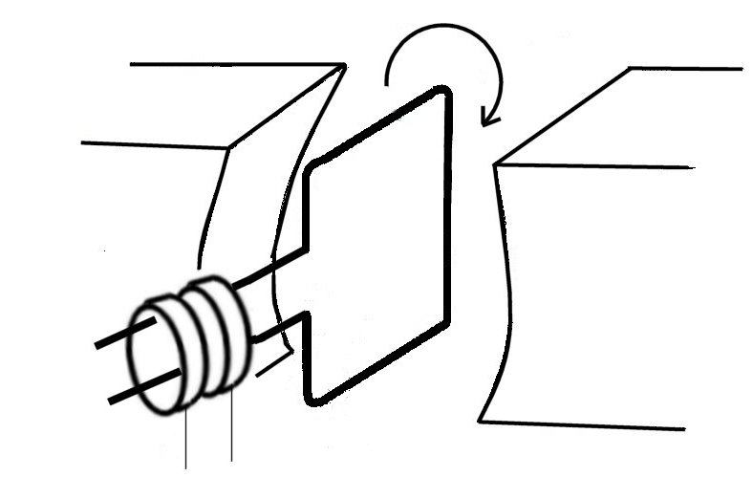
N
S
Magnetic field ✓
Current taken via slip rings ✓
Diagram ✓✓

[5]
(b) Faraday's Law: emf is proportional to rate of change of flux linking the coil ✓
Coil is rotated at a steady rate, flux through coil changes as angle of coil to field changes ✓
On each half turn the polarity of the emf changes (side of coil that was rising is now falling so direction of current reversed) ✓
Output is a continuous alternating voltage ✓
Contact via slip rings allows current to be collected while maintaining coil rotation ✓
[5]
(c) Replace slip rings with a commutator ✓ to reverse connections on each half turn
so that polarity of output remains constant ✓
[2]

Total 12 marks

16.(a) (i) Flux linkage through coil, Φ = B × area × number of turns ✓
= 5.2 × 10⁻⁵ × 3.4 × 10^{-4 ×} 1000 = 1.768 × 10⁻⁵Wb ✓
Flux changes to zero in 0.3s
emf = rate of change = 1.768 × 10⁻⁵ / 0.3 = 5.9 × 10⁻⁵V ✓
[3]
(ii) Current = V/R = 5.9 × 10⁻⁵ / 45 = 1.3 × 10⁻⁶A ✓
[1]
(b) The change in flux linkage is doubled ✓
The induced emf is multiplied by 4, i.e. rate of change of flux linkage is × 4 ✓
The time taken must be halved, i.e. time = 0.15s ✓
[3]
(c) (i)
I
t (s)
1
2

Correct axes ✓ two cycles shown ✓
[2]
(ii) Maximum current = BAN × 2πf / R ✓
= 5.2 × 10⁻⁵ × 3.4 × 10⁻⁴ × 1000 × 2π × 1 / 45 ✓
= 2.5 × 10⁻⁶A = 2.5 μA ✓
[3]

Total 12 marks

17. (a) Connect coil to a galvanometer ✓
push magnet into coil, observe deflection ✓
remove magnet from coil, observe deflection in opposite direction ✓
Induced current produces a field that opposes the motion of the magnet ✓
[4]
(b) As coil is pushed into magnet, work is done against repulsion due to field of coil ✓
Kinetic energy of the magnet is converted into electrical energy in the coil and then to KE
in the meter ✓
As coil is removed, work is done against attraction of field of coil ✓
The same energy conversion takes place ✓
In each case Lenz's Law predicts the direction of induced current consistent with the energy
transfer ✓ The opposite direction would allow energy to be created from nothing ✓
[6]

Total 10 marks

18.(a) (i) dI/dt = V / L ✓
Initially, all supply voltage is across inductor, so dI/dt = 5 / 5 ✓ = 1As⁻¹ ✓
[3]
(ii) When I = 0.3A the pd across R is IR = 0.3 × 10 = 3V
So the voltage across L is 5 - 3 = 2V ✓
dI/dt = V / L = 2 / 5 = 0.4As⁻¹ ✓
[2]
(iii) After 5s the current will have reached a steady value ✓ limited only by the resistance,
I = V / R = 5 / 10 = 0.5A ✓
[2]
(b) (i) Changing the value of R will not affect the initial rate of change of current
(supply voltage / L) ✓
[1]
(ii) I = 0.3A , IR = 0.3 × 1 = 0.3V
V across L = 5 - 0.3 = 4.7V ✓
dI/dt = V / L = 4.7 / 5 = 0.94As⁻¹
Steady current after 5s, I = V / R = 5 / 1 = 5A ✓
[2]

Total 10 marks

19. (a) (i) Ring is repelled by the coil and floats above it on the iron rod ✓
Ring becomes hot due to current circulating in it ✓
[2]
(ii) Current in coil is changing (AC)
This induces a current in the ring ✓
This current opposes the change producing it, as its field repels the field of the coil ✓
[2]
(b) (i) Hold magnet with one pole near rim of disc ✓
Move magnet round the disc, just above it. The disc follows the magnet ✓
[2]
(ii) Movement of magnet induces a current in the disc ✓
The field due to this current opposes the change producing it, i.e. the magnet moving away ✓
Thus the field of the disc is attracted to the magnet and the disc follows it ✓
[3]

Total 9 marks

