A-level Physics required practical No 9

Investigation of the charge and discharge of capacitors

NB This worksheet gives full details of the experiment, primarily for use by teachers and technicians who may be unfamiliar with the experiment. The worksheet would normally be adapted for student use to provide opportunity for students to make procedural decisions.

Materials and equipment

- Stopclock
- electrolytic capacitors ( suitable values: 1000µF, 2200µF, 4700µF)
- resistors (0.25W carbon film, values in the range 10kΩ to 100kΩ)
- battery 3V, 6V or 9V
- digital voltmeter, range 0 – 10V
- SPDT (single pole double throw) switch
- connecting leads
Technical Information

- It is essential that the electrolytic capacitors are connected into the circuit with correct polarity, as indicated on the capacitor body. The voltage rating of the capacitor should also be greater than the dc supply used.
- Resistor and capacitor values, indicated above, have been chosen to give a time constant RC in the range 10s to 500s.

Discharging a capacitor through a resistor

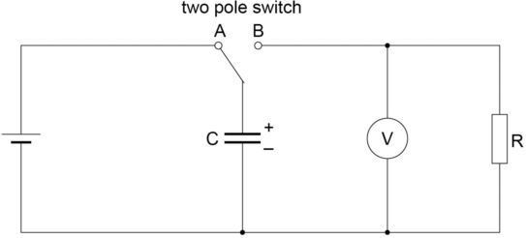

Method
- Set up the circuit as shown in the diagram (taking care to ensure the polarity of the capacitor is correct).
- With the two pole switch in position A the capacitor will charge. The internal resistance of the battery is usually enough to limit the charging current to a safe value, but allowing the capacitor to charge up almost instantly.
- The switch should now be moved to position B so that the capacitor, C, will discharge through the resistor, R. (It is well worth doing a ‘trial discharge’ at this point, to see how quick the discharge is so that a suitable time interval can be decided when taking voltage readings during the discharge process).
- After the ‘trial discharge’ move the switch to position A to charge up the capacitor.
- Switch to position B, start the stopclock, and observe and record the voltage reading at time t = 0. Continue to take voltage readings at 5s intervals as the capacitor discharges. (For a slower discharge, voltage readings at 10s intervals will be sufficient).
- Repeat the process with the same capacitor and different resistors.
- The process can also be repeated with different capacitors.
- Plot a graph of pd across the capacitor, V, on the y-axis against time, t. This should give an exponential decay curve, as given by the equation
- To confirm that this is an exponential, plot a graph of Ln(V/V) on the y-axis against t. This will give a straight line graph with a negative gradient according to the ‘log form’ of the equation V = lnV₀ - t/RC

This graph will have a gradient of

Hence the time constant RC can be determined from the gradient of the graph. If R is known, the value of C can also be found.

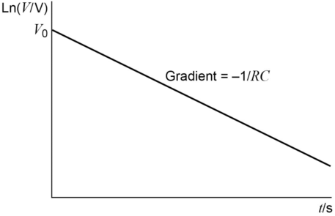

Charging a capacitor through a resistor

Materials and equipment

- Stop-clock
- electrolytic capacitors ( suitable values: 1000µF, 2200µF, 4700µF)
- resistors (0.25W carbon film, values in the range 10kΩ to 100kΩ)
- battery 3V, 6V or 9V
- digital voltmeter, range 0 – 10V
- SPST (single pole single throw) switch
- connecting leads

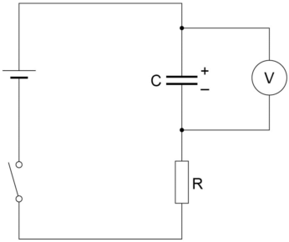

Method

- Set up the circuit as shown in the diagram. (Ensure the capacitor is connected with correct polarity). With the switch open and the capacitor initially uncharged, the voltmeter should read zero.
- Close the switch to start the charging process and observe and record the voltage across the capacitor at 5s intervals (or longer time intervals if the charging process is ‘slow’).
- Repeat with different combinations of C and R. Ensure the capacitor is completely discharged before starting each new charging process
- Plot graphs of pd, V, on the y-axis against time, t. The graph will show an ‘exponential growth’ of pd across the capacitor as it charges as given by the equation

