Investigation of the relationship between magnetic flux density, current and length of wire using a top pan balance

NB This worksheet gives full details of the experiment, primarily for use by teachers and technicians who may be unfamiliar with the experiment. The worksheet would normally be adapted for student use to provide opportunity for students to make procedural decisions.

Materials and equipment

- A 25cm length of straight bare copper wire of thickness 1.5mm, for example
- Low voltage variable DC supply (eg 0-6V)
- Ammeter (eg 0-10A with 0.1A precision or better)
- Two crocodile clips
- Two clamps on stands
- Three connecting leads
- Four magnadur magnets with a metal cradle
- An electronic top pan balance with precision 0.1g or better
- 30cm ruler
Technical Information

- High currents (up to 6A) will flow through the wire, so care must be taken as it will get warm.
- The current and field directions shown in the diagrams will give an upward force on the wire according to Fleming’s left hand rule. However, because the wire is clamped and cannot move, there will be a downward force acting on the magnets and cradle which will cause the reading on the electronic balance to increase.

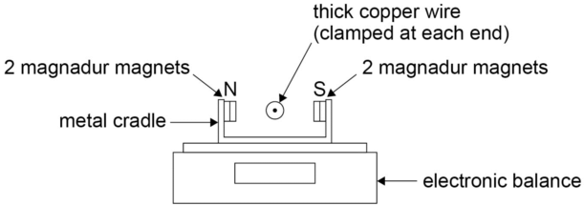

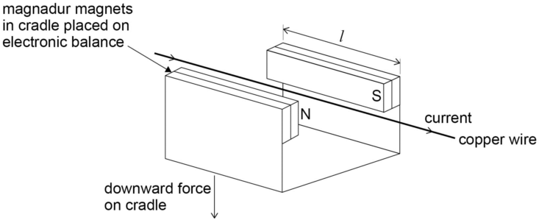

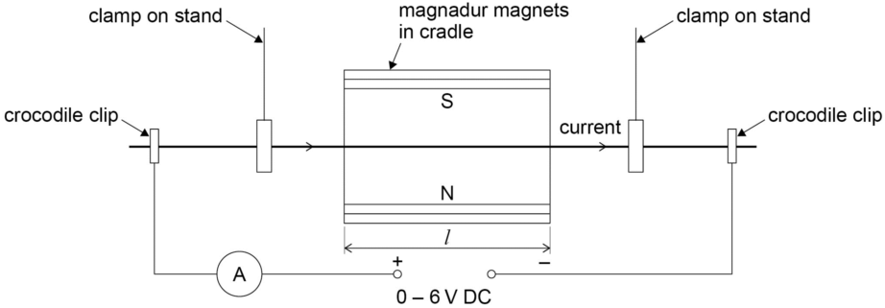

Method
- Set up the apparatus as shown in the diagrams (3 views of the apparatus have been given to make the arrangement clear).
- With no current flowing through the wire, the electronic balance should be set to zero.
- Adjust the voltage of the supply so that the current, I, flowing through the wire is 6.0A as measured on the ammeter.
- Read the top pan balance display, m, in grams.
- Repeat the procedure for I = 5.0, 4.0, 3.0, 2.0 and 1.0A.
- Obtain a second set of results by repeating the experiment and find the mean value of m for each value of I.
- Plot a graph of the mean m against I.
- Draw the best straight line of fit though the points and find the gradient (the graph should be a straight line through the origin).
- Measure the length of the magnadur magnets, L, in metres. (This will be the length of wire in the magnetic field, ignoring edge effects.)

The force on the wire is
F = BIL (where B is the magnetic flux density in Tesla).
F = mg/1000 (converting m into kg and with g = 9.81Nkg⁻¹).
Equating
BIL = mg/1000
Re-arranging
B = mg/(I x L x 1000)
The gradient of the graph gives m/I
Hence B = gradient x g/(L x1000)
The value obtained for B is typically around 5 x 10⁻² Tesla.

