A-level Physics required practical No 11

Investigation of the effect on magnetic flux linkage of varying the angle using a search coil and oscilloscope
NB This worksheet gives full details of the experiment, primarily for use by teachers and technicians who may be unfamiliar with the experiment. The worksheet would normally be adapted for student use to provide opportunity for students to make procedural decisions.

Materials and equipment
- oscilloscope
- large circular coil
- Stand (or support) for circular coil
- Low voltage 50Hz AC supply (or AF signal generator)
- Connecting leads
- protractor
- Axial or lateral search coil
- Stand, boss and clamp to support search coil

Technical Information
- The exact set up for this experiment will depend on the circular coils and search coils available in your laboratory. A large circular coil of approximately 15 – 20 cm diameter is connected to an AC supply. The search coil can be positioned to investigate the magnetic field at the centre of the circular coil.
- An oscilloscope connected to the search coil can be used to measure the induced emf, which is proportional to the magnetic field strength and flux linkage in the search coil. By tilting the search coil at different angles to the field, the variation of flux linkage with angle can be investigated.
- The circular coil can be placed flat (horizontal) on a suitable surface or mounted vertically with a stand. If you have a pair of circular coils used as Helmholtz coils, one of these could be used together with the dedicated stand which supports the coils vertically. Do not exceed the specified current rating for the coil or damage will result.
- Alternatively a circular coil can be made by wrapping about 10 turns of 0.45mm PVC covered copper wire into a coil of about 15cm diameter. This can be placed flat on the bench. A 50Hz AC current of about 5A will usually provide a sufficiently strong field at the centre of this coil. (This is similar to the arrangement suggested in the Nuffield Advanced physics course.)
- Either an axially or laterally mounted search coil can be used. The search coil can be clamped at the centre of the large circular coil. The induced emf in the search coil can be measured on the oscilloscope.
- If the induced voltage is not large enough to measure on the oscilloscope, an AF signal generator can be used with the circular coil instead of the 50Hz AC supply. The higher frequency will give a greater induced emf in the search coil. (Typically a frequency of 5 – 10kHz might be used, but some preliminary experimentation is required to find what works best with your circular coil and search coil).
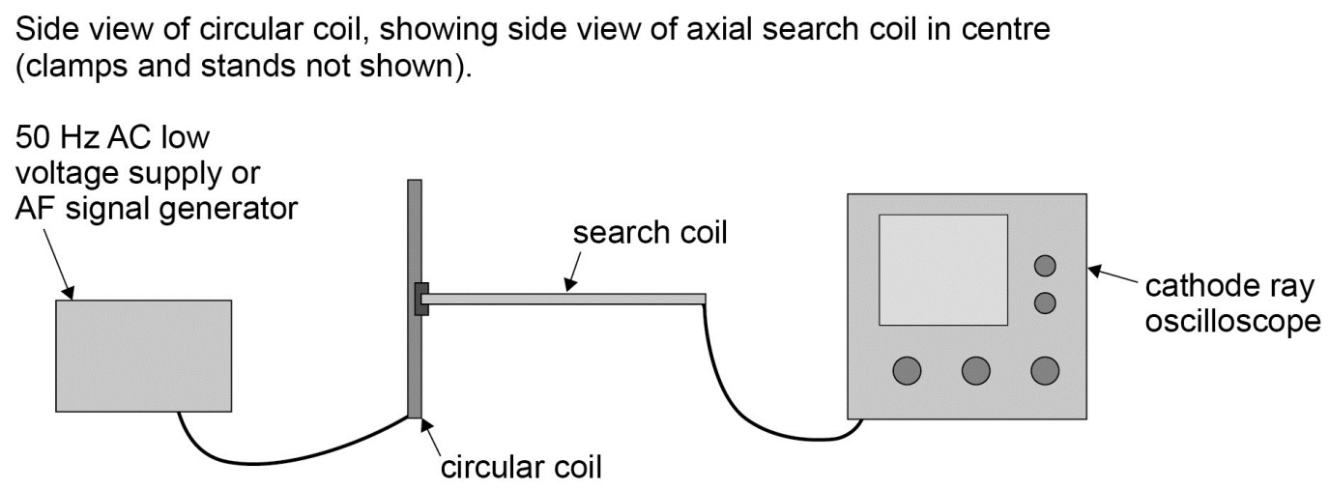
Method
- The search coil is clamped so that the plane of the coil is initially parallel to the plane of the large circular coil, and therefore perpendicular to the B-field lines produced by the circular coil, as shown in the diagram. This position will produce maximum flux linkage and maximum induced emf in the search coil.
- A preliminary experiment will be necessary to determine the appropriate voltage (and frequency) to use on the circular coil. (An ammeter might be required to ensure the current through the circular coil does not exceed the manufacturer’s specifications.) Select suitable voltage sensitivity and time base settings on the oscilloscope, to establish that the induced emf produced in the search coil is large enough to be easily measured.
- With the search coil in the initial position, as shown, record the induced emf in the search coil from the CRO display – eg by measuring peak to peak value of the induced AC voltage.
- Tilt the angle of the search coil and use a protractor to measure the angle between the plane of the circular coil and the plane of the search coil. (It might be possible to clamp a large protractor behind the search coil support rod, although students could be set the task of devising a suitable method to measure this angle). Measure the corresponding induced emf in the search coil from the CRO display.
- Repeat for a range of angles from 0º to 90º between the search coil and the the circular coil, and in each case measure the corresponding induced emf in the search coil.
- Plot a graph to show the variation of induced emf against the angle of the search coil in the field. This should be maximum for the position shown in the diagram, where the angle between the plane of the circular coil and the plane of the search coil is 0^{o.} The induced emf should be zero when the plane of the search coil is at an angle of 90º to the plane of the circular coil.

Alternative method using a Hall Probe

The variation of magnetic flux linkage with angle can easily be investigated with a hall probe. This has the advantage that the magnetic field around a permanent magnet can be investigated.

In the above experiment with the circular coil, the search coil and oscilloscope can be replaced by a hall probe and voltmeter. The hall voltage is proportional to the magnetic field strength. There is no requirement for a varying field to produce an induced emf, so a low voltage DC supply is connected to the circular coil instead of the AC supply. The probe can be placed at various angles in the ‘steady’ field at the centre of the circular coil, and the corresponding hall voltage measured.
The hall probe could also be used to investigate the variation in flux linkage with angle, using the magnetic field from a permanent magnet, as shown below. The hall probe can be rotated at varying angles in the field, and the corresponding hall voltage recorded.

