**Cinematography: Camera work and lighting.**

Consider the two different locations and how the camera angles and lighting highlight the difference.

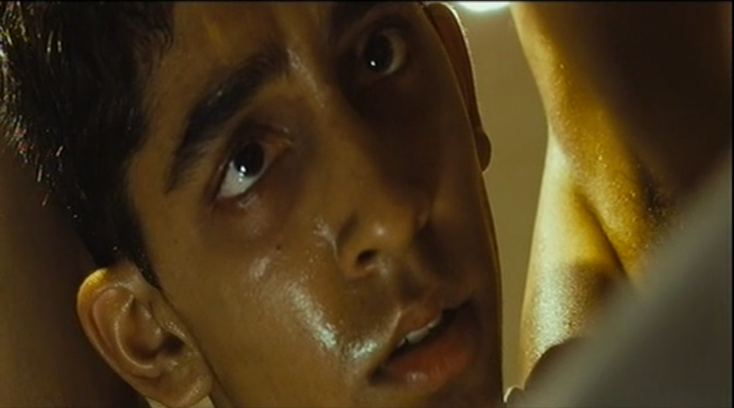

**Opening Sequence**

What themes are raised in this scene?

**Narrative**

How does the narrative make the audience feel? What happens in the plot? What narrative devices are used?

**Editing**

Pace of editing. Cross cutting between locations. Match cut editing of the slap.

**Sound**

Use of dialogue and tone of voice to add to the mood and narrative, use of music and theme tunes and how it works alongside the images.

**Mise-en-Scène**

The look of the different locations, what the costumes tell us about the different characters, the performance and how this tell us about the characters emotional state . . . .

**Aesthetics**

What is the overall mood of the scene? How is this created? Is there a particular colour palette? Consider the monochrome colour and the saturated colour.

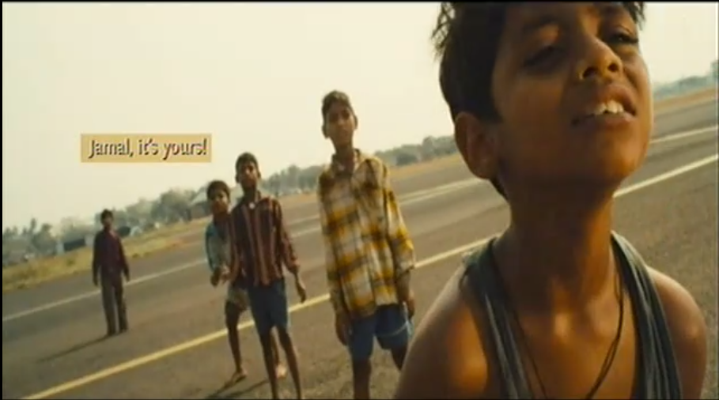

**Mise-en-Scène**

Various locations and how this paints a picture of life in the slums. Costumes of all the characters and what this tells us about them. Any props? Performance and interaction from the main characters.

**Aesthetics**

What is the overall mood of the scene? How is this created? Is there a particular colour palette?

**First flashback - slums**

What themes are raised in this scene?

**Narrative**

How does the narrative make the audience feel? What happens in the plot? What narrative devices are used?

**Cinematography: Camera work and lighting.**

Establishing shot. The POV shots. Extreme close ups. Cut away shots. Change in depth of field and comments on composition. Emotional impact on the audience.

**Editing**

Pace of the edit and choices made about which images to cut to. Any other editing effects?

**Sound**

Use of dialogue and tone of voice to add to the mood and explain the brother’s emotional state and lifestyle. Diegetic and non diegetic sound. Sound bridges? Parallel sound?