**Cinematography: Camera work and lighting.**

Consider the different locations and how the camera angles and lighting highlight the difference. Which shot encourage an emotional reaction from the viewer?

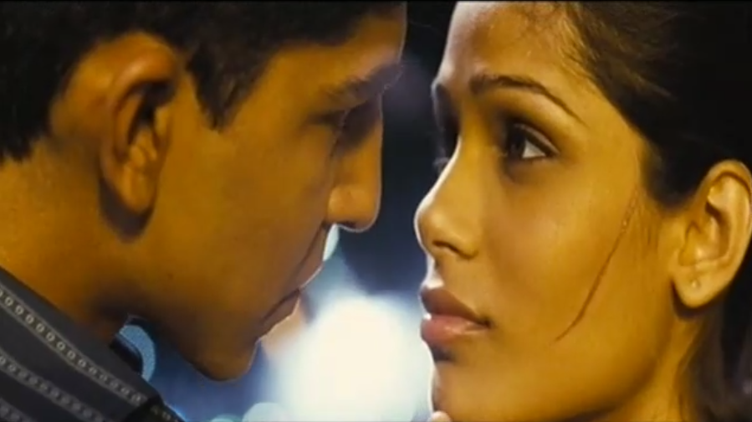

**Final Chapter**

What themes are raised in this scene?

**Narrative**

How does the narrative make the audience feel? What happens in the plot? What narrative devices are used? What does it tell us about the films resolution and overall character development?

**Editing**

Pace of editing. Cross cutting between locations. Montage sequence and the meaning it creates.

**Sound**

Use of dialogue and tone of voice to add to the mood and narrative, use of music and theme tunes and how it works alongside the images. Consider the sound track and how it add to the excitement and tension.

**Mise-en-Scène**

The look of the different locations, what the costumes tell us about the different characters, the performance and how this tell us about the characters emotional state . . . .

**Aesthetics**

What is the overall mood of the scene? How is this created? Is there a particular colour palette? Consider the colours which stand out.