**Productivity**

**1. Fill in the missing words.**

1.1 Labour productivity measures output per ________________. It is a measure of business _____________________.

1.2 Productivity is affected by the level of ______________________ in machinery and equipment, the amount and quality of staff training, and the level of employee ______________________.

1.3 If productivity rises when demand is unchanged, the likely consequence for staff is a programme of _______________________.

1.4 The formula for calculating productivity is ________________________. This shows output per worker. Number of staff employed

**HINT:** Use the following words to complete: ***efficiency, investment, motivation, output, redundancies/redeployment, worker***

**2. Calculations**

2a) Vartex employs 120 production staff. Their average earnings are £17,500 per year. This year’s output is expected to be 42,000 units.

i. Calculate labour productivity at Vartex ________________________________________________

ii. Calculate the labour cost per unit ____________________________________________________

2b) A benchmarking exercise has shown that Vartex’s most efficient competitor pays £21,000 per year to its 80 staff. The staff produces a total annual output of 48,000 units.

i. Calculate the competitor’s labour productivity ___________________________________________

ii. Calculate the labour costs per unit for the competitor _____________________________________

iii. Both firms price their goods at £59.00. Assuming there are no other costs, what profit per unit is made by each business?

_______________________________________________________________________________

1. **Capital Productivity**

Write the formula for measuring capital productivity below

________________________ =

1. **Cause and Effect.**

Some of the following statements are causes and some are effects of low productivity at a business. Others are neither. Write a C or an E by the causes and effects of low productivity. Put an N by the others.

|  |  |
| --- | --- |
| 1. High labour costs per unit | 6. Old machinery |
| 1. High automation | 7. Business is uncompetitive internationally |
| 1. Low profitability | 8. Poorly educated and trained workers |
| 1. Low morale among the workforce | 9. Prices may need to rise |
| 1. High levels of re-working | 10. Less labour required in the short term |

**5. Methods of improving productivity**

|  |
| --- |
| Make notes explaining the methods of improving productivity**:** |
| Why do businesses measure productivity? |
|  |

**Past Paper Questions**

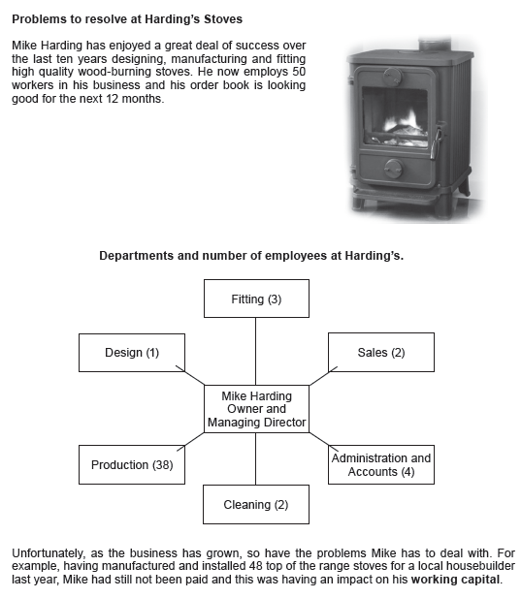

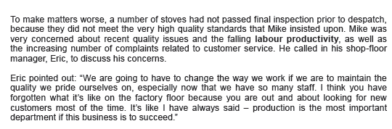



|  |
| --- |
|  |



|  |
| --- |
|  |

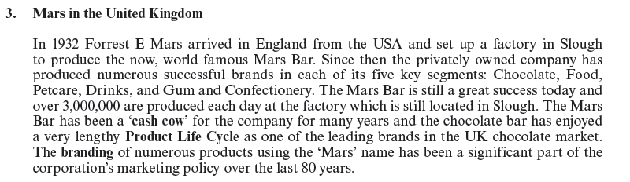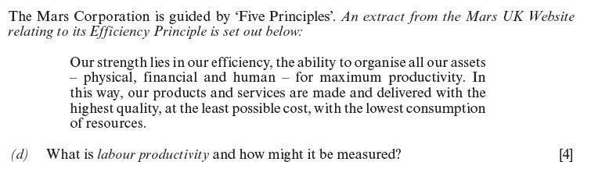

|  |
| --- |
|  |



|  |
| --- |
|  |

Added Value Question







|  |
| --- |
|  |

|  |
| --- |
|  |