CAPACITY UTILISATION

Define capacity utilisation

|  |
| --- |
|  |

What is the formula for calculating capacity utilisation?

|  |
| --- |
|  |

What are the problems of working with spare capacity?

|  |
| --- |
|  |

What are the problems with working at full capacity?

|  |
| --- |
|  |

How can a firm increase its capacity utilisation / avoid spare capacity?

|  |
| --- |
|  |

Read the Capacity Utilisation text book chapter (from page 486) and make brief notes on the following:

*Operations decisions and targets*

|  |
| --- |
|  |

Costs and capacity utilisation

|  |
| --- |
|  |

How to improve capacity utilisation

|  |
| --- |
|  |

*(Questions continue over the page)*

Past Paper Question

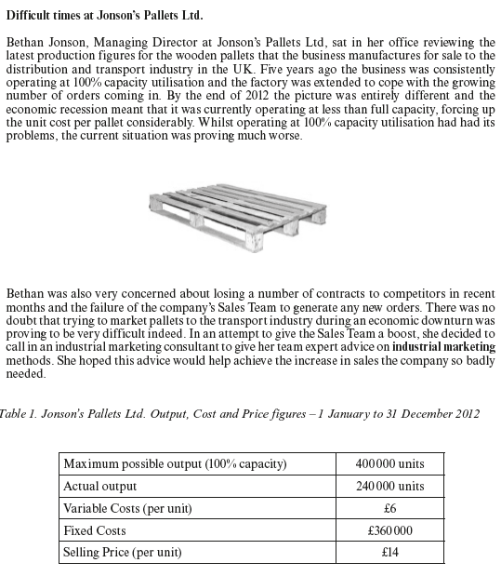

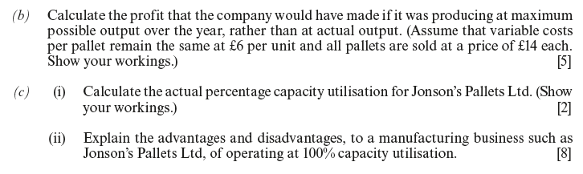

|  |
| --- |
|  |



|  |
| --- |
|  |



|  |
| --- |
|  |

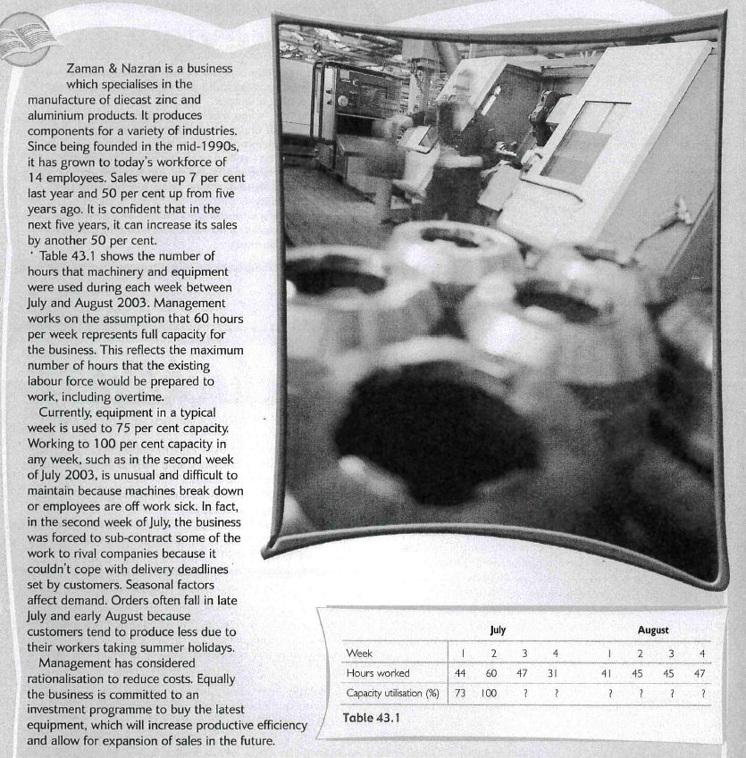

1. Calculate capacity utilisation for weeks 3-4 in July and weeks 1- 4 in August

|  |
| --- |
|  |

2. Analyse two ways in which the business could increase capacity utilisation

|  |
| --- |
|  |

