[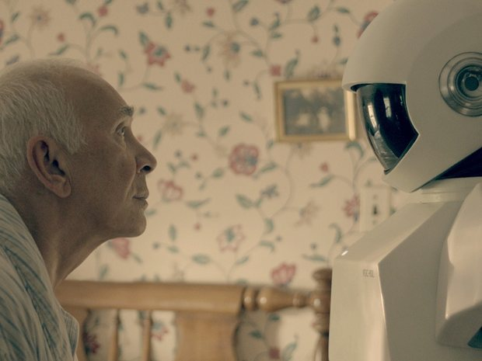](http://www.theguardian.com/commentisfree/2014/mar/22/robot-jobs-humans-used-to-do-fight-back#img-1)**When robots take our jobs, humans will be the new 1%. Here's how to fight back**

Michael Belfiore - Guardian

From assembly lines to highways, the workforce is becoming more autonomous. Good thing we're still smarter than machines

Will you be replaced by a machine? There's nearly a 50-50 chance, according to a recent study by Oxford University researchers who found that 47% of the labor market in the US alone is at risk of being mechanized out of existence. Approximately 702 jobs thus far held by humans are now threatened by non-humans, as we were reminded by a widely shared report on the study this week.

It’s not hard to see why. Advances in robotics and artificial intelligence are bringing robots into more and more workplaces. For example:

* Autonomous vehicles now in development by just about every major automaker threaten the jobs of truckers and cabbies.
* The Baxter robot from Rethink Robotics is designed to work side-by-side with human factory supervisors, learning new tasks on the go – something only human workers could do previously.
* Robotic surgeons such as those made by Intuitive Surgical and the open-source Raven project currently require human surgeons in the loop, but inroads have already been made into giving these machines autonomy as well.
* Unmanned aerial vehicles – as in, drones – are getting set for integration into the US national airspace next year, potentially replacing the jobs of many human pilots.
* My profession isn't immune to robotic outsourcing either. The Quill robotic journalist digests facts from raw data, and spits out fully formed sports and business stories.
* Oh, and Mark Zuckerberg and Elon Musk are now backing ["](http://www.theguardian.com/technology/2014/mar/21/zuckerberg-invest-startup-brain-software-vicarious)a computer that thinks like a person except it doesn't need to eat or sleep". So there's that.

There’s even a robotic burger flipper in the works. The website of Momentum Machines boasts that its slicing, grinding, frying robot can do "everything employees can do except better", and that it will "democratize access to high-quality food, making it available to the masses".

All of which begs the question: will there be anyone left who can afford those better burgers, or will everyone be out of work? And what the hell are we supposed to do about the inevitable rise of the machines?

The march of the worker drones *does* seem inevitable, and not just into specialized job functions. The Pentagon's mad-science research arm, Darpa, is currently hosting the Darpa Robotics Challenge for the creation of humanoid robots capable of working in disaster areas that are too dangerous for humans. These all-purpose machines are designed to let themselves into buildings and pick up and use whatever tools are at hand there – indeed, to do the things we cannot.

At the Darpa trials in Miami a few months ago, I watched one of the 16 struggling 'bots stare for 10 minutes at a door handle, apparently uncertain what to do with it. The machine *looked* capable enough: two arms, two legs, about six feet tall, a head studded with sensors. But it was definitely lacking in the brains department. Still, the program manager at Darpa in charge of the operation imagines future versions serving as in-home aides for the elderly or disabled. The robots are in the primitive, baby-step stages right now, but things can move quickly when it comes to Darpa robotics programs.

Autonomous vehicles, for example, went from being unable to complete a course through open desert in the Darpa Grand Challenge, to deftly navigating simulated city streets – complete with human-driven traffic – in three short years. Three US states and the District of Columbia have [already passed legislation](http://www.slate.com/blogs/future_tense/2013/11/22/autonomous_car_legislation_backs_google_s_vision_of_the_future_over_ford.html) regulating robotic cars on public roads.

Sooner or later, it seems, robots will have staged a takeover not only of our workplaces, and streets, but also of our homes. What then?

As early as the 1960s, Arthur C Clarke, professional visionary and inventor of the communications satellite, predicted the end of menial labor (mental as well as manual), due to mechanization (and, more disturbingly, bio-engineered apes). In his essay The World of 2001, originally published in Vogue and reprinted in his book The View from Serendip, Clarke wrote: "the main result of all these developments will be to eliminate 99 percent of human activity … *if* we look at humanity as it is constituted today."

Our salvation, in Clarke's view, will lie in our looking toward loftier pursuits than all those kinds of jobs that machines will take over:

In the day-after-tomorrow society there will be no place for anyone as ignorant as the average mid-twentieth-century college graduate. If it seems an impossible goal to bring the whole population of the planet up to superuniversity levels, remember that a few centuries ago it would have seemed equally unthinkable that everybody would be able to read. Today we have to set our sights much higher, and it is not unrealistic to do so.

Of course this depends on our valuing, as a society, individual knowledge, creating thinking, curiosity and all the other things that elevate us above the level of machines. It depends on our fostering the kind of society that not only frees people from menial labour, but also enables them to reach their full human potential – not just go begging for want of a lousy job.

How many ways can a cook contribute to society other than flipping burgers? What can a sportswriter do beyond coming up with endless variations on "beat," topped", "outshot" and "defeated"? It's about time to find out.

Technology

**Read the text book chapter p 512 – 518 to help you complete the workbook**

1. What is the difference between invention and innovation?

|  |
| --- |
|  |

1. State 4 areas (or functions) of a business that might benefit from new technology, with reasons

|  |
| --- |
|  |

1. Define the terms and describe the use of CAD, CAM and robotics in industry

|  |
| --- |
| CAD means:  How CAD is used in industry: |

|  |
| --- |
| CAM means:  How CAM is used in industry: |

|  |
| --- |
| Robotics means:  How Robotics are used in industry: |

1. How has information technology been incorporated in production?

|  |
| --- |
|  |

1. How has new technology benefitted (a) business owners; (b) management?

*Benefits to business owners:*

*Benefits to business management:*

1. Explain the problems that (a) workers and (b) management may face with the introduction of new technology

*Problems faced by workers:*

*Problems faced by managers:*

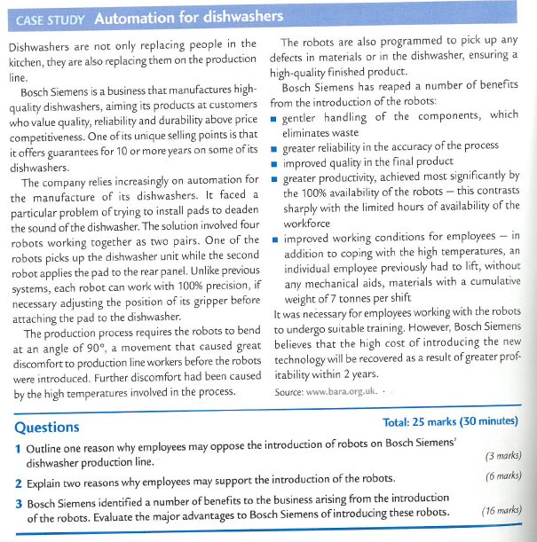

1. Outline one reason why employees may oppose the introduction of robots on Bosch Siemens’ dishwasher production line

|  |
| --- |
|  |

2. Explain two possible reasons why employees may support the introduction of the robots

|  |
| --- |
|  |

3. Bosch Siemens identified a number of benefits to the business arising from the introduction of the robots. Evaluate three major advantages to Bosch Siemens of introducing these robots.

|  |
| --- |
|  |

50/50 additional reading

**Automation could replace 1.5 million jobs, says ONS**

* 25 March 2019

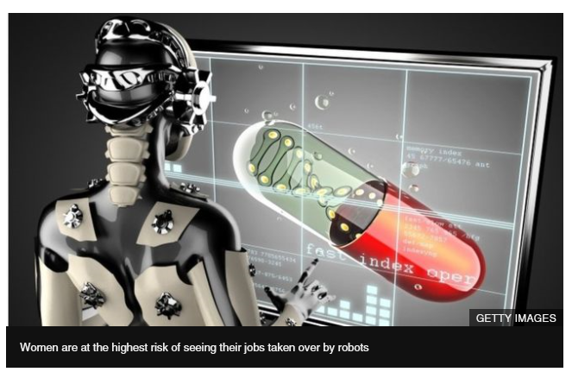

**Some 1.5 million people in England are at high risk of losing their jobs to automation, according to the Office for National Statistics (ONS).**

It says 70% of the roles at high risk of automation are currently held by women. Part-timers and the young are the next most at risk.

The ONS analysed the jobs of 20 million people in 2017 and found 7.4% of these were at high risk of being replaced.

[**It has developed a "bot"**](https://www.ons.gov.uk/employmentandlabourmarket/peopleinwork/employmentandemployeetypes/articles/whichoccupationsareathighestriskofbeingautomated/2019-03-25) to show the risks for particular occupations.

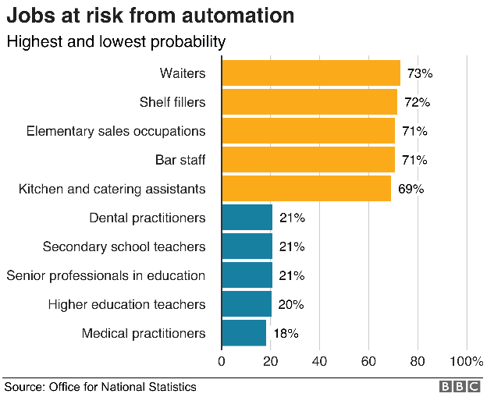The ONS defines automation as tasks currently carried out by workers being replaced with technology. That could mean computer programs, algorithms, or even robots.

The three occupations with the highest probability of automation are waiters and waitresses, shelf fillers and elementary sales occupations, all of which are low-skilled or routine.

Those at the lowest risk are medical practitioners, higher education teaching professionals, and senior professionals in education.

"It is not so much that robots are taking over, but that routine and repetitive tasks can be carried out more quickly and efficiently by an algorithm written by a human, or a machine designed for one specific function," the ONS said.

It added it had looked into the automation of jobs as it could have an impact on the labour market, economy and society.

The ONS says there are fewer jobs at risk of automation now than was thought in 2011, from 8.1% to 7.4%, but the proportion of jobs at low and medium risk of automation has risen.

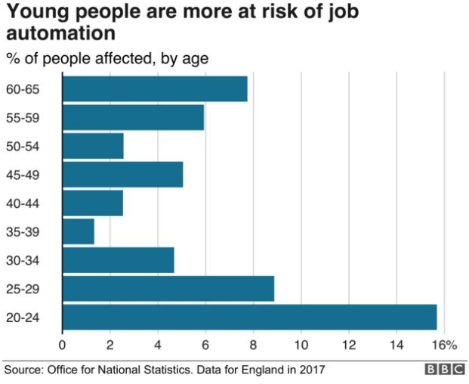It says the exact reasons for the decrease in the proportion of roles at high risk of automation are unclear, but it is possible that automation of some jobs has already happened: "For instance, self-checkouts at supermarkets are now a common sight, reducing the need to have as many employees working at checkouts."

The statistics body says that while the overall number of jobs has increased, the majority of these are in occupations that are at low or medium risk.

That suggests, it says, that the labour market may be changing to jobs that require more complex and less routine skills.

Maja Korica, associate professor of organisation at Warwick Business School, said: "What is most concerning is the speed at which the biggest players are introducing these changes.

"If you take a company like Amazon, it introduced more than 50,000 new robots in 2017, a 100% increase from the previous year. Estimates suggest 20% of its workforce may already be made up of robots.

"Policymakers and business leaders need to be thinking about how they work together to deal with these problems."

**Analysis:**

**By Jonty Bloom, business correspondent**

Automation is not just about robots or self-driving cars, it can also involve computer programs and algorithms, but the message from this analysis is clear: the better trained and educated you are the lower are the chances of you losing your job.

So although all those self-check-out terminals at your supermarket are taking a lot of work and jobs from shop staff, the head of marketing at Sainsbury's is probably safe; for now.

It is routine and repetitive tasks that are better done by a machine, be it adding up long columns of numbers or filling boxes with baked beans, but it is also true that more and more complicated tasks can and are being broken down into a series of simple tasks, each of which can be done by a machine that needs no training, holidays, tea breaks or sick leave.

So increasing numbers of factory workers are at threat of losing their jobs, even if they are highly skilled and that also means that the young are worst affected.

After all, experience, qualifications and promotion all take time, the longer your career the more likely it is you are doing a job that is safe from the rise of the machines.