Operations Management

Lean Production

Define lean production

|  |
| --- |
|  |

Explain what is meant by “waste” in lean production

|  |
| --- |
|  |

Lean production involves a range of techniques. Use the exam board notes and the text book chapter to briefly summarise each of the techniques below. You summary should include:

* + Explanation of the key elements of each method
  + 2 advantages of using the method
  + 2 disadvantages of using the method

|  |
| --- |
| Cell production: |

|  |
| --- |
| Time based management: |

|  |
| --- |
| Benchmarking: |

|  |
| --- |
| Kaizen: |

|  |
| --- |
| Just in time: |

What is required to implement lean production in a business? Give examples

|  |
| --- |
|  |

What are the general benefits of adopting lean production methods?

|  |
| --- |
|  |

In the space below, make notes on the lean production methods used at the BMW mini plant in Oxford

Watch: [estream.godalming.ac.uk/View.aspx?ID=880~3D~mOKLCd](http://estream.godalming.ac.uk/View.aspx?ID=880~3D~mOKLCd)

|  |
| --- |
|  |

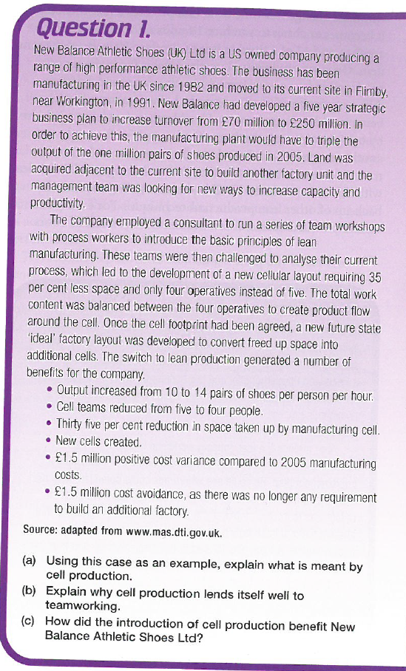

Answer all questions (a, b and c) in the space below: