**Week 3 Physical Development**

**Name: Date:**

**Physical development in the EYFS**

Physical development is a prime area in the Early Years Foundation Stage. It is an important area for children’s development. If you work in an early years setting or are studying childcare, read on for tips to support the children you work with.

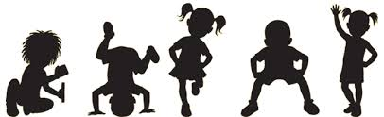

**Physical development and the EYFS**

Physical development is one of the three prime areas within the [**Early Years Foundation Stage**](https://www.gov.uk/government/publications/early-years-foundation-stage-framework--2) (EYFS). Each prime area is divided into Early Learning Goals, for physical development these are:

* **Moving and handling** - skills enabling children to show good control and coordination in large and small movements. Children are able to handle equipment and tools effectively, including pencils for writing.
* **Health and self care** - children knowing the importance of good health which includes physical exercise and a healthy diet. Children are able to manage their own basic hygiene and personal needs successfully, including dressing and going to the toilet independently.
* 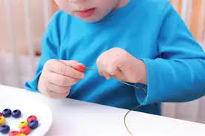 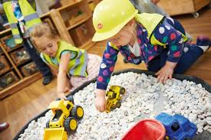

## Best practice and activity ideas

The Department of Health say to aim for at least three hours of physical activity across the day for children in the early years. But every movement counts and you don't need to plan extra activities, just make the most of everyday opportunities. For example when you're changing toddlers' nappies, encourage them to lie down and get up themselves as this helps to strengthen their core muscles and to support and develop their balance and coordination.

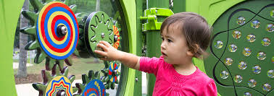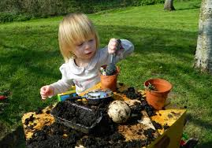

Encouraging children to walk up and down stairs by themselves is another good opportunity (it's challenging so they may need your support). And help children learn to use alternate feet by making sure there are opportunities in your setting for them to climb. Try starting off with having large blocks for the children to crawl, walk and climb up and over and when they're more confident, provide stilts so that they can get used to moving their feet at different times.

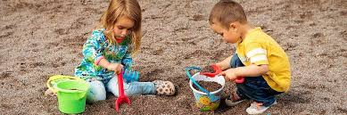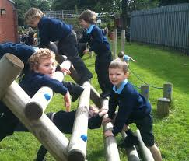

Let babies and children feed themselves finger foods as this helps to promote fine motor skills like grasping and hand-eye coordination (just be aware of choking hazards).

If you're new to working in early years you may not be familiar with some words/term so here's a handy guide:

* **Cruising** - when a child walks or moves along using furniture for support.
* **Fine motor skills** - when a child uses precise movements using specific body parts, such as the thumb and finger to pick objects up.
* **Gross motor skills** - when a child uses their whole body in a movement, such as jumping or running.
* **Hand-eye coordination** - when a child's hands and eyes are working together, for example catching a ball.
* **Mark making** - this could be anything, from a baby or child making marks with their fingers in sand, to dipping their hands or fingers in paint, to paint a picture.
* **Pincer movement** - when a child uses an index finger and thumb, to pick up and move objects.
* **Tummy time** - placing a baby on their tummy with engaging toys, lights, mirrors, or you to look at. This can help the baby build gross motor skills as they improve neck, back and arm strength from this position. Short, frequent sessions of tummy time will eventually help support a baby to crawl. During Tummy Time a baby can learn to kick their legs and flap their arms. They can reach and do push ups when they are strong enough. Eventually, they'll learn to roll over to their back from their tummy.

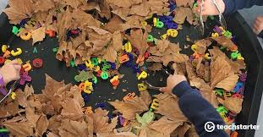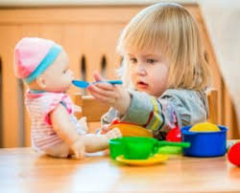

Follow the link below to print off this leaflet by the Department for Health. It includes different activities you can do with children to support their physical develoment.

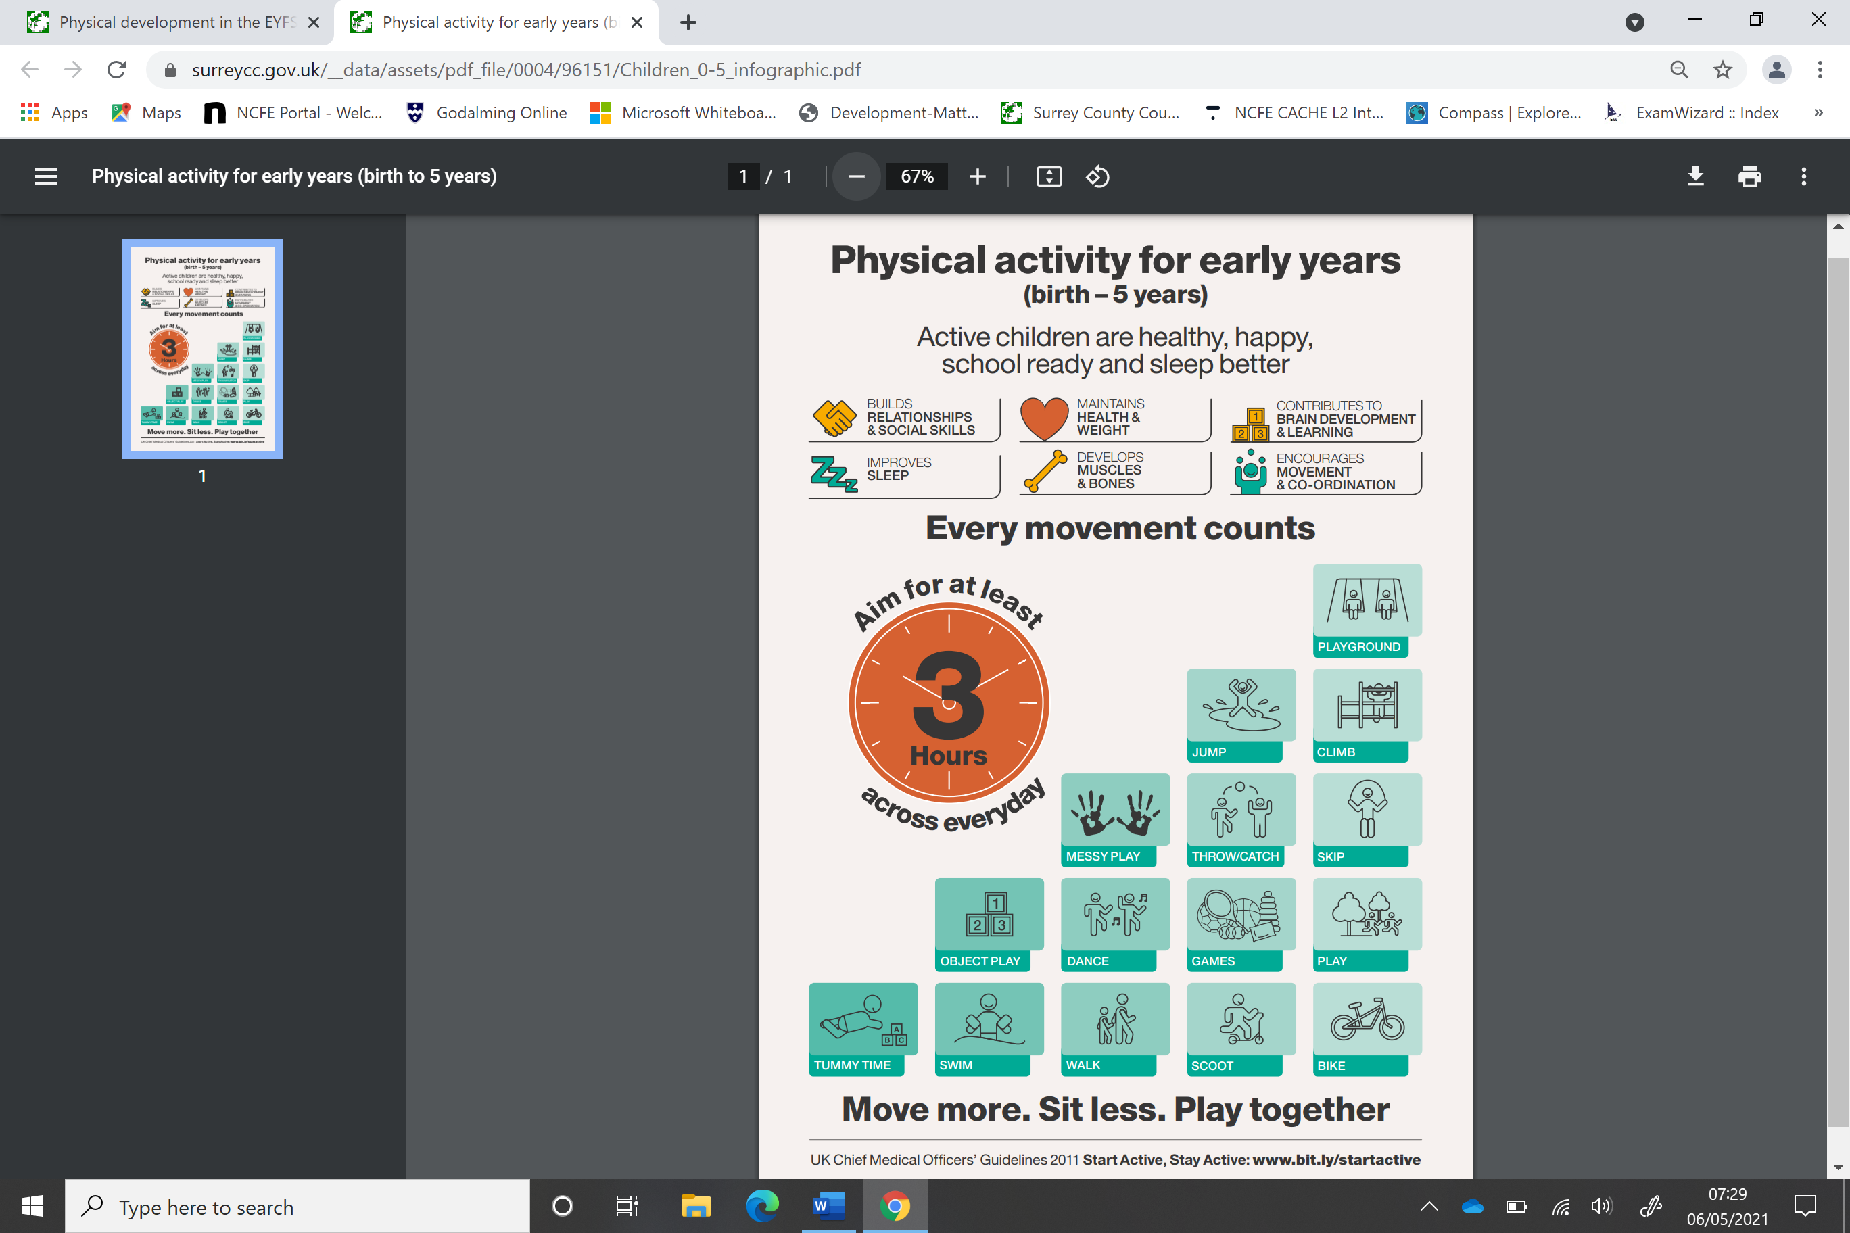

<https://www.gov.uk/government/collections/physical-activity-guidelines>

**Describe what physical development is:**

What are gross motor skills?

What are fine motor skills?

***Find a suitable quote about physical development and write it into the bubble***

**Quote:**

**Who is the quote from?**

**What is your understanding of this quote?**

Make a list of games and activities that you could do with babies and children to support their **physical development skills**. Use textbooks, handouts, your imagination and the internet for ideas.

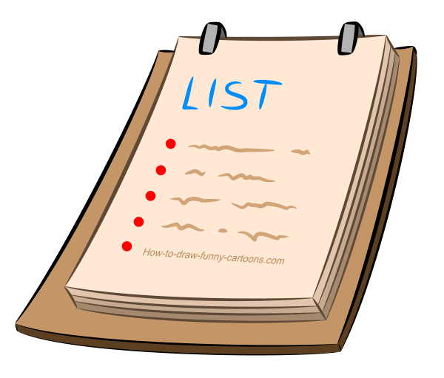

|  |  |
| --- | --- |
| **Age Group** | **Games and Activities** |
| Babies  6 months to 1 year |  |
|  |  |
| 1 to 2 years |  |
| 2- 3 years |  |
|  |  |
| 3-4 years |  |
|  |  |
| 4- 5 years |  |

**My Physical Development Chart**

What can I do physically from birth to 6 months?

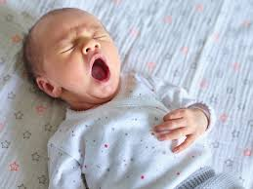

What can I do physically from 6 months to 1 year?

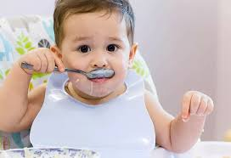

What can I do physically from 1 to 2 years?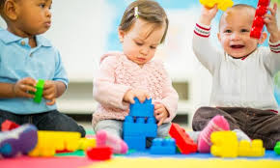

What can I do physically from 2 to 3 years? 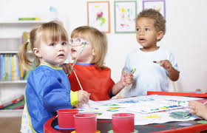

What can I do physically from 3 to 4 years? 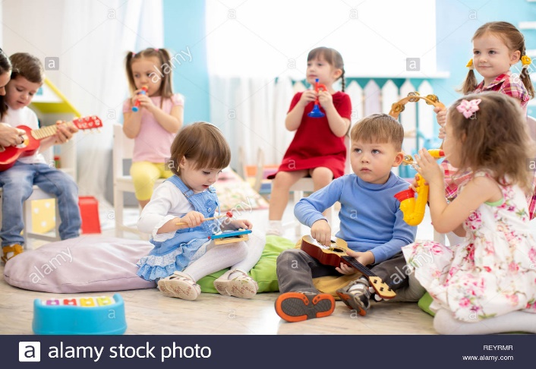

What can I do physically from 4 to 5 years?

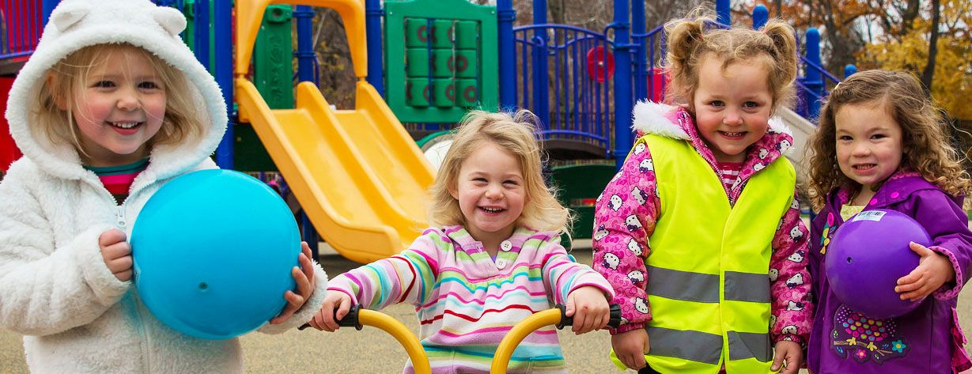

**ASSIGNMENT WORK:** Now complete the ‘Physical Development Table’ in your Assignment D1 and save your work.

**Look at these activities and identify how they support children’s all round development?**

**Yoga for babies and children**

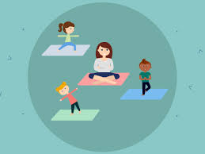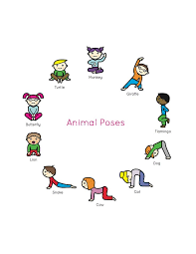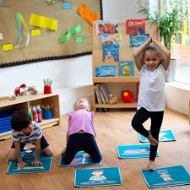

Physical Development:

Intellectual Development:

Language Development:

Social Development:

Emotional Development:

**Outdoor play**

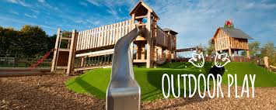 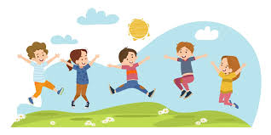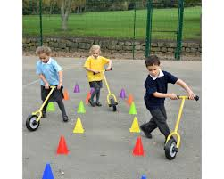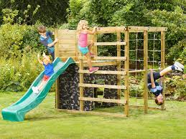

Physical Development:

Intellectual Development:

Language Development:

Social Development:

Emotional Development: