Quality

Use the exam board notes, lesson slides and textbook pages to help you complete all sections of this workbook

1. What is quality?

|  |
| --- |
|  |

1. What is quality assurance? When does it occur (in the production process)?

|  |
| --- |
|  |

1. Describe the following quality assurance methods:

|  |
| --- |
| Teamworking: |

|  |
| --- |
| Production control: |

|  |
| --- |
| Product design checking: |

|  |
| --- |
| Benchmarking: |

|  |
| --- |
| Recognised standards: |

1. What is quality control? When does it occur (in the production process)?

|  |
| --- |
|  |

1. What does TQM stand for and what does it involve?

|  |
| --- |
|  |

1. What is the difference between quality assurance and quality control?

|  |
| --- |
|  |

7. How is quality achieved in the different functional areas (purchasing, operations, human resource, finance, marketing)?

|  |
| --- |
|  |

# Quality activity

## Read the following statements

## Then identify where they belong in the table

|  |  |  |  |
| --- | --- | --- | --- |
|  | TQM | QC | QA |
| Definition |  |  |  |
| Pros |  |  |  |
| Cons |  |  |  |

|  |  |  |  |
| --- | --- | --- | --- |
| 1. Can be used to guarantee that not many defective items will leave the factory | 1. Does not promise a high quality product, only a high quality reliable process. | 1. To imbed this into the culture of the business may be expensive as it requires training of all staff. | 1. Leaving quality for the inspectors to sort out may mean poor quality is built into the product. |
| 1. Customers like the reassurance provided by a badge such as ISO9000 | 1. Based on the inspection of the product or a sample of products | 1. Should become deeply rooted into the company culture | 1. At first, staff are likely to be sceptical of management initiatives may treat it as ‘hot air’. |
| 1. Once all staff think about quality it should show through design to manufacture to aftersales service. | 1. Require little training therefore suits a business with untrained or temporary staff. | 1. A system that assures customers that detailed systems are in place to govern quality at every stage. | 1. May encourage compliancy; it suggests quality has been sorted. |
| 1. This is an approach to quality that   aims to involve all employees in  the quality improvement process | 1. Cannot be trusted when it is based on sampling *i.e. test just 1 of 7 new cars* | 1. Ensure the company has a quality system for every stage in the production process |  |

Past paper question practice

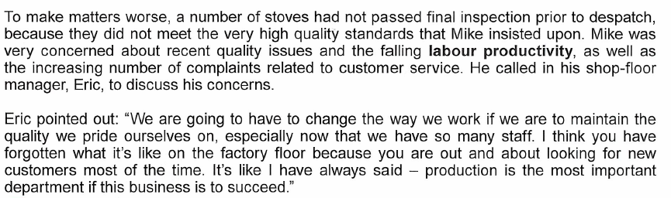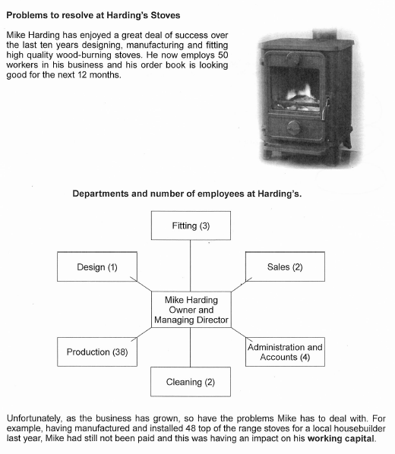

(go to next page for question)

1. Explain ways in which Harding’s Stoves can try to ensure that it maintains its reputation for providing its customers with quality goods and services. [8]

|  |
| --- |
|  |