**Unit 2 Development and well-being 0-5 years**

**Assignment D7 and C1**

|  |  |
| --- | --- |
| **Name:** | **CACHE Pin No:** |
| **Start Date:** | **Hand-in Date:** |

Criteria 5.1: Identify different transitions that children may experience.

Criteria 5.2: Identify the possible effects of transitions on the development of children.

**For this assignment you will create an Information Booklet about transitions that children may experience.**

**Your guide will need to include the following:**

* *An* ***Introduction Page e*xplaining** in your own words what ‘transitions’ are when working with children in an early year’s setting.
* *Include a referenced definition of the word ‘transition’.*
* Identify **4 different** transitions that children may experience and provide an **explanation** of each one (use a separate page for each one). Give at least one example of how early years workers can support the child in the setting.
* *Finally,* **explain how children’s development may be affected** when they experience these transitions.

**Bibliography:**

Penny Tassoni and Louise Burnham (2017), Cache Level 2 Award in Child Development and Care. Hodder Education

**Remember to gain higher marks for a C grade:**

6-7 marks: mainly correct; more depth; may give relevant examples of practical situations

8 marks: a fuller explanation; showing a wider level of understanding; may include relevant examples

9 – 10 marks: may link experience to theory or current research

**D7 Unit 2 - FEEDBACK and GRADE**

|  |  |  |  |  |
| --- | --- | --- | --- | --- |
| **Criteria** | **Feedback Comments for Unit 1 - Assignment D7** | **1st Marker Grade** | **2nd Marker Grade** | **2nd Marker Comments** |
| **D7** |  |  |  |  |

**C1 Unit 2 - FEEDBACK and GRADE**

|  |  |  |  |  |
| --- | --- | --- | --- | --- |
| **Criteria** | **Feedback Comments for Unit 1 – Assignment C1** | **1st Marker Grade** | **2nd Marker Grade** | **2nd Marker Comments** |
| **C1** |  |  |  |  |

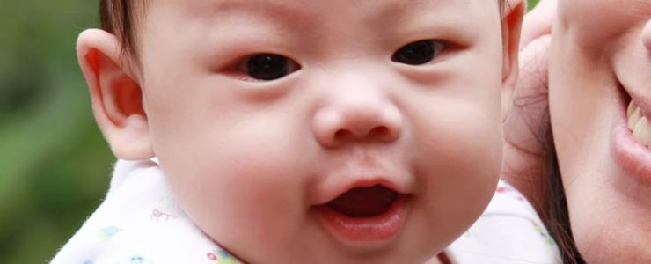

# **Transitions**

Children’s lives today are so much more hectic than ever before.  Going to a setting for the first time, moving to another one, starting school or moving into a new class are seen by many people as a normal part of the lives of children. Yet transitions are milestone events for children and have a definite effect on their development. They are times of exciting change certainly and times of new opportunities and growth for every child. They can also be times of uncertainty where surroundings are not the same, expectations and procedures different and faces as yet unfamiliar. Getting transition right is vital for every child and is not a single event that merely ‘happens’. Transition should be viewed as a process rather than an event that involves children, practitioners and parents together. Transition has been described as an ongoing journey rather than a destination.

### ****Transition into Reception classes****

Transition is always about change; particularly adjusting to change – and successful change is about then forgetting that the change happened. When young children move from a pre-school environment such as from home or a childminder or a daycare setting into a school environment they will experience huge change in their lives. This change is often accepted by adults with little idea of what the change will mean for the child. This is simply because adults often take things for granted – so a parent or teacher might unwittingly fail to recognise what is involved for the child. If transition is to be successful, from pre-school to school, preparation should begin early so that there is good communication between the two organisations. This needs to be considered carefully by leaders who will decide how best to support the transition process.

### ****Transition into Key Stage 1****

Through the EYFS children are entitled to a curriculum that is based on what interests them and what they already know, can do and understand. Year 1 teachers build on these starting points and continue to nurture children’s natural desire for learning. As they continue their journey into Year 1 consideration should be given to what children experience as similar in Reception and Year 1 classes and how this can be developed further. This should include consideration of physical resources such as sand, water and construction and opportunities for learning through first hand-experiences. There should be opportunities for children to initiate activities themselves and to follow up their own interests independently. Headteachers and senior managers influence smooth transitions from the EYFS to Key Stage 1 through school organisation, staffing, resourcing and the transfer of information about children’s learning. Parents should be encouraged to continue to be involved as partners in their children’s learning.

<https://www.earlyyearsmatters.co.uk/eyfs/positive-relationships/transitions/>

**Transitions**

There are many types of transitions in a child’s life. Big transitions such as moving house or starting childcare for the first time, and smaller ones during the day such as moving from an activity to snack or mealtime. Transitions can be stressful for children and adults, and helping children cope with them and make them as smooth as possible will help their future resilience to change.

<https://www.pacey.org.uk/Pacey/media/Website-files/PACEY%20member%20practice%20guides%20(PDFs)/PG10-transitions-and-settling-in.pdf>