Purchasing and Stock Control

Past Paper Questions

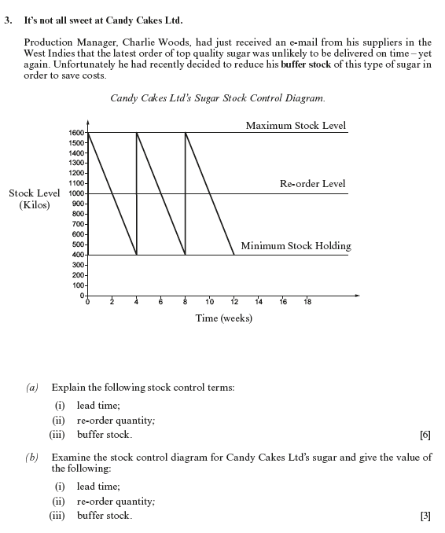

|  |
| --- |
| (i)  (ii)  (iii) |



|  |
| --- |
| (i)  (ii)  (iii) |



  
  
  



  
  
  