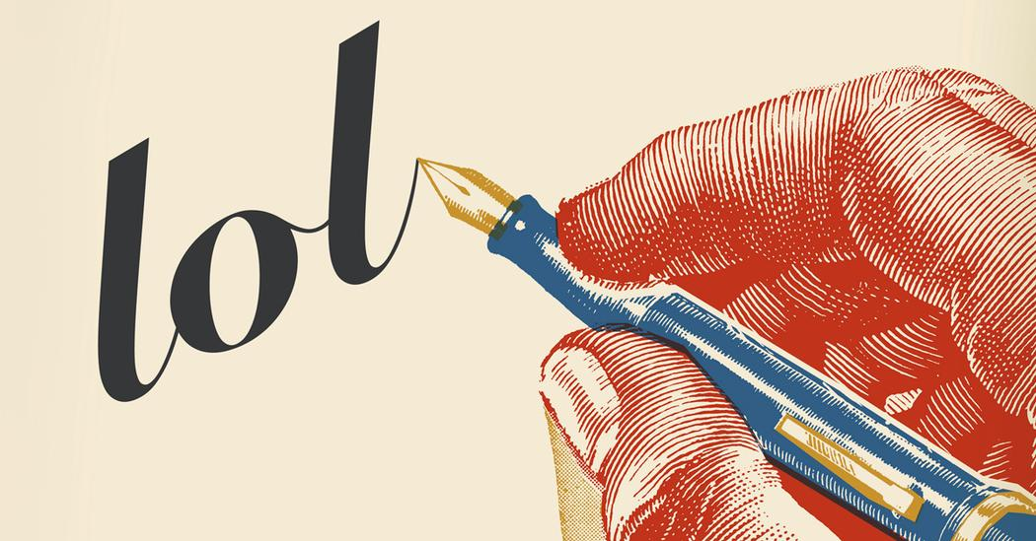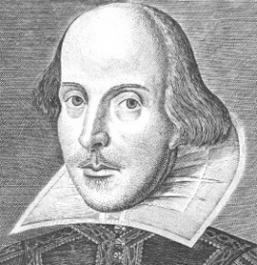

**LANGUAGE CHANGE**

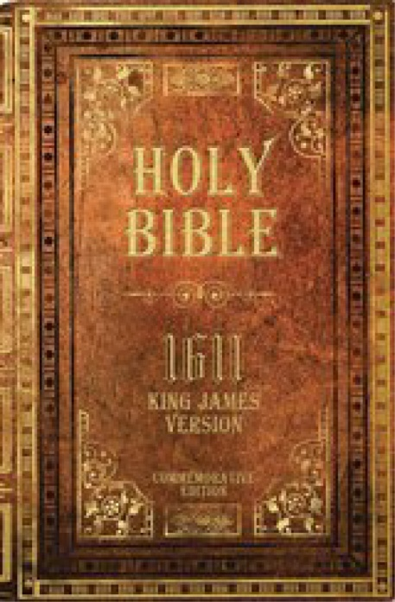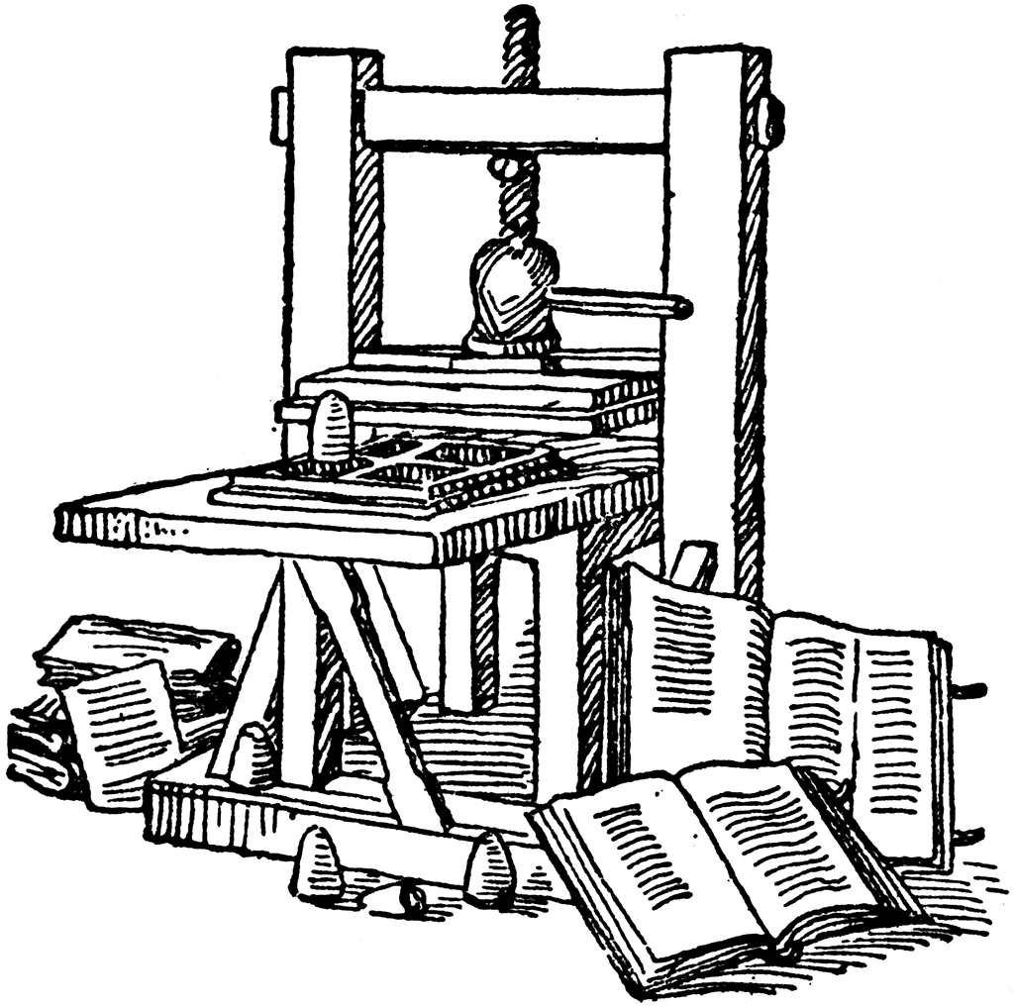Revision Guide

**Language Change in Context**

**Consider the following contexts and how language change would have occurred in them:**

**1. Language and Law (Forensic Linguistics)** e.g. laws, statutes, wills. Remember legal language has undergone a limited degree of change over the centuries due to the large amount of **French-Latinate lexis** in the field. There are many debates surrounding the **accessibility** of legal language. The **passive voice** is often used. The key functions of legal language are to be **referential** (to convey information), **persuasive** and **metalinguistic** (to discuss language itself). There are **archaic features**, **few contractions**, **punctuation is used sparingly** and **collocations** e.g. *it shall be deemed*.

**2. Language and Politics** e.g. political speeches, House of Commons extracts, political propaganda, elections’ leaflets. The key functions of political language are to be **referential** (informative), **persuasive** and **rhetorical**. Although language is primarily **formal**, a change to **informal language** can be used for effect. Use of **formulaic utterances** e.g. *I beg to move* and **address terms** e.g. *the Right Honourable Lady*. **Conceptual metaphors** are often used e.g. *flood of immigrants* as well as **rhetorical devices** e.g. anaphora, hyperbole, etc.

**3. Language and Religion** e.g. Bible extracts, morality guide books, prayers. The key functions of religious language are to **uphold spiritual belief**, to be **persuasive**, **expressive** and **prescriptivist**. Religious language (like legal language) is seen to be often **inaccessible**. Often **formal phrases/idioms** (e.g. *in the beginning*), **formulaic expressions** (e.g. *Amen*), **antithesis** (e.g. *heaven and hell*) and naming of the godhead (e.g. *Lord*). **Metaphors**, **personification** and **symbolism** are used as a rhetorical function.

**4.** **Reclamation of Language & Language of Minorities** e.g. song lyrics, political liberation extracts, speech communities. Women, LGBT+ (Lesbian, Gay, Bisexual, Trans*), BME (Black and Minority Ethnicities), age, disability, mental health are all areas of society which have undergone **progressive language change** to liberate these minorities. In many cases they have reclaimed language used in a derogatory way by the majority e.g. use of *queer*

**5. Taboo** **Language & Political Correctness** e.g. television/radio extracts, business/institution guidelines, language of humour. What individuals find **taboo** has changed significantly over time. A much larger proportion of young people use **swear words** as a form of **bonding**. Taboo language is very **context-dependent** as to whether you threaten somebody’s **face** (Brown & Levinson, 1987). **Political correctness** is where the state has the power to **exert control** over language to **protect** others.

**6. Language of Teaching & Education** e.g. Ofsted inspections, students’ reports, newspaper articles. Comment on how **schools** and **colleges** are much more open and **descriptivist** environments rather than **prescriptivist**. Use of education-specific lexis which is often **Latinate**. The involvement of **government** and the requirement for learning to be more **tangible** and to incorporate **differentiation** rather than **standardisation**.

**7. Language of Romantic Relationships** e.g. love letters, love poetry, diary extracts, internet dating profiles. Comment on how the language of romantic relationships has changed from following **literary conventions** from the Romantic/Renaissance periods to now a rather **functional/transactional process** – how **societal attitudes** have pressured individuals to conform to the norms of how to communicate with each other including **address terms** e.g. *darling, babe*. Link this to Language and Gender/Brown & Levinson’s Politeness Theory. Consider the **language of breaking up** and whether there is **finality.** Also **limited apologies**/**self-deprecatory comments**.

**8. Language of Family Relationships** e.g. advertising, problem letters, government initiatives. Think about how the **family unit** has changed dramatically over time – an increase in the number of **single parent** and **same-sex parent** families. Link with **Child Language Acquisition.** Consider how children speak to their parents now vs. previous decades. How has **linguistic authority** from parents diminished? Children/parents may now discuss topics and issues that were previously never disclosed.

**9. Global English: English as a Native Language (ENL)** – American English, Australian English, New Zealand English, South African English, Canadian English.

**10. Global English: English as a Second Language (ESL)** – West Africa, Southern Africa, East Africa, South Asia, South East Asia & The Pacific, The Caribbean.

**11. Language and Technology** e.g. social media web pages, electronic instruction manuals, blog articles, online retailing. Consider how technology has influenced language change linking to topic last year. The large amount of **neologisms, eponyms, proprietary names** and **IT jargon** are important discussion points. Also think about words that have undergone **semantic broadening** including technology definitionse.g. think of how *click, browse, scroll, file* are all **polysemic** (have multiple meanings).

**12. Language of Advertising** e.g. product adverts, experience advertorials, editorials, posters/flyers, job vacancies. Consider how this language is **persuasive** and link to Language and Power (**synthetic personalisation**) and Language and Gender (**gender roles**). Think about the large number of **acronyms** for greater efficiency and the **reduction of text** and **increase in visual content**. Language has to be **accessible** to a **mainstream audience** – consider how that term has broadened from **white upper/middle class families** to an eclectic mix of individuals from all **races and social backgrounds**.

**1. Middle English Period (1350 – 1500):**

> **Emergence of Standard English**

> **Hundred Years’ War (1337 – 1453)** – dynastic conflict between the **French** and the **English** crown. Nationalistic sentiment after the war led to resentment towards France with French no longer a realistic language choice for the English nobility. French was only used by the educated in high society as a matter of culture and fashion rather than economic or political necessity (from Norman Invasion 1066)

> **Peasants’ Revolt (1381)** – labour shortages gave the peasants a stronger bargaining position; increased geographical mobility. Rise of commoners to positions of leadership and authority in public service e.g. Henry VII filled his officers increasingly with the **growing middle class**. Social upheaval was part of the rise of capitalism.

> **War of the Roses (1455 – 1485)** – **House of York vs. House of Lancaster**. House of York was supported by commercial classes in London. House of Lancaster supported religious/language change but introduced the poll tax. Henry VII (a Lancastrian and a Tudor) created centralisation of power. A standard language started to emerge in the 14th C.

> **Lollardy** – challenged the role of **Latin** in the **Medieval Church** due to the language being accessible to only the few but with control over the many. Major part of the movement was **John Wycliffe’s** translation of the Bible into English (1382). It was resisted by the authorities but indicated presence of a growing reading public.

> **Parliament** used French until about 1423 for petitions. From 1485 on English and French were used and only in English after 1489. The turning point seemed to be during the reign of **Henry V** due to the victory over the French at **Agincourt**.

> English was used officially by the **royal bureaucracy** after 1420.

> The earliest known **will** in English is recorded as 1383 with Latin remaining the **language of record**.

> **New Standard** – From the beginning of the 13th C, people from all over England were moving to London and bringing their widely divergent dialects with them. This was due to London being the centre of government and administration, trade and commerce.

> **Drive to Standardisation** – **Levelling**: London vernacular was no longer a Southern variety but more a Midlands one laced with Northern features; **Chancery English**: written language promoted by government administration. Contributed greatly by **Caxton’s printing press** in 1476. Teaching in English was introduced in mid 14th C and rule of law by 1385. English was used in law courts of London in 1356.

> **Impact of Great Vowel Shift** – attributable to greater social mobility and partially due to migration. Also due to upper classes emphasising variants of vowels to maintain distinction from the lower classes. **Wave theory**: as particular speakers and speech communities gained in power and prestige, the language variants they used were adopted in neighbouring areas.

> **Borrowings** – from Flemish, Dutch and Low German. Large number from French & Latin.

**2. Early Modern English Period (1500 – 1700):**

> Growth of a **national market**; competition between countries. Land enclosures carried out meaning **privatisation** of the commons (more beneficial for the better of). This contributed to **social unrest** of the period with depopulation of villages (**urbanisation**).

> **King** replaced **Pope** as **Head of Church**; religious movements included **Puritanism** (growing concerns of the **middle class**)and **Quakerism** (concerns of **lower classes**).

> Renewed interest in **classical learning** (**Renaissance**); science became more **empirical**; beginning of a literary boom (Shakespeare, Marlowe, Milton). Shakespeare coined new words e.g. *eared* (conversion), *green-eyed*(compound), *glisters*(blend). Literacy started to spread and significance of the press grew.

> Key conflicts based on religion included the **English Civil War** (1641 – 1649), **Commonwealth** (1649 – 1653) and the **Protectorate** (1653 – 1659). Consequences of the Commonwealth and Protectorate included promoting **godliness**, closing theatres and laws against adultery, blasphemy and religious education.

> **Royalists** (aristocracy) wanted to maintain **feudal order** (King > Nobles > Peasants)vs. **Parliamentarians** (middle class) who wanted to secure more **democratic** control through Parliament. Continuing **weakening power** of the monarch

> Restoration ended ill feeling toward foreign ideas – French ideas and social ideals as well as **French borrowings** were once again in fashion

> **Standardisation** – **written English** lost almost all of its regional features reinforced by the introduction of **printing**. The Standard was a Southern variety rather than Northern or Western found among the **well-bred** and **well-educated** in London. This ruled out speakers of **regional dialects** who were viewed as vulgar, effeminate or affected. **Prescriptivism** took on a greater force after 1660 (as a result of Commonwealth/Protectorate).

> **Latin** maintained as language of record and also **scholarship**. English was not considered to have the **fixity of morphological and syntactic form** that was desirable for a language meant to convey scientific and scholarly thought. Latin used mainly in domain of law.

> **Grammatical change** – more rigid word order; do-periphrasis (auxiliary verb e.g. I **do** like going to the seaside); shift from the gender system to one based on the feature; new neuter possessive form (*its*); **demonstrative pronouns** (including *yonder*)

> **Lexical change** – *you* started to replace *thou* as a singular form; growth of **compounds**; plural alternation of <f> with <v> (*wife/wives*); hierarchical address terms (*Lord/Lady*)

> **Orthographical change** – high degree of regulation of orthography; toleration towards alternative spellings; capitalisation of most prominent words (nouns); respect for learning and recognition of etymologies of numerous words (spellings became more Latin-like); contractions reached their peak (e.g. *&*); phonetic spellings; retention of older spellings

> **Borrowings** – many were tied to specific fields (e.g. science, medicine, religion). Backlash against number of borrowings (Inkhorn terms) regarded as obscure, affected, pompous.

> **Semantic change** – examples include *secure* (carefree > fixed/fastened); *enthusiasm*(religious fanaticism > eager enjoyment); *ringleader*(leader > initiates illegal activity).

**3. Late Modern English Period (1700 – Present):**

> **Act of Union** (1707) creates **United Kingdom** linking **Scotland** with England and Wales. This has later been followed by **political devolution** in Scotland and Wales (although no movement to raise Scots to a national language unlike Welsh).

> **Second Act of Union** (1801) links **Ireland** to United Kingdom before Republic of Ireland separated in 1922.

> Continuation of **urbanisation** and **industrialisation** leading to impoverished urban class and overpopulation. Urbanisation led to **higher rates of literacy** – by the 1840s, majority of population could read and write. Expanding **publishing market** geared to cheap books and newspapers with high entertainment value.

> Building of **canals and railways** after 1750 – development of regional and supraregional markets, greater labour force mobility in a money economy. New industrial centres in the **North East** (mining) and in the **West Midlands** (textiles).

> Migration to **North America** and **immigration** from trade. Weakening of the **rural, traditional dialects** and an upsurge of **new urban varieties** through the process of **dialect levelling**. Local consciousness and pride in vernacular language/culture illustrated in pamphlets (class solidarity).

> **Grammatical change** – **Standard English** existed as a monument to the new unity of the nation and ensured that innovations of the Early Modern English period were maintained. These included: completion of *you* as a second person singular; present tense plural *are* for previous *been*; use of **relative pronouns** (*who* for persons, *which* for other nouns); reduction of **demonstrative pronouns** from three to two (*yonder* disappeared); adoption of **standardised spelling and punctuation**

> **Standard English** – emerged as a **national language** of the UK. Expectation that the standard should be learnt and used by everyone led to 2 problems: readiness to extend English to speakers of other languages (e.g. Welsh) which was **systematically repressed**; misapprehension that the use of Standard English correlated with **intelligence**. With spread of primary and secondary education, **traditional dialects were** **marginalised**. They became increasingly associated with **poor education** and **lack of sophistication.**

> **Codification** – **prescriptivist** project aimed to **purify and fix** the language affecting pronunciation, grammar, spelling and vocabulary. Widespread feeling that good grammar and good morals were connected. Grammarians prescribed **correct language** for getting ahead in London society. Advent of **grammars, orthoepy books** (correct pronunciation) and **dictionaries** e.g. *Dictionary of the English Language* (**Samuel Johnson, 1755**).

> **Vocabulary** – expansion of vocabulary due to **linguistic and cultural contact** leading to the adoption of **new words and expressions**. **Differentiation** due to class, gender, ethnicity, age

> **Orthographical change** – move to lower case letters for all but **proper nouns**; the long **ʃ** disappeared; the *k* at the end of words disappeared e.g. *teutonic(k)*. Standard English continues to give preference to etymological spellings to increase **inter-linguistic intelligibility**. Retains silent letters such as *r* in *car* – universal spelling conventions

**Language Change Terminology**

**1. Semantic Change:**

* **Amelioration** – a word’s meaning has become more positive over time e.g. *sick*
* **Pejoration** – a word’s meaning has become more negative over time e.g. *bitch*
* **Broadening** – a word’s meaning becomes broader or is extended over time e.g. *holiday* used to refer only to religious festivals (holy day) and now applies to any break
* **Narrowing** – a word’s meaning becomes narrower or more specialised over time e.g. *meat* used to refer to any kind of food but now refers only to the flesh of an animal
* **Weakening** – a word loses its power e.g. *epic* is increasingly used to refer to day-to-day experiences rather than extraordinary ones

***Metaphorical Change*:**

* **Metaphor** – a word acquires new meanings because it is used metaphorically e.g. *bug* now means ‘to annoy somebody’ or ‘a fault in a system’
* **Euphemism** – a way of describing something unpleasant in a more pleasant manner e.g. *passed away* for ‘death’
* **Dysphemism** – a derogatory or unpleasant term used instead of a pleasant or neutral one e.g. *going for a dump* for ‘going to the toilet’
* **Idiom** – a speech form, or an expression, that can’t be understood literally from the meanings of the individual parts e.g. *pull your socks up* for ‘try harder’

**2. Lexical Change:**

* **Derivation** – adding affixes (prefixes and suffixes) to an existing word e.g. *un*pleasant
* **Compounding** – two words are joined together to form a new word e.g. *classroom*
* **Blending** – two words are moulded together to form a new word e.g. *motor* and *hotel* = *motel*
* **Clipping** – removing a section of a word to shorten it e.g. *intro* for *introduction*
* **Conversion** – changing a word class e.g. *Google* (noun) > to Google (verb)
* **Acronym** – taking the initial letters of words and making them into a combination pronounceable as a new word e.g. *NATO*. **Initialisms** are when acronyms are not pronounceable as a new word e.g. *lmk*
* **Coinage** – this is the process of adding new words (**neologisms**) to a particular language. They are usually formed from brand names e.g. *nylon* and/or named after a particular individual (**eponyms**) e.g. *Sandwich*. **Proprietary names** is when the name given to a product by one organisation becomes the commonly used name for the same product e.g. *Hoover* when referring to any vacuum cleaner
* **Borrowing** – a process of integrating vocabulary from other languages into a particular language e.g. *bungalow* is from Indian origin

***Orthographical Change:*** a word’s spelling changes over time e.g. *trowsers* > *trousers*

**3. Grammatical Change: Key areas to focus on are:-**

* **Negation** e.g. *I know not*
* **Auxiliary verbs** e.g. do-periphrasis (using ‘do’ for emphasis) *I* ***do*** *like treacle*
* **Passive voice** e.g. *The letter was opened by the clerk.*
* **Pronouns** e.g. *yonder, thou*
* **Prepositions** e.g. ***at*** *London*
* **Contractions** e.g. *can’t* for *cannot*

***Syntactical Change:*** how word order changes over time

**4. Graphological Change:** how the layout/structure of the text has changed over time (**discourse**)

N.B. Always leave graphological change until the end in your exam. Generally, the exam board will award fewer marks for this as this could be identified by individuals who haven’t studied English Language at A Level and does not illustrate linguistic rigour.

**5. Diachronic Change:** refers to the study of historical language change occurring over a span of time

**6. Synchronic Change:** refers to an approach that studies language at a theoretical point in time without considering the historical context

**7. Prescriptivism** – an attitude to language use that makes judgements about what is right and wrong and holds language up to an ideal standard that should be maintained

**8. Descriptivism** – an attitude to language use that seeks to describe it without making value judgements