Worksheet 5: Input - output devices Answers

**Task 1 Reading barcodes**

Barcode readers or scanners are used to read barcodes on supermarket products, library books, and for tracking packages during shipping for example.

The Code-128 system can represent all alphanumeric characters. The UPC-A barcode below contains guard bars and represents numeric values only.

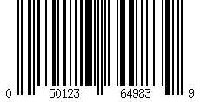

|  |  |  |  |  |  |  |  |  |  |  |  |  |  |  |
| --- | --- | --- | --- | --- | --- | --- | --- | --- | --- | --- | --- | --- | --- | --- |
|  |  |  |  |  |  |  | **0** |  |  |  |  |  |  |  |
|  |  |  |  |  |  |  |  |  |  |  |  |  |  |  |
|  |  |  |  |  |  |  | **1** |  |  |  |  |  |  |  |
|  |  |  |  |  |  |  |  |  |  |  |  |  |  |  |
|  |  |  |  |  |  |  | **2** |  |  |  |  |  |  |  |
|  |  |  |  |  |  |  |  |  |  |  |  |  |  |  |
|  |  |  |  |  |  |  | **3** |  |  |  |  |  |  |  |
|  |  |  |  |  |  |  |  |  |  |  |  |  |  |  |
|  |  |  |  |  |  |  | **4** |  |  |  |  |  |  |  |
|  |  |  |  |  |  |  |  |  |  |  |  |  |  |  |
|  |  |  |  |  |  |  | **5** |  |  |  |  |  |  |  |
|  |  |  |  |  |  |  |  |  |  |  |  |  |  |  |
|  |  |  |  |  |  |  | **6** |  |  |  |  |  |  |  |
|  |  |  |  |  |  |  |  |  |  |  |  |  |  |  |
|  |  |  |  |  |  |  | **7** |  |  |  |  |  |  |  |
|  |  |  |  |  |  |  |  |  |  |  |  |  |  |  |
|  |  |  |  |  |  |  | **8** |  |  |  |  |  |  |  |
|  |  |  |  |  |  |  |  |  |  |  |  |  |  |  |
|  |  |  |  |  |  |  | **9** |  |  |  |  |  |  |  |

**Left Right**

|  |  |  |  |  |  |  |  |  |  |  |  |  |  |  |  |  |  |  |  |  |  |  |  |  |  |  |  |  |  |  |  |  |  |  |  |  |  |  |  |  |  |  |  |  |  |  |  |  |  |
| --- | --- | --- | --- | --- | --- | --- | --- | --- | --- | --- | --- | --- | --- | --- | --- | --- | --- | --- | --- | --- | --- | --- | --- | --- | --- | --- | --- | --- | --- | --- | --- | --- | --- | --- | --- | --- | --- | --- | --- | --- | --- | --- | --- | --- | --- | --- | --- | --- | --- |
|  |  |  |  |  |  |  |  |  |  |  |  |  |  |  |  |  |  |  |  |  |  |  |  |  |  |  |  |  |  |  |  |  |  |  |  |  |  |  |  |  |  |  |  |  |  |  |  |  |  |
|  |  |  |  |  |  |  |  |  |  |  |  |  |  |  |  |  |  |  |  |  |  |  |  |  |  |  |  |  |  |  |  |  |  |  |  |  |  |  |  |  |  |  |  |  |  |  |  |  |  |
| Left  Guard | | | **0** (Start) | | | | | | | **5** | | | | | | | **9** | | | | | | | **2** | | | | | | | **7** | | | | | | | **3** | | | | | | | Middle Guard | | | | |

1. The grid below represents the left hand side of a standard UPC-A barcode.   
   Shade in the bars according to the code patterns in the left side of the chart above.
2. Each dark line in the barcode is represented by the binary value ‘1’ and each light line is represented by the binary value ‘0’. Thus, the number 7 (appearing on the left) has the following pattern and a binary representation of 0111011:

|  |  |  |  |  |  |  |
| --- | --- | --- | --- | --- | --- | --- |
|  |  |  |  |  |  |  |
| **0** | **1** | **1** | **1** | **0** | **1** | **1** |

Give the binary interpretation of the following barcode:

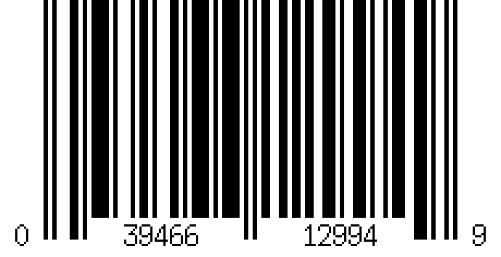

Left: 0111101/0001011/0100011/0101111/0101111

Right: 1100110/1101100/1110100/1110100/1011100

1. Use an online barcode generator (such as [www.barcode-generator.org](http://www.barcode-generator.org)) to create a UPC-A barcode for the product code number:

**3 9 4 6 6 1 2 9 9 4**

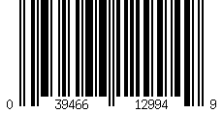

**Task 2 Scanners and cameras**

Two-dimensional scanners can be used to scan a text document. The resulting image of the text document can then be converted back into live text for editing within a Word Processor. This uses a process called Optical Character Recognition or OCR.

|  |  |  |  |  |  |  |
| --- | --- | --- | --- | --- | --- | --- |
|  |  |  |  |  |  |  |
|  |  |  |  |  |  |  |
|  |  |  |  |  |  |  |
|  |  |  |  |  |  |  |
|  |  |  |  |  |  |  |
|  |  |  |  |  |  |  |
|  |  |  |  |  |  |  |
|  |  |  |  |  |  |  |

**R**

1. Describe how a scanner can recognise a character of text using OCR technology.

Each character will be stored in computer memory (as a grid of pixels). When a code is scanned in, the pattern is searched from the stored data.

A handheld digital camera includes face detection technology which can be used to recognise if a person’s face is within the frame and adjust the focus on the face.

1. Explain one factor that could cause the camera to fail to recognise a face in the picture?

If the person was wearing hat/glasses or had facial hair.

**Task 3 Operation of laser printers**

A laser printer is about to print out a document. The table below lists 12 steps that need to occur to print the document. They are not in the correct sequential order.

Put the numbers 1 to 12 in the first column to show the correct sequence of steps.

|  |  |
| --- | --- |
| **Order of step** | **Steps** |
| **6** | As printer drum rotates, a laser beam scans across it removing the positive charge in certain areas; this leaves negatively charged areas which match the text or images to be printed |
| **12** | At the very end of the printing process, a discharge lamp removes the electric charge from the drum making it ready for the next page |
| **4** | Data sent to printer and then stored in a printer buffer |
| **1** | Data to be printed is first sent to the printer driver |
| **8** | Negatively charged sheet of paper is then rolled over the drum |
| **11** | Paper goes through a fuser which melts the ink making a permanent copy |
| **3** | Printer driver checks the status of the printer (e.g. is the printer out of toner?) |
| **2** | Printer driver puts data into a format that the printer can process |
| **7** | Printer drum is coated with positively charged toner; it only sticks to the negatively charged parts of the drum |
| **5** | Printing process starts by giving printer drum a positive charge |
| **9** | Toner on the drum now sticks to the paper producing exact copy of the text and images |
| **10** | To prevent paper sticking to the drum, electric charge is removed once the page has been printed |

**Task 4 Radio frequency ID**

A passive RFID chip inside a travel pass is used to board a bus as an electronic ticket. Complete the table to correctly place each of the steps on the diagram below.

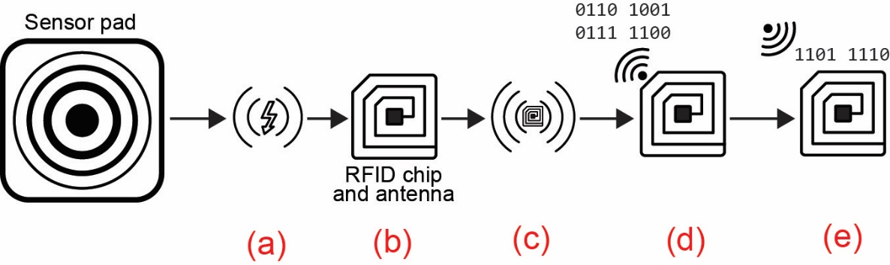

|  |  |
| --- | --- |
| **Step** | **Position** |
| RFID chip is able to receive updated data | e |
| Sensor pad emits radio energy | a |
| RFID chip is able to send identification data | d |
| RFID antenna picks up radio waves | b |
| RFID chip becomes energised | c |