# Worksheet 6 Secondary storage devices

# Task 1 Hard drive operation

1. A hard disk uses an electromagnet to change the polarity of ferrous (iron) particles on the platter.

1. Label the diagram below with the following descriptions:

**Read / write head Cluster of four sectors**

**Disk constantly spinning at 5400 – 7200rpm Platters**

**Head moves radially across disk Sector**

**Concentric tracks Magnetic surface**

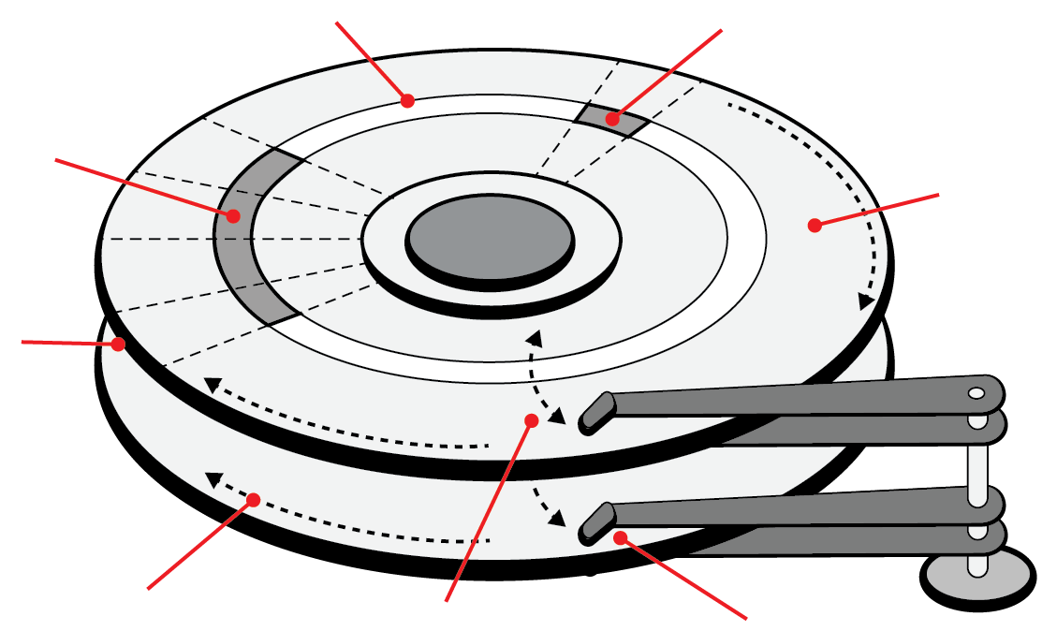

1. Data is written to a disk as the write head creates patterns of positive and negative polarity in the magnetic particles on the disk. A change in the polarity from one particle to the next is detected by a read head and interpreted as a binary 1. No change in polarity is interpreted as a 0.

Reading **from left to right** as the disk spins, what would the two 8-bit binary strings be read as, in the diagram below? The first four bits have been completed for you.

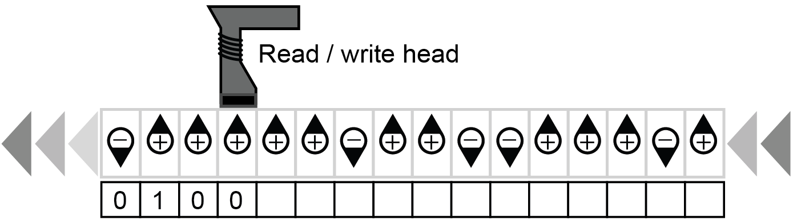

1. Using 8-bit ASCII codes, what characters are ‘stored’ on the hard disk?

# Task 2 Reading a CD-ROM

A CD-ROM is pressed at the point of manufacture with pits in the disks surface before a clear, protective coating is applied. This media relies on a low-powered laser projected from underneath the disk to read data. Look at the section of a disk below and manually read the stored binary data.

1. Read the start or end of a pit as a 1. Anything else is a 0.

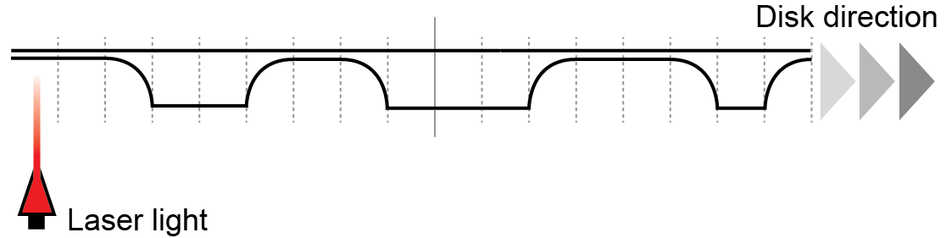

1. Convert each byte into its decimal equivalent.

# Task 3 Solid state memory

1. Solid state media commonly uses Flash NAND memory cells. Data is stored using floating gate transistors that can trap and store a charge, indicating a binary 0.

Data is stored in blocks consisting of several pages. Unlike a hard disk, a solid state disk cannot overwrite existing data so old data must be erased before writing new data.

Simulate a write operation to write new data 0010 into the first page of block 1 below.

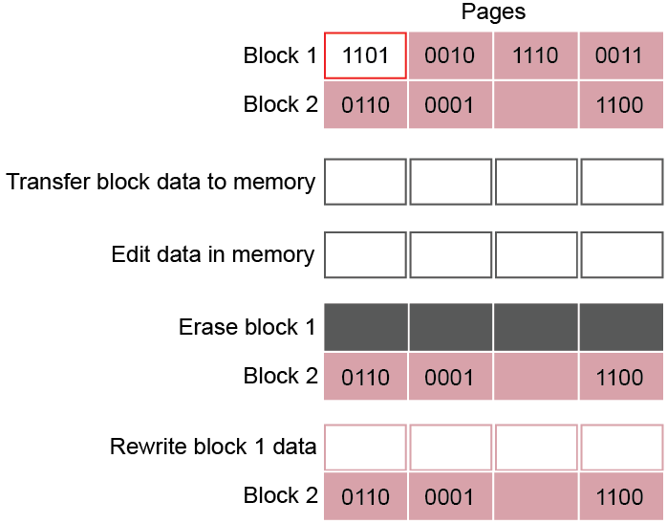

Step 1: Write in the binary data to transfer all block data to memory:



Step 2: Write the new page data (0010) in memory:



Step 3: Erase block 1 and rewrite block data in the blank spaces:

