**3.1.5.1 The concept of hazard in a geographical context**

***This is what the exam board says you should know:***

* **Nature, forms and potential impacts of natural hazards (geophysical, atmospheric and hydrological).**
* **Hazard perception and the factors that determine a person’s perception.**

**Key terms:**

**Hazard Natural hazard Disaster Risk Vulnerability**

**Write down all the words and different events you can think of associated with this term:**

Hazards

**Types of natural hazard**

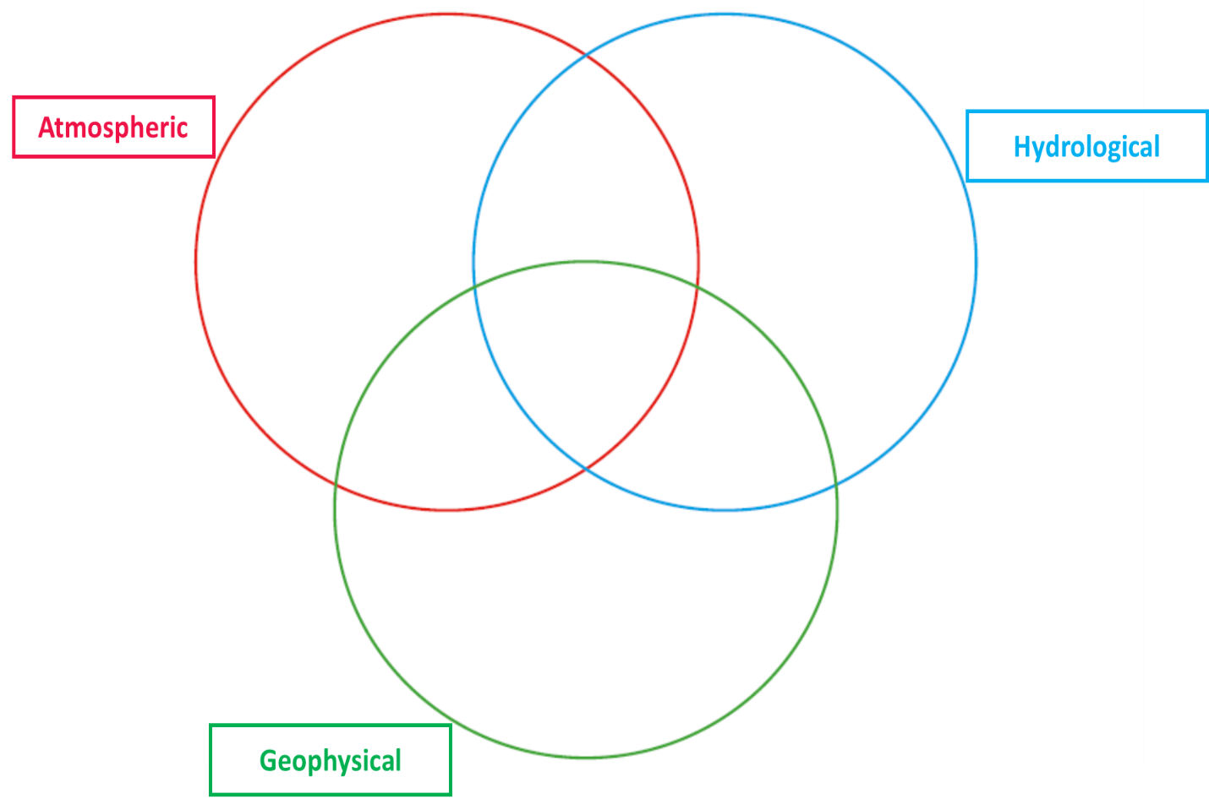Classify the examples of natural hazards that you have into the following categories:

Add in other hazards from the list on the board.

**What is a hazard?**

How would you define a hazard? Work on a definition with, no more than **20 words.**

**KEY TERMS**

|  |  |
| --- | --- |
| HAZARD |  |
| NATURAL HAZARD | An event perceived to be a threat to people, the built environment and the natural environment. They occur in the physical environments of the atmosphere, lithosphere and hydrosphere. |
| DISASTER | A hazard event that causes widespread disruption, destruction of property and loss of life on a significant scale. |

**The United Nations (UN) classifies a hazard as a disaster when:**

* A report of ten or more people are killed.
* A report of 100 or more people are affected.
* A declaration of a state of emergency by the relevant government is made.
* There is a request by the national government for international assistance.

**Common characteristics of natural hazards:**

* Clear origins and distinctive effects, e.g. earthquakes causing buildings to collapse;
* Only a short warning time before the event;
* The scale and intensity require an emergency response;
* Exposure to the risk is involuntary, particularly in less well developed countries.
* Most loss of life and damage occurs shortly after event; Effects can be felt long after.

**What are the potential impacts of natural hazards?**

Watch the clip and make notes on the different ways people can be affected:

What is the difference between a natural hazard and risk?

* Natural hazard = Natural phenomenon with the potential to harm;
* Risk = the probability of a hazard occurring and creating loss.

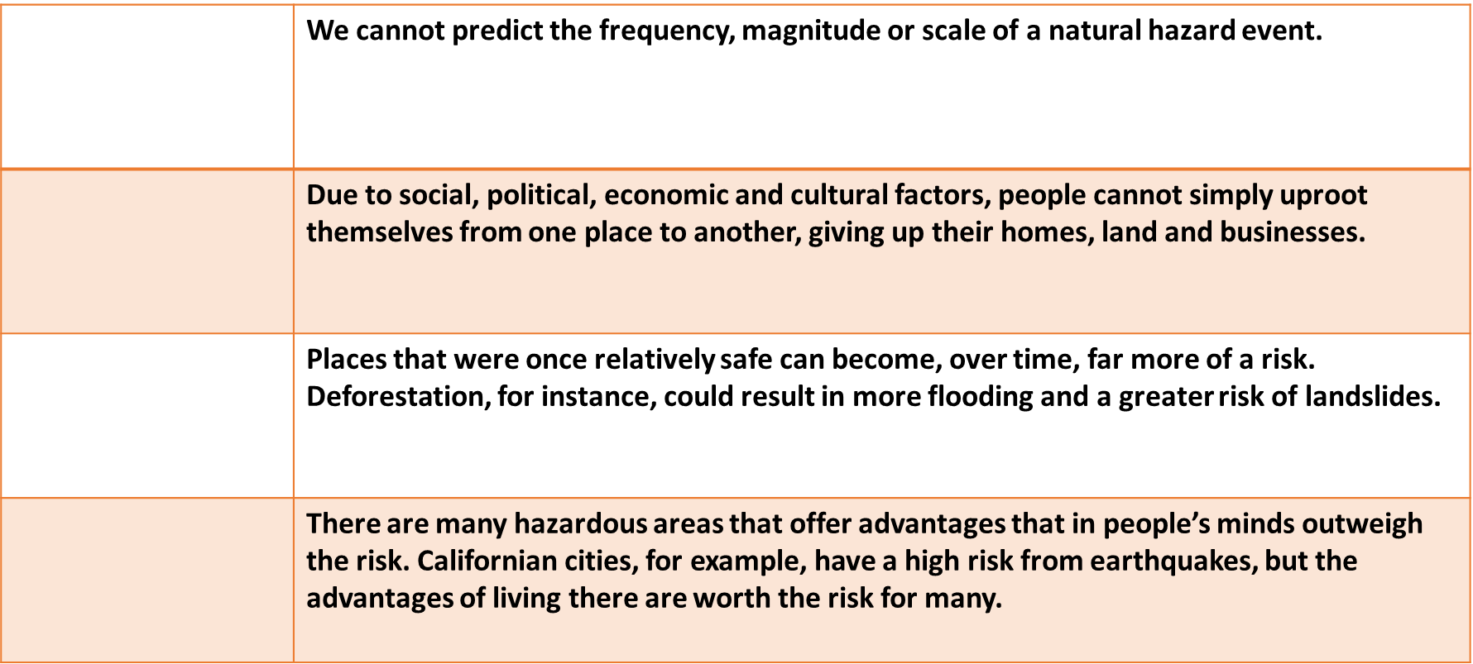**Why do some people put themselves at risk?**

Lack of alternatives - Cost/benefit - Hazard events are unpredictable - Changing the level of risk

**Perception of hazards**

Perception = the way in which an individual or a group views the threat of a hazard event. This will ultimately determine the course of action taken by people, governments and other organisations.

*Read the section under ‘Perception of hazards’ on page 213, Oxford.*

Try to come up with 3 or more factors that influence people’s perception of natural hazards:



*Take one factor and explain its role in influencing perceptions of hazards:*

**Risk and vulnerability**

Vulnerability = risk + ability to cope with potential loss.

When ability to cope is lower a community is more vulnerable.

***Discuss***: *Why are some populations vulnerable to natural hazards and exposed to risk?*

1) Suggest reasons why poorer people often more vulnerable to a natural hazard event:

2) Why are urban areas, particularly large ones, considered to be very vulnerable to natural hazard events?

**Review questions:**

What is a hazard? How can hazards be categorised?

What is a natural hazard and what makes it a disaster?

What are the common characteristics of hazards?

What is risk and what factors affect risk?

Why do people put themselves at risk from hazards?

What factors cause different people to perceive hazards differently?

What is vulnerability and what makes some people more vulnerable than others?