**3.7 Research methods**

**3.7.1 Scientific methodologies and 3.7.2.1 Quantitative measures and abiotic factors**

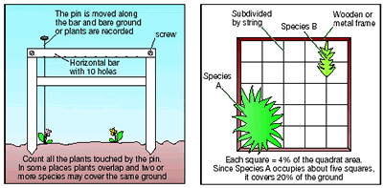

**Specification content**

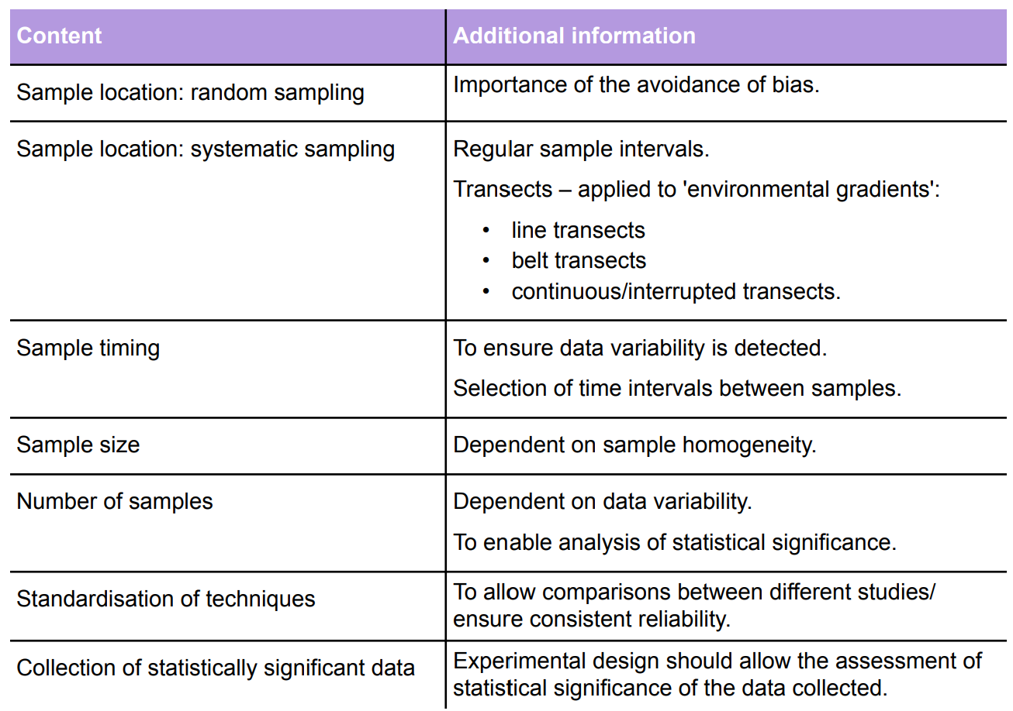

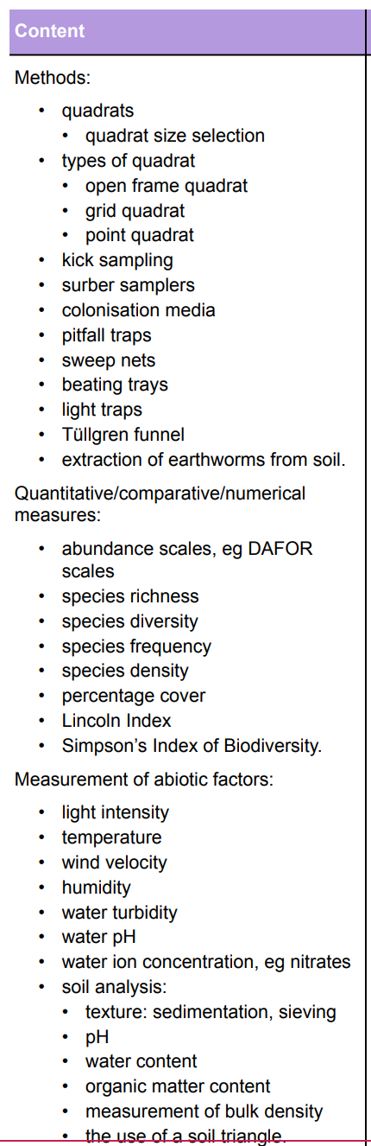





**3.7.1 Scientific Methodologies**

* When designing an investigation, data collected must be relied upon to be able to draw valid conclusions.
* The table below outlines the various qualities that a good investigation must have considered.
* Most environmental investigations will need to measure both biotic and abiotic factors.
* All investigations must have an appropriate risk management.

|  |  |
| --- | --- |
| **Quality** | **Definition** |
| **Accuracy** |  |
| **Bias** |  |
| **Precision** |  |
| **Representative sample** |  |
| **Reliable method** |  |
| **Anomalous result** |  |
| **Valid study** |  |

**What are the main stages in a scientific investigation?**

1.

2.

3.

4.

5.

6.

7.

**What is a hypothesis?**

**What is a null hypothesis?**

**How does a statistical test show if results are significant? (include probability in your answer)**

**In the following investigations the hypothesis is given to you. Write the null hypothesis in each case**

Investigation 1:

Hypothesis: There is more species diversity in the top area of a salt marsh compared to the lower area.

Null hypothesis:

Investigation 2:

Hypothesis: There is a correlation between the distance from the shoreline and the distribution of species found on a sand dune.

Null hypothesis:

**Investigation Planning.**

Good scientific research needs good planning. These are often what you need to decide before you answer investigation exam questions.

Planning stages

1.

2.

3.

4.

5.

6.

7.

**Write your mnemonic to remember these planning stages below.**

**Investigating Populations**

**Why Investigate Populations?**

Ecologists need to know population sizes (i.e. counting numbers of individuals from samples) to:

* Study the dynamics of a population
* Look at the distribution of the members of a population to see if they are influenced by a biotic or an abiotic factor
* Compare differences between communities and species
* Impact assessments (measuring effects of disturbance from changes in ecosystems)
* Restoration ecology (restoring ecological systems that have been damaged)
* Set harvest limits on commercial and game species (e.g. fish, deer, etc.)
* Controlling pest populations

**What are the difficulties when investigating populations?**

**Preliminary Studies**

* Once a hypothesis has been decided and an experiment designed a preliminary study is used to test the reliability of the methods chosen.
* Investigations can be time consuming and expensive so preliminary experiments can give an idea whether the entire experiment is worth performing.
* It will give information about the success of the sampling techniques chosen plus the size and number of samples to be taken to get valid results.

**Sampling**

The object is to collect as many randomly selected samples as possible (to increase the proportion of the total population sampled).

The accuracy of an estimate increases with the number of samples taken. This is because the number of individuals found in any given sample will vary from the number found in other samples. By collecting numerous samples, the effect of these variations can be averaged out.

The purpose for collecting the samples randomly is to avoid biasing the data. Data can become biased when individuals of some species are sampled more frequently, or less frequently, than expected at random. Such biases can cause the population size to be either over estimated or underestimated and can lead to erroneous estimates of population size.

**Random Sampling**

**Random sampling with a frame quadrat video**

<http://www.bing.com/videos/search?q=using+quadrats&&view=detail&mid=45D8E03FDC5EF69EC1E545D8E03FDC5EF69EC1E5&FORM=VRDGAR>

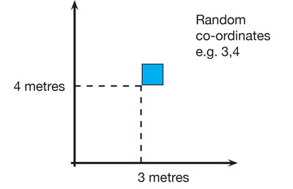**Method**

1. Lay out 2 long tapes at right angles in the study area
2. Obtain a series of coordinates by using random numbers taken from a table or computer
3. Place a quadrat at the intersection of each pair of coordinates and record number of individuals of the target species.

**How can you randomly sample an area that has an irregular shape? Draw a diagram to explain your answer.**

**Systematic Sampling**

To investigate changes in habitats or along lines of succession (sand dunes, rocky shores) systemic sampling is more appropriate

Line Transects

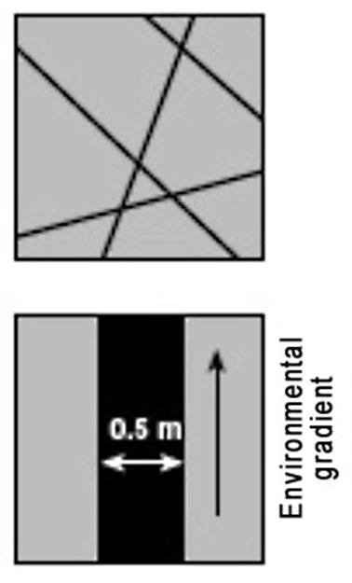Transects are used:

**Line transect** - records all the species which actually touch the rope or tape stretched across the habitat. A lot of organisms could be missed out = less representative.

**Belt transect** – a frame quadrat is laid down along a straight line and species recorded in the transect

**Interrupted belt transect** - records all those species present in a number of quadrats places at fixed points along a line stretched across the habitat.

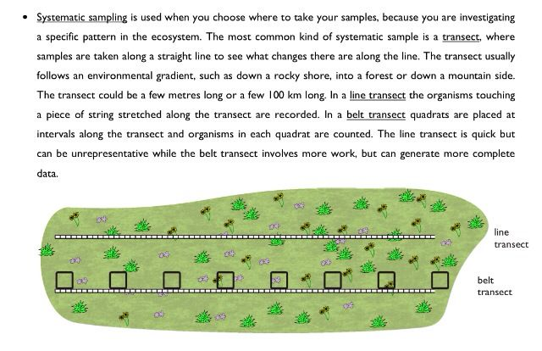

Belt Transect

**Line transect video**

<http://www.bing.com/videos/search?q=using+quadrats&&view=detail&mid=48C6E5A75A89FB9823BB48C6E5A75A89FB9823BB&FORM=VRDGAR>

**Sample Timing**

If something being investigated changes with time, then you may need to plan to sample on different occasions to produce a mean value that is accurate.

Timings between samples depends on the rate of change. Preliminary studies can help to identify this.

**Give 2 examples of studies that require different times scales when collecting data.**

**1.**

**2.**

**Sample Size**

* If the variable being measured is not homogenous then larger samples are more likely to produce representative results. The sample size needed can be determined with a preliminary study

**Number of samples**

* A single sample may not be representative as there may be variability between samples.
* Multiple samples eliminate this effect (**in an exam don’t ever say less than 10**)
* If possible, during a preliminary study, a running mean can be calculated to show how many samples should be taken.

**3.7.2.1 Quantitative measures**

It is important to be able to compare data about populations in different locations or at different times in the same place. There are many methods available to do this.

* Population size/density
* Abundance scales
* Species richness/diversity (covered in population dynamics topic)
* Species frequency
* Species density
* Percentage vegetation cover
* The Lincoln index

**Species Density**

Density = the mean number of individuals per unit area.

Achieved by counting numbers of organisms within a quadrat

What are the advantages and disadvantages of this measure?

Advantage:

Disadvantage:

**Species Frequency**

Frequency = likelihood of a particular species occurring in a quadrat.

If a species is present in 15 out of 30 quadrats, then the frequency of its occurrence is 50%.

What are the advantages and disadvantages of this measure?

Advantage:

Disadvantage:

This diagram shows how species may be distributed in different ways

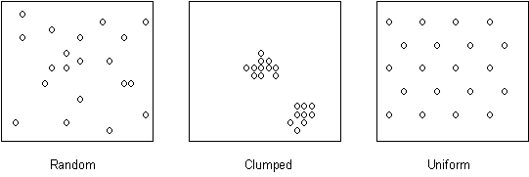

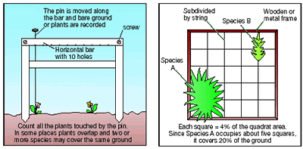**Percentage Vegetation Cover**

Percentage cover = estimate of the area within a quadrat that a particular species covers

What are the advantages and disadvantages of this measure?

Advantages:

Disadvantages:

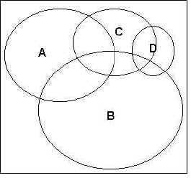To record percentage cover of species in a quadrat, look down on the quadrat from above and estimate the percentage cover occupied by each species (e.g. species A - D *left*).

Species often overlap and there may be several different vertical layers. Percentage cover may therefore add up to well over 100% for an individual quadrat.

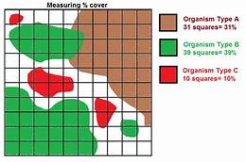

The estimation can be improved by dividing the quadrat into a grid of 100 squares each representing 1% cover. If the plant takes up a square that will represent 1% cover.

This is only practical if the vegetation in the area to be sampled is very short, otherwise the string/wire will impede the laying down of the quadrat over the vegetation.

**Species Diversity**

What is the definition of a species?

Define habitat diversity.

Define species evenness

Define species richness

Why is it important to know species diversity?

.

**Simpsons Diversity Index**

If a community with high diversity was randomly-sampled twice, there is a good chance that the two samples will contain different species. However, if a low-diversity community were sampled twice, it is likely that both of the samples will contain many of the same species. Simpson (1949) derived a formula based on the expected outcome of two random samples.

|  |  |  |
| --- | --- | --- |
| D = | N(N-1)  ______  sigman(n-1) |  |

where N = the total number of individuals of all species

n = the number of individuals of species

∑ = sum of

**Worked Example**

Often Simpsons diversity index is used to compare 2 habitats. Which of the habitats below is the most diverse?

|  |  |  |  |
| --- | --- | --- | --- |
|  |  | **Number of individuals** | |
| **Flower species** | **Habitat 1 n(n-1)** | | **Habitat 2** |
| **Daisy** | 300 | 300 x299 = 89700 | 20 |
| **Dandelion** | 335 | 335 x 334 = 111890 | 49 |
| **Buttercup** | 365 | 365 x 364 = 132496 | 931 |
| **Total** | 1000 |  | 1000 |

**Simpsons diversity index for habitat 1**

**Step 1 – calculate N(N-1)**

Given in the table N = 1000 N-1 = 999

Therefore N(N-1) = 1000 x 999 = 999000

**Step 2 – calculate ∑n(n-1)**

This is best done by adding the figures for n(n-1) for each species into your table (see above)

∑n(n-1) = 89700 + 111890 + 132496 = 334086

**Step 3 – calculate the index with the figures from steps 1 & 2**

|  |  |  |
| --- | --- | --- |
| D = | N(N-1)  ______  sigman(n-1) |  |

= 999000 = 2.99

334086

Use the space below to calculate the diversity index for habitat 2

**Interpreting Results**

A low value of diversity would suggest that the habitat was dominated by a few species and therefore a small change to the environment would have a large affect on the habitat. A higher value shows a higher diversity and therefore greater ecological stability.

Which habitat from the examples above is more diverse? ………………………………………………….

**More Examples**

Which side of the line has the highest index of diversity?

B

Text Box Tools tab to change the formatting of the pull quote text box.]

A

|  |  |  |
| --- | --- | --- |
| **Species** | **Number of individuals** | |
|  | **Community A** | **Community B** |
|  |  |  |
|  |  |  |
|  |  |  |
|  |  |  |
|  |  |  |

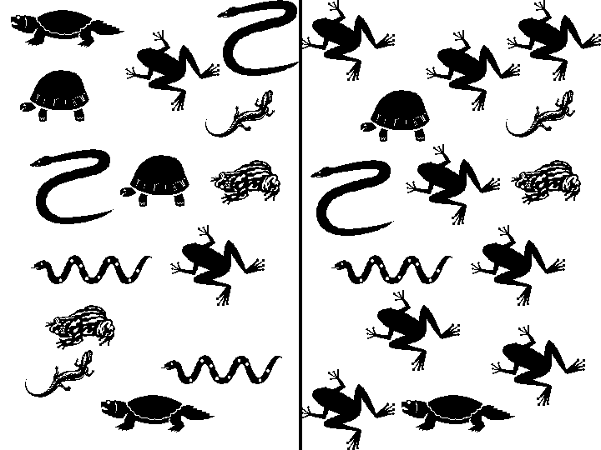

Complete the table to show your data

Calculate the diversity index for community A and community B

Which is the most diverse community? …………………………………………………..

In which kind of environments would you expect to find a high index of diversity? Will the ecosystem be stable or unstable where there is a high index of diversity of species?

**Estimating the total number of species that exist**

Explain how the graph below can be used to estimate the total number of species that exist.

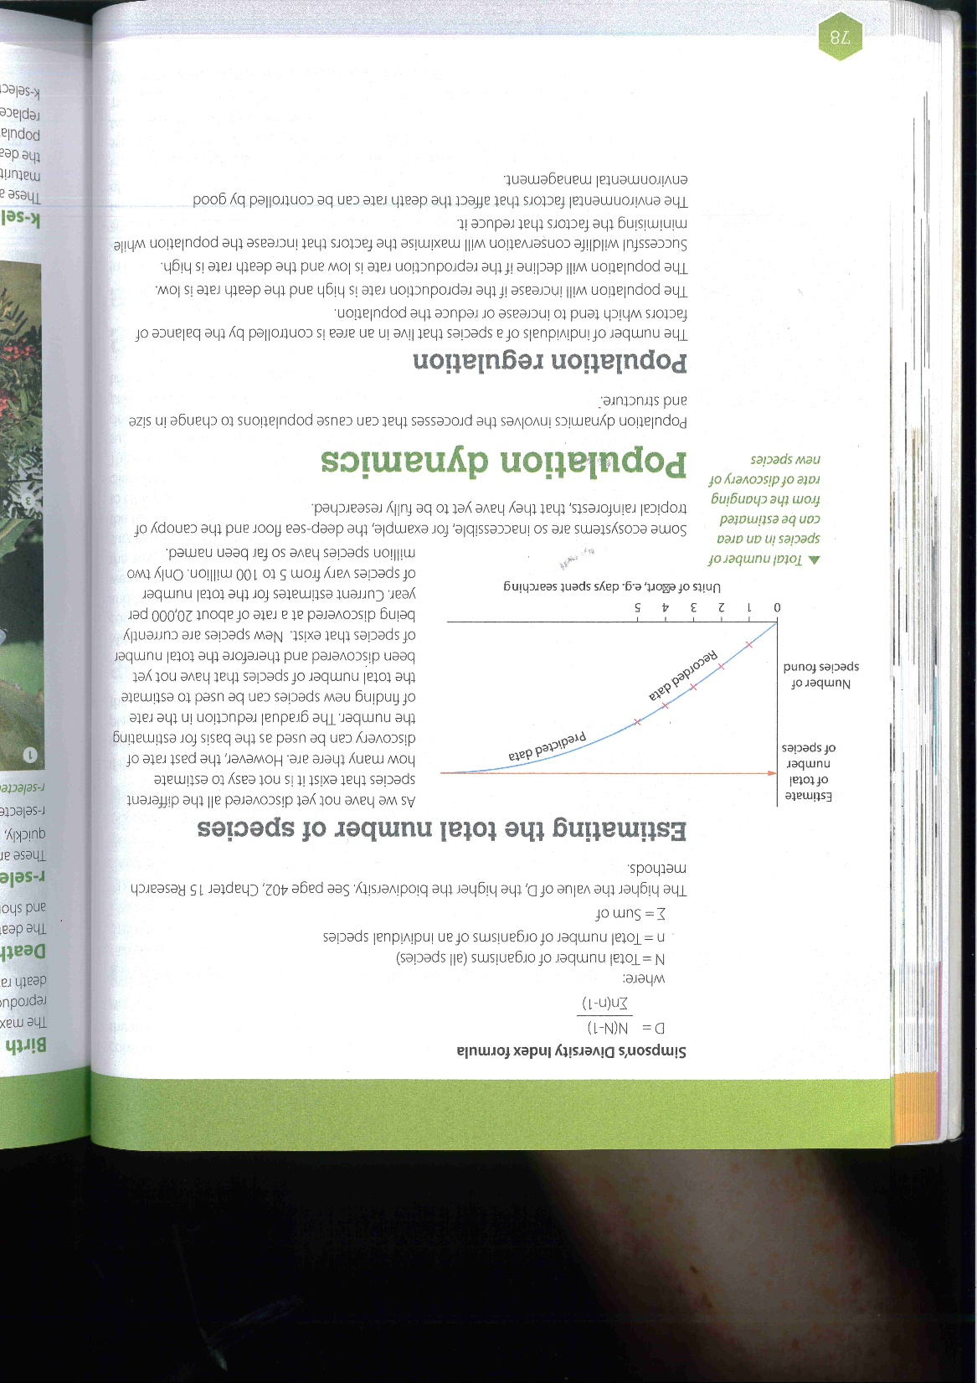

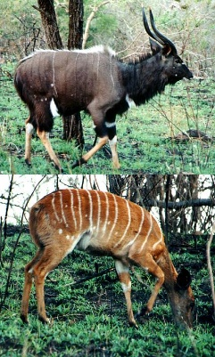

Why are some species still undiscovered?

What new methods can be used to help in the identification of new species?

[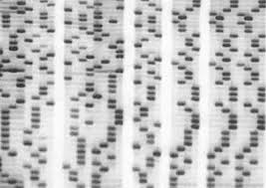](http://www.mchem.btinternet.co.uk/SciImage/gel_blot_storm_storage_phosphor_files/0_002.jpg)

What value may undiscovered species have to humans?

[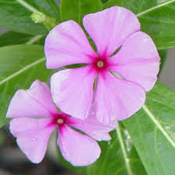](http://www.nybg.org/images/flowering/Rosy_Periwinkle.jpg)

**More practice for the Index of Diversity**

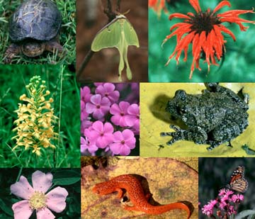

Biological diversity or biodiversity can be calculated by the formula:

D = N(N – 1)

∑ n(n – 1)

where

D = the biodiversity index;

N = total number of organisms of all species;

n = total number of organisms of a particular species;

∑ = the sum of.

**Exercise 1**

|  |  |
| --- | --- |
| **Species in a pond:** | **Number of each species:** |
| Great pond snails | 8 |
| Dragonfly larvae | 6 |
| Frogs | 4 |
| Water beetles | 8 |

*Calculate the biodiversity index for the pond:*

**Exercise 2**

*Calculate the biodiversities of these two 20 m lengths of hedgerow:*

|  |  |  |
| --- | --- | --- |
| **Tree / Shrub** | **Hedge 1** | **Hedge 2** |
| Hawthorn | 20 | 34 |
| Field maple | 5 | 1 |
| Oak | 8 | 3 |
| Ash | 5 | 1 |
| Blackthorn | 2 | 1 |
| *Total:* |  |  |

*Complete a biodiversity calculation and then say what this tells you about the biodiversity value?*

**Abundance Scales**

An important part of understanding ecosystems is an understanding of the numbers of species in an area and how abundant they are.

To do this comprehensively is very time-consuming so many studies use partial information to make comparisons.

**Abundance Scales**

Counting numbers of individuals of plant species in different areas is very time-consuming. If quantitative detail in not required then abundance scales can be used. General comparisons can then be made between different areas.

**DAFOR abundance scale**

Qualitative scale that is a relatively quick way of assessing the abundance of species in a study area.

**Method**

Species are identified in an area and allocated to a category based on their abundance:

D = Dominant

A = Abundant

F = Frequent

O = Occasional

R = Rare

**Limitations**

1.

2.

3.

**Mark-release–recapture and Lincoln Index**

**Quantitative measurement of mobile populations**

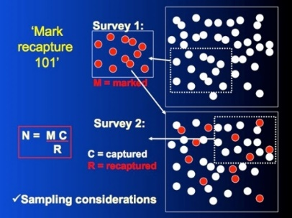

The best way to measure the size of a population is to count all the individuals in that population. If the organism is mobile, however, such as a fish, counting every individual would be difficult. Some individuals might be counted twice or not at all.

**Method – Mark-Release-Recapture**

1. **Capture a sample of** animals (the sampling method will depend on the animal). The larger the sample the better the estimate works.
2. **Count all the animals** in this sample (n1) **and mark** (using one of methods below) then so that they can be recognised later.
3. **Release all the animals** where they were caught and give them time to mix with the rest of the population (typically one day).
4. **Capture a second sample** of animals using the same trapping technique.
5. **Count the total animals** in the second sample (n2**), and the number of marked** (i.e. recaptured) animals in the second sample (m).
6. Calculate the population estimate using the **Lincoln Index**

**Lincoln Index**

Write the formula below for calculating the Lincoln Index.

List some examples of tags that can be used for specific organisms below.

**Assumptions that need to be true of populations to use the Lincoln index.**

1.

2.

3.

4.

5.

6.

**Limitations of Mark-Release-Recapture**

* Accuracy of the Lincoln index is based on capturing a large proportion of the population and this may be difficult to do with some species
* Animals that are territorial will not be distributed evenly and therefore the results will not be accurate. If you sample in the same area the second time you will just end up with the same individuals being caught

**Modelling Mark-release-recapture**

In this investigation, you will **model** a population of trout, capture and make a sample of the population, and then capture a second sample. You will then **estimate** the size of the model population using the Lincoln Index. The accuracy of the Lincoln Index will be inferred by counting the model population.

**Estimating trout population size using the Lincoln index**

**Materials**

* Paper bags with beans in – represent different habitats and a population of trout
* Permanent marker pens

**Testing the accuracy of the mark-release-recapture method of calculating population size**

Method

1. Collect your population of fish (beans from either from lake A or lake B)
2. Remove a handful of beans from the model habitat. (More than 20 beans but less than half of the total population.)
3. Using a permanent marker pen draw a line on each side of the beans.
4. Count the beans and record this number as n1 for trials 1-6 in the data table.
5. Place the beans back into the habitat. Mix them well by shaking the bag.
6. Remove another handful of beans. Count the total number of beans in the second sample (n2) and record in the table.
7. Count the marked number of beans and record as m for Trial 1. (If m is zero, do this step over again.)
8. Return the organisms to their habitat and mix them well.
9. Repeat steps 6 & & five more times giving you a total of six trials.
10. Using the Lincoln Index, calculate N (population size)
11. Remove all beans and count the total population size and record this below your table. Put the beans back in the bag and keep on your table.

**Data Table**

|  |  |  |  |  |
| --- | --- | --- | --- | --- |
|  | **n1**  **Number of marked beans in sample** | **n2**  **Size of second (recaptured) sample** | **m**  **Number of marked beans recaptured in second sample** | **N**  **Population Estimate** |
| Trial 1 |  |  |  |  |
| Trial 2 |  |  |  |  |
| Trial 3 |  |  |  |  |
| Trial 4 |  |  |  |  |
| Trial 5 |  |  |  |  |
| Trial 6 |  |  |  |  |

Note: n1 will be the same for all trials**.**

**Actual population size (count the actual number of beans) :**  ………………………………..

**Analysis Questions**

1. Use your data to estimate the average size of the mobile population in the model habitat.
2. Calculate the percent error of the average population estimate calculated with the Lincoln Index to the actual size of the population. If you get a negative number, take the absolute value and make it positive.



1. Did your results differ greatly from the actual number of individuals in the model habitat? Discuss at least 3 factors that might affect the accuracy of your estimates.
2. To get an accurate estimate, why is it important that the beans “caught” during the first sampling are returned to the habitat unharmed?
3. When estimating an organism’s population size, why is it important that the time between first and second samples be a short time compared to the organism’s life span?
4. Based on what you observed in this exercise, do you think that the mark-recapture method is a good way to estimate population? Explain your answer.

**3.7.2.1 Measuring Abiotic Factors**

It is important to measure abiotic factors in environmental investigations.

Many abiotic factors are measured using **electronic meters** that need to be **calibrated** before use so that readings are accurate.

Examples of electronic meters include:

* + Temperature
  + pH
  + Dissolved oxygen
  + 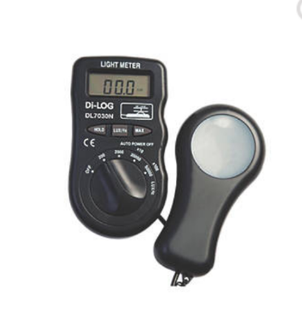Light levels
  + Wind and water velocity

**Light intensity**

* When using a light meter, a standardised method needs to be used e.g. holding the sensor at the same height from the ground and facing the same direction

**Humidity (traditional method)**

* 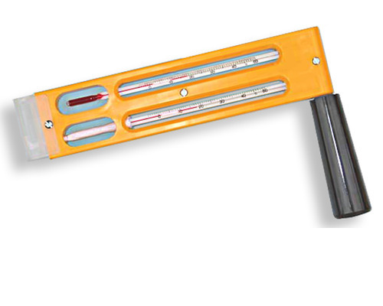Measured using a **whirling hygrometer**
* 2 thermometers (1 wet and 1 dry) are spun, the wet one is cooled by the evaporation of the water. The rate of evaporation depends on the humidity in the atmosphere. The temperature difference between the 2 thermometers can be compared with a table of values to estimate humidity.
* To ensure **accuracy**, spinning is continued until no further cooling occurs

**Wind velocity**

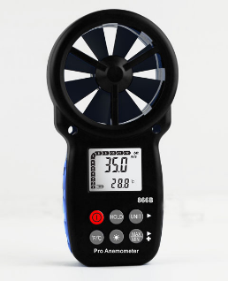

* Measured using an electronic **anemometer**
* Standardised by:
  + Holding at the same height above ground
  + Ensuring there are no obstacles to air flow
  + Axis of rotation must be horizontal or vertical (depending on type)
  + Impeller type anemometers must face into the wind