**3.7 Research methods**

**3.7.2.1 Standard environmental techniques and 3.7.2.3 Specialist techniques**

[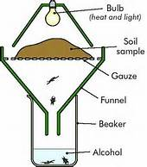](https://www.bing.com/images/search?q=tullgren+funnels&view=detailv2&&id=24B0CC6807E169C346E40264BBDBD237E7C4BC02&selectedIndex=5&ccid=g3k8gzcY&simid=608007756478940857&thid=OIP.M83793c833718e2a47fe25d47594c0c9cH0)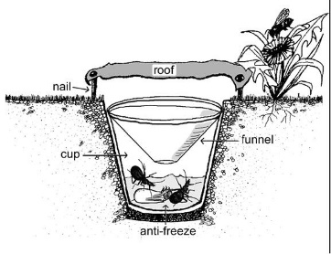

**Specification content**

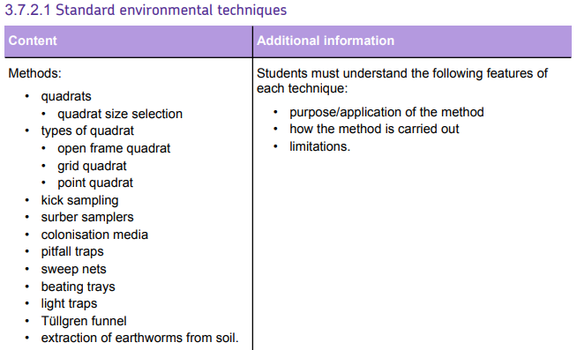

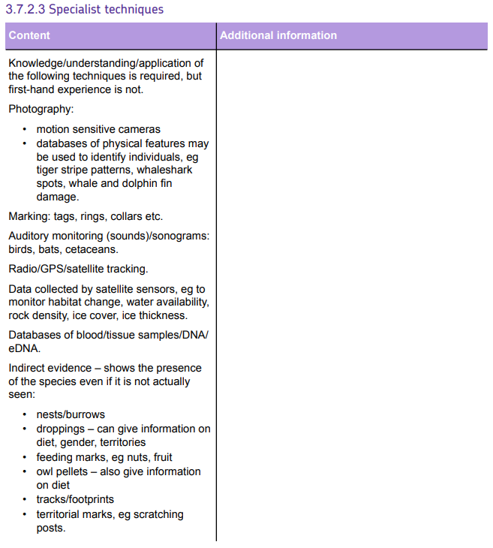

**3.7 Research Methods**

Scientific research is very important to obtain representative data of different situations in the environment. This data can be used to make valid conclusions that can be used when making decisions about how to help with environmental problems e.g. conservation efforts.

Population Studies

Ecological monitoring is very important for helping to make decision on wildlife conservation programmes. A good survey can be used to:

* to find out the species present in a habitat or ecosystem;
* to monitor the conditions in a habitat and see if they change over time;
* to find population sizes;
* to see the age structure of a population;
* to find the growth rate and breeding rate of a population;
* to find out the territory size of a species;
* to map population movements;

There are many different techniques used to obtain data on ecosystems and the species that live in them. The technique will depend on the species being studied.

**3.7.2.1 Standard Ecological Techniques**

**Task 1:**

**For each sampling technique research the following and put the notes into table 2 below:**

1. **Which organisms do you use the technique for**
2. **What is the method used for that technique**
3. **What are the limitations of using this technique**
4. **How do you standardise the method so that results gained are representative and can be used by other researchers**
5. **Find a diagram/picture of the technique**
6. **Find a good video that shows how this technique works. (Put the link for this in the table 1 below)**

**Table 1: List of web links to video clips of the sampling technique.**

***You need to find a good video explaining each technique and add the link below***

|  |  |
| --- | --- |
| **Sampling technique** | **Web link** |
| **Quadrats:**  **Grid quadrat**  **Point quadrat** |  |
| **Pond net** |  |
| **Kick sampling** |  |
| **Surber sampling** |  |
| **Plankton net** |  |
| **Sweep net** |  |
| **Aerial insect net** |  |
| **Colonisation media** |  |
| **Pitfall trap** |  |
| **Beating trays** |  |
| **Light trap** |  |
| **Tullgren funnel** |  |
| **Suction sampler:**  **Pooter**  **Motor-driven suction sampler** |  |
| **Earthworm collection:**  **Soil flooding**  **Soil pit extraction** |  |

**Table 2: Summary of different sampling techniques, their methods, limitations and standardisation.**

|  |  |  |  |  |
| --- | --- | --- | --- | --- |
| **What organism/s are sampled** | **Method of how to use the equipment** | **How would you standardise the method** | **Limitations of the method** | **Diagram/picture of the equipment** |
| **Quadrats** | | | | |
| **Open frame quadrat:**  **Grid quadrat:**  **Point quadrat:** |  |  |  |  |
| **Pond net** | | | | |
|  |  |  |  |  |
| **Kick sampling** | | | | |
|  |  |  |  |  |
| **Surber sampling** | | | | |
|  |  |  |  |  |
| **Plankton net** | | | | |
|  |  |  |  |  |
| **Sweep net** | | | | |
|  |  |  |  |  |
| **Aerial insect net** | | | | |
|  |  |  |  |  |
| **Colonisation media** | | | | |
|  |  |  |  |  |
| **Pitfall trap** | | | | |
|  |  |  |  |  |
| **Beating trays** | | | | |
|  |  |  |  |  |
| **Light trap** | | | | |
|  |  |  |  |  |
| **Tullgren funnel** | | | | |
|  |  |  |  |  |
| **Suction samplers** | | | | |
| **Pooter:**  **Motor-driven suction sampler** |  |  |  |  |
| **Earthworm collection** | | | | |
| **Soil flooding**  **Soil pit extraction** |  |  |  |  |

**3.7.2.3 Specialist techniques used in ecological research**

More recent technological developments have been developed to improve results obtained and can be applied to new research situations.

These techniques include:

Imagery – image databases, motion sensitive cameras and CCTV

Marking

DNA databases – environmental DNA (eDNA)

Auditory monitoring

Position monitoring

**Task 2: For each of the different specialist techniques, research the following and complete the table 3 below:**

1. **How the technique works, equipment used and limitations**
2. **Which species or taxa this technique is used on**
3. **Add a relevant diagram or picture of the technique used.**

**Table 3: Table showing the ways in which specialist techniques can be used to obtain data on populations.**

|  |  |  |
| --- | --- | --- |
| **Method/information about the technique, equipment used and limitations** | **Examples of taxa monitored with this technique** | **Picture/image** |
| **Image databases** |  |  |
| **Motion sensitive cameras** |  |  |
| **CCTV** |  |  |
| **Marking** |  |  |
| **eDNA & DNA databases** |  |  |
| **Auditory monitoring** |  |  |
| **Position marking** |  |  |

**Indirect methods of monitoring populations**

Some species can be difficult to count directly, but they may leave other evidence that indicates their presence, and possibly their numbers. Researchers can count the numbers of these in the environment to gain an indication as to the population numbers.

* Nests/burrows
* Droppings e.g. otter spraints. These can give information on diet, gender and territory size.
* Feeding marks e.g. chewed nuts
* Owl pellets (undigested parts of a bird's food, such as hair or bones, which are regurgitated) – these give information on diet
* Tracks/footprints
* Territorial marks e.g. scratching posts of bears