**Assessing Biodiversity**

“Invertebrates are declining in response to widespread habitat loss and fragmentation,

urbanisation, changing agricultural and land management practices, environmental pollution,

non-native invasive species and many other factors.” (buglife, 2019)

Vegetation species and abundance has a direct impact on soil characteristics including the species and abundance of organisms, in this investigation you will use a range of methods to sample invertebrate communities on the soil surface and in the soil in two contrasting areas, comparing the differences in species present and their relative abundance.

**Investigation title: Investigating differences in invertebrate communities between a deciduous and coniferous woodland.**

For this investigation you will be collecting field data to use as part of a class investigation, the data you collect will form part of a larger class data set. You will be told how many repeats to carry out in each of the two woodland areas.

**Equipment to take to field:**

2 x 30 cm rulers

Distilled water bottle

Spade/trowel

Small bottle with lid

Mustard powder and water mixture

OPAL earth worm key

2 x white tray

Spatula

Plastic bag

Scissors

Small plastic spoon

Forceps

Plastic cup

Skewer with tape attached

**Equipment in the lab:**

Tullgren funnel

Lamp

Beaker

Leaf litter identification key

Barium sulphate

Universal indicator and chart

**Risk Assessment**

|  |  |  |
| --- | --- | --- |
| **Hazards** | **Risk rating** | **Control** |
| Uneven ground/tripping | Low | Move slowly in sample areas and make sure you have sensible footwear on |
| Scratches, thorns | Low | Take care to notice hazardous plants and avoid touching them. College first aid kits available in the event of broken skin |
| Ticks, bacterial infections | Low | Ensure that ankles are covered, any cuts have plasters over them. Wash hands thoroughly after handling soil/animals |

**Methods**

**A. Leaf litter collection**

1. Decide the sample area you will collect your data from. (There will be a class discussion on this.)
2. Place 2 x 30cm rulers in your sample area to mark out the area (30cm x 30cm).
3. Remove all leaf litter within the sample area (remove any large twigs/branches).
4. Place the leaf litter into a large plastic bag and seal to take back to the lab.

**B. Earthworm sampling**

1. Dig a soil pit 30cm x 30cm to a depth of 10cm.
2. Take 1cm3 of soil (a spatula full) from the A-Horizon (Figure 1) and place into the glass bottle and put a lid on.
3. When digging the soil pit, place the removed soil in one of the white trays and put any earthworms in this soil into the other tray.
4. Look at each earthworm and see if it has a well-developed saddle (Figure 2).
5. Sort all earthworms found in the removed soil into two groups, those with saddles (adults) and those without saddles (immature).
6. Record the numbers in each group.
7. Rinse all earthworms with water and return the immature worms to the soil (not the pit).
8. Save adult worms in the white tray for identification. Add a little water to the tray to avoid the worms drying out.
9. To extract deep burrowing earthworms pour the mustard solution into the pit slowly (this is not toxic to the earthworms but encourages them to come to the surface).
10. Collect any earthworms that emerge and separate into adult and immature as in step 5.
11. Count and add to your tally before returning immature worms to the soil.
12. Use the Earthworm Identification Guide to identify and record the species of each adult earthworm found.
13. Once all worms are identified and counted return them to the hole you have dug and replace the soil.

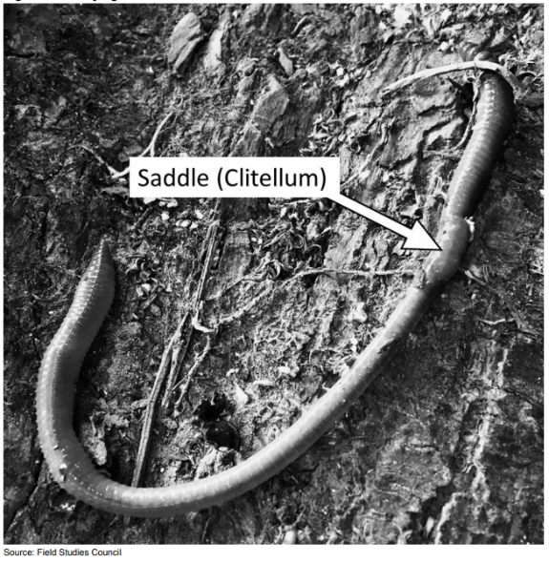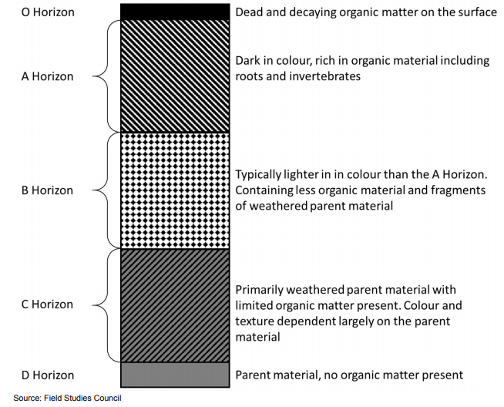**Figure 1 – Soil profile Figure 2 – Earthworm saddle**

**C. Setting up the pitfall trap**

**Figure 3 – Setting up a pitfall trap**

1. 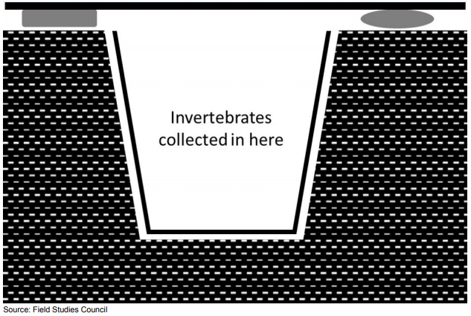Use the trowel to create a hole deep enough for the plastic cup.
2. Place the cup into the whole so that the top of the cup is just below the surface of the soil but below any leaf litter.
3. Place the cover over the top of the cup, using sticks or stones to ensure that the lid sits above the surface of the soil (Figure 3).
4. Place a skewer with take attached into the ground by your pitfall trap so that you know where you have set it up.
5. Leave the pitfall traps overnight, returning the next day to collect any invertebrates which have fallen into the traps.

**D. Testing pH**

1. Take the sample of soil and add a spatula full of Barium Sulphate to the bottle.
2. Half fill the pot with distilled water.
3. Place the lid on and agitate the sample for 2 minutes
4. Place 3 drops of Universal Indicator solution into the sample.
5. Rest the bottle for 20 minutes
6. Using the colour key provided with the Universal Indicator solution, record the pH of the soil sample.

**E. Tullgren funnel**

**Figure 4 – Setting up a Tullgren funnel**

1. 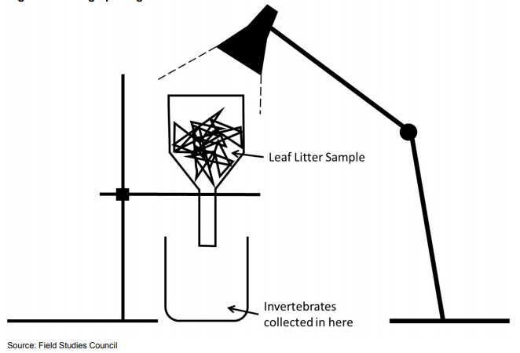Set up the Tullgren funnels as shown in Figure 4.
2. Add 2cm depth of water to the beakers and a small drop of washing up liquid.
3. Place the sample of leaf litter into each funnel and place the light close to the top of the soil.
4. Leave the Tullgren funnels (at least overnight) before collecting any invertebrates that have fallen into the beaker.
5. Use the key to identify and count any invertebrates using the key and add these to your results.

**F. Pitfall traps**

1. Return to your pitfall traps and remove the plastic cup.
2. Fill in the hole and remove the skewer.
3. Take your cup back to the lab.
4. Use the key to identify the invertebrates found and record each species and number of each species.

**Results**

**Earthworm extraction**

|  |  |
| --- | --- |
| **Type of worm** | **Number collected** |
| Immature |  |
| Red |  |
| Stripey |  |
| Pale |  |
| Green |  |

**Tullgren funnel**

|  |  |
| --- | --- |
| **Species/Taxa** | **Number collected** |
|  |  |
|  |  |
|  |  |
|  |  |
|  |  |
|  |  |
|  |  |
|  |  |
|  |  |
|  |  |
|  |  |
|  |  |

**Pitfall Trap**

|  |  |
| --- | --- |
| **Species/Taxa** | **Number collected** |
|  |  |
|  |  |
|  |  |
|  |  |
|  |  |
|  |  |
|  |  |
|  |  |
|  |  |
|  |  |
|  |  |
|  |  |